GAMBARAN KADAR LAJU ENDAP DARAH (LED) TERHADAP KEBIASAAN MEROKOK PADA REMAJA
by Suko Legowo Dwi Prastyo

Submission date: 27-Oct-2021 08:26AM (UTC+0700)
Submission ID: 1685149174
File name: SUKO1111_KTI_BENAR111_1.doc (947K)
Word count: 5286
Character count: 33270

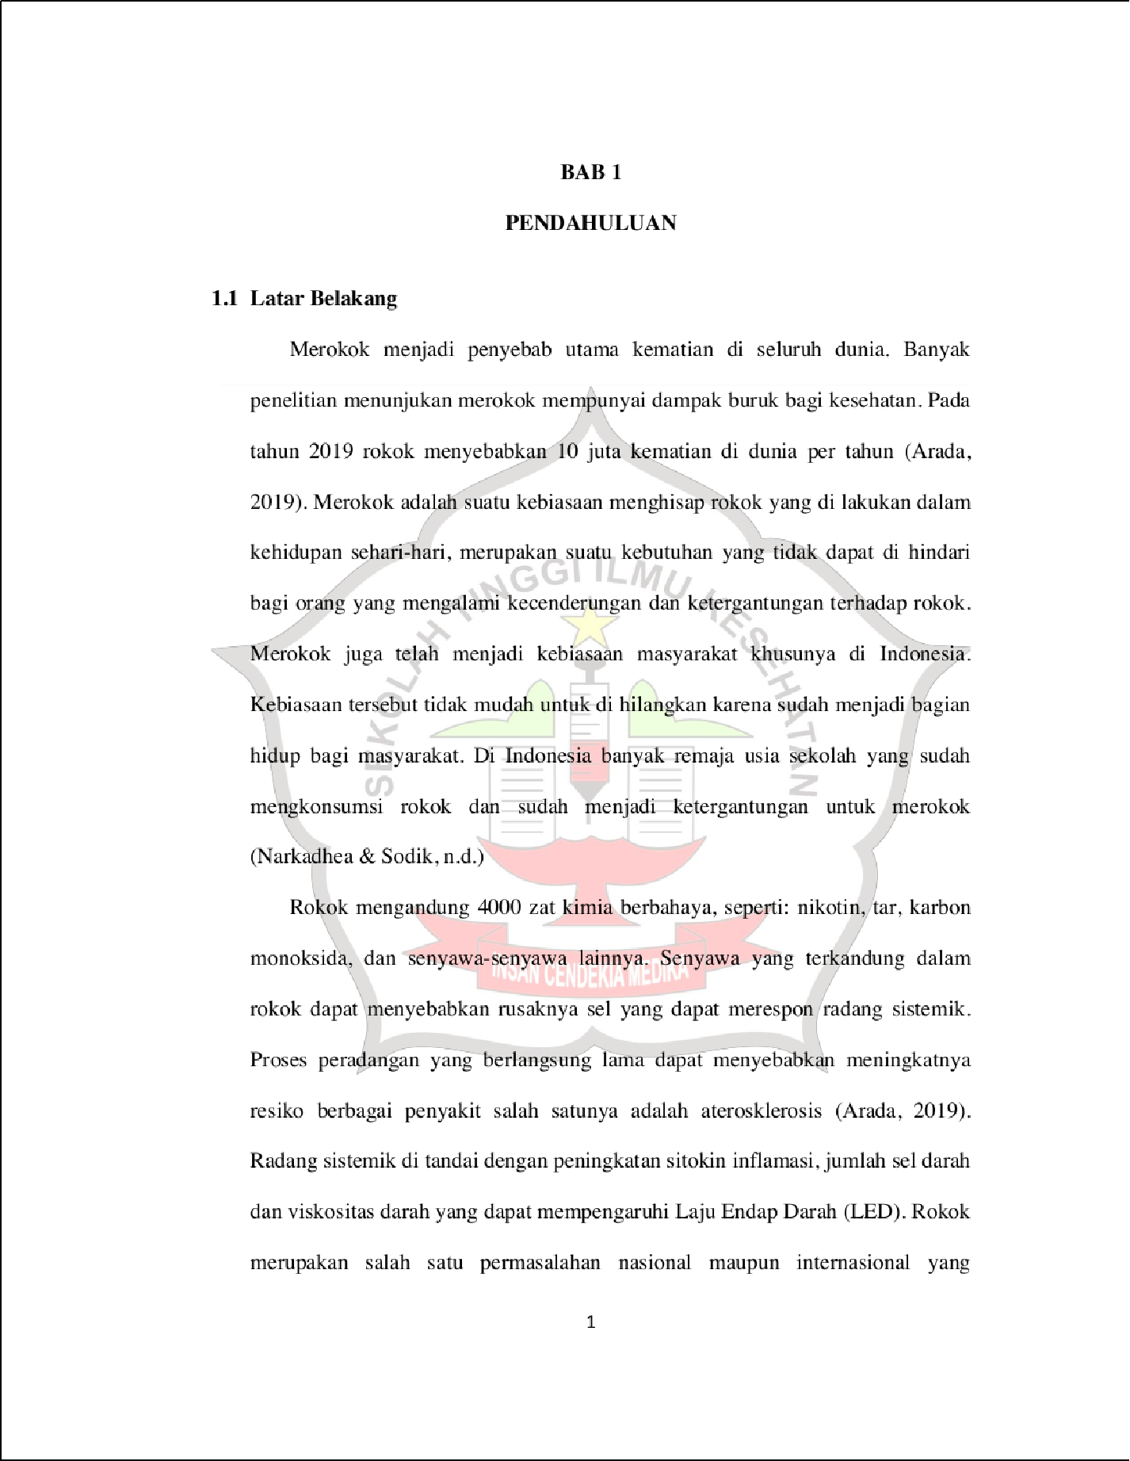

18

20

44

7

9

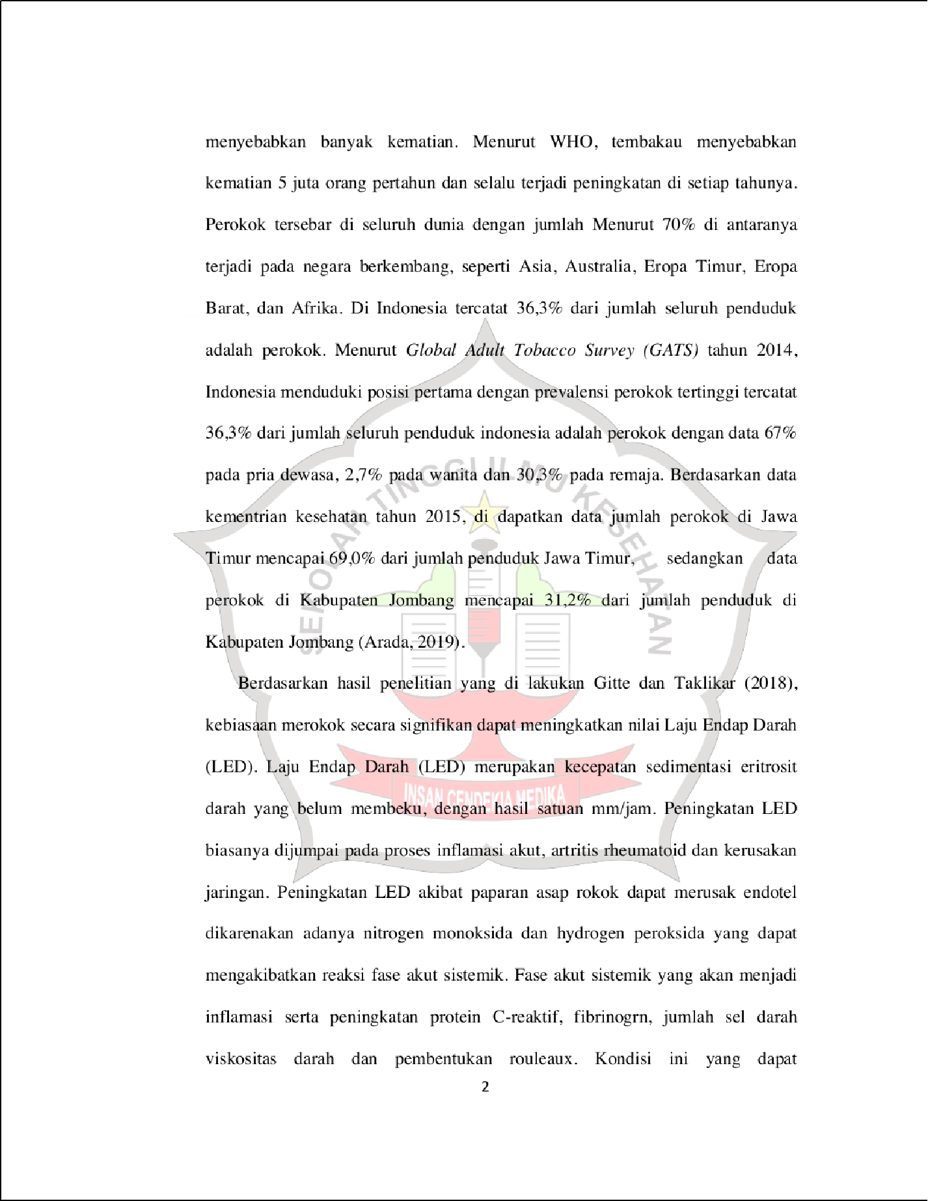

31

9

4

13

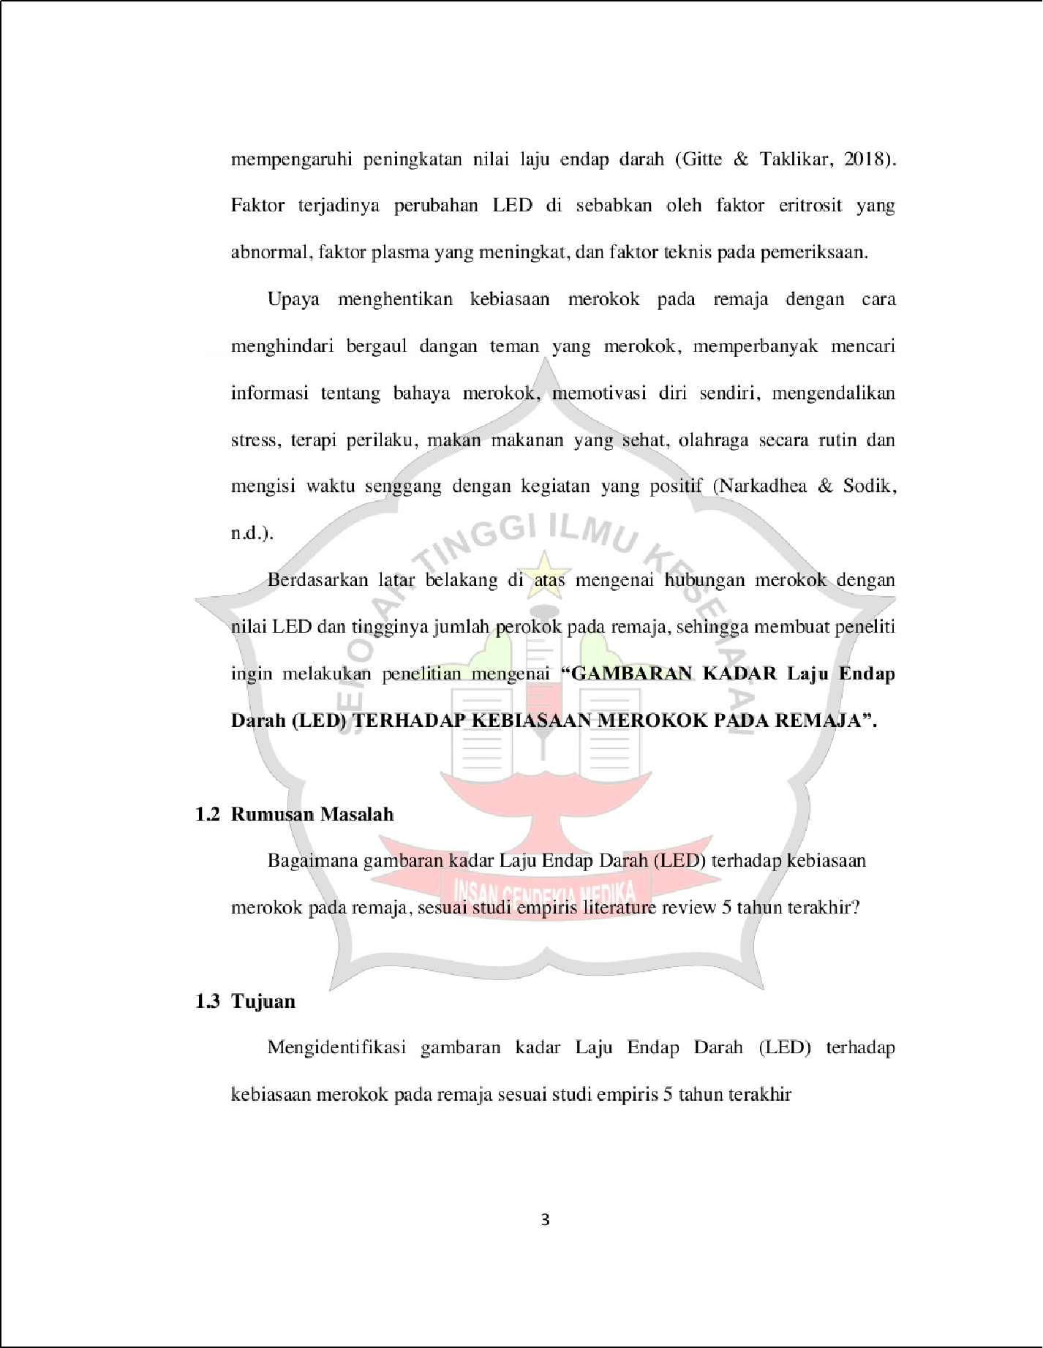

52

6

45

6

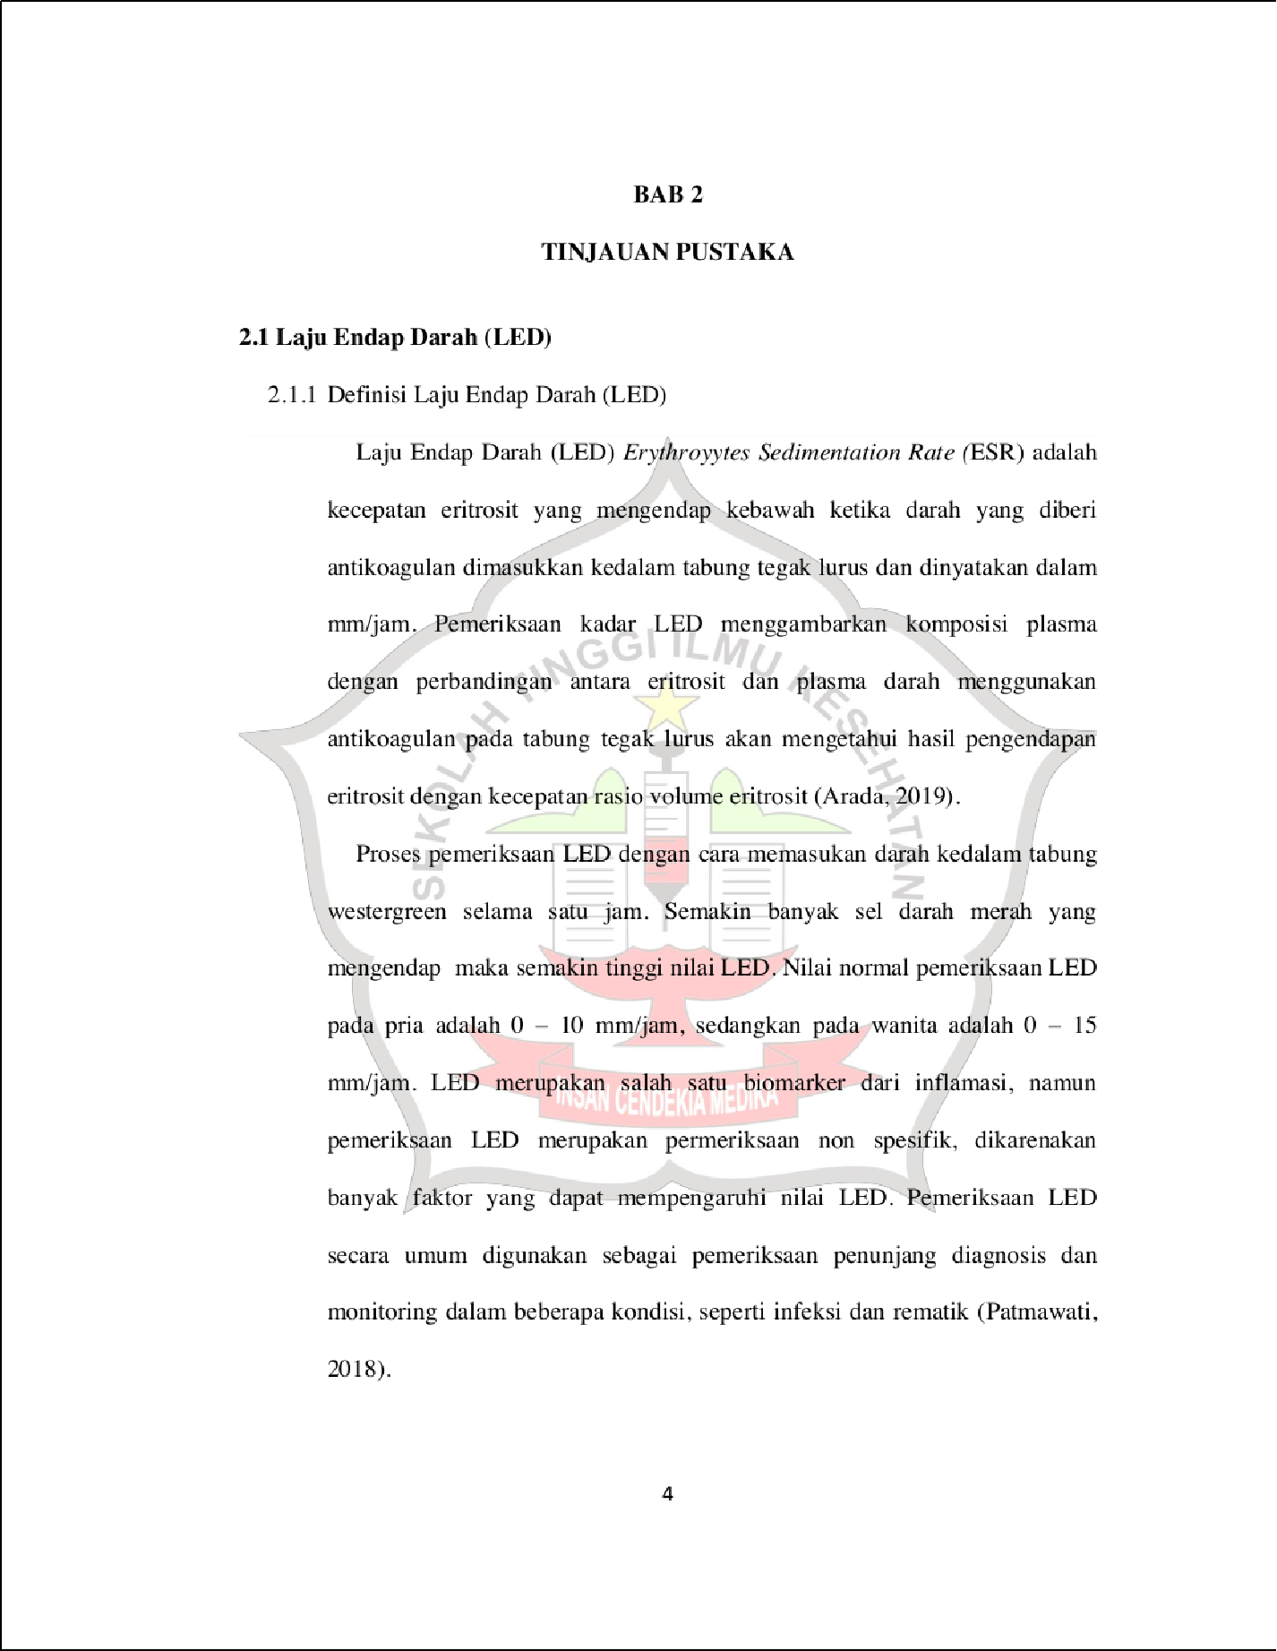

6

4

11

29

13

27

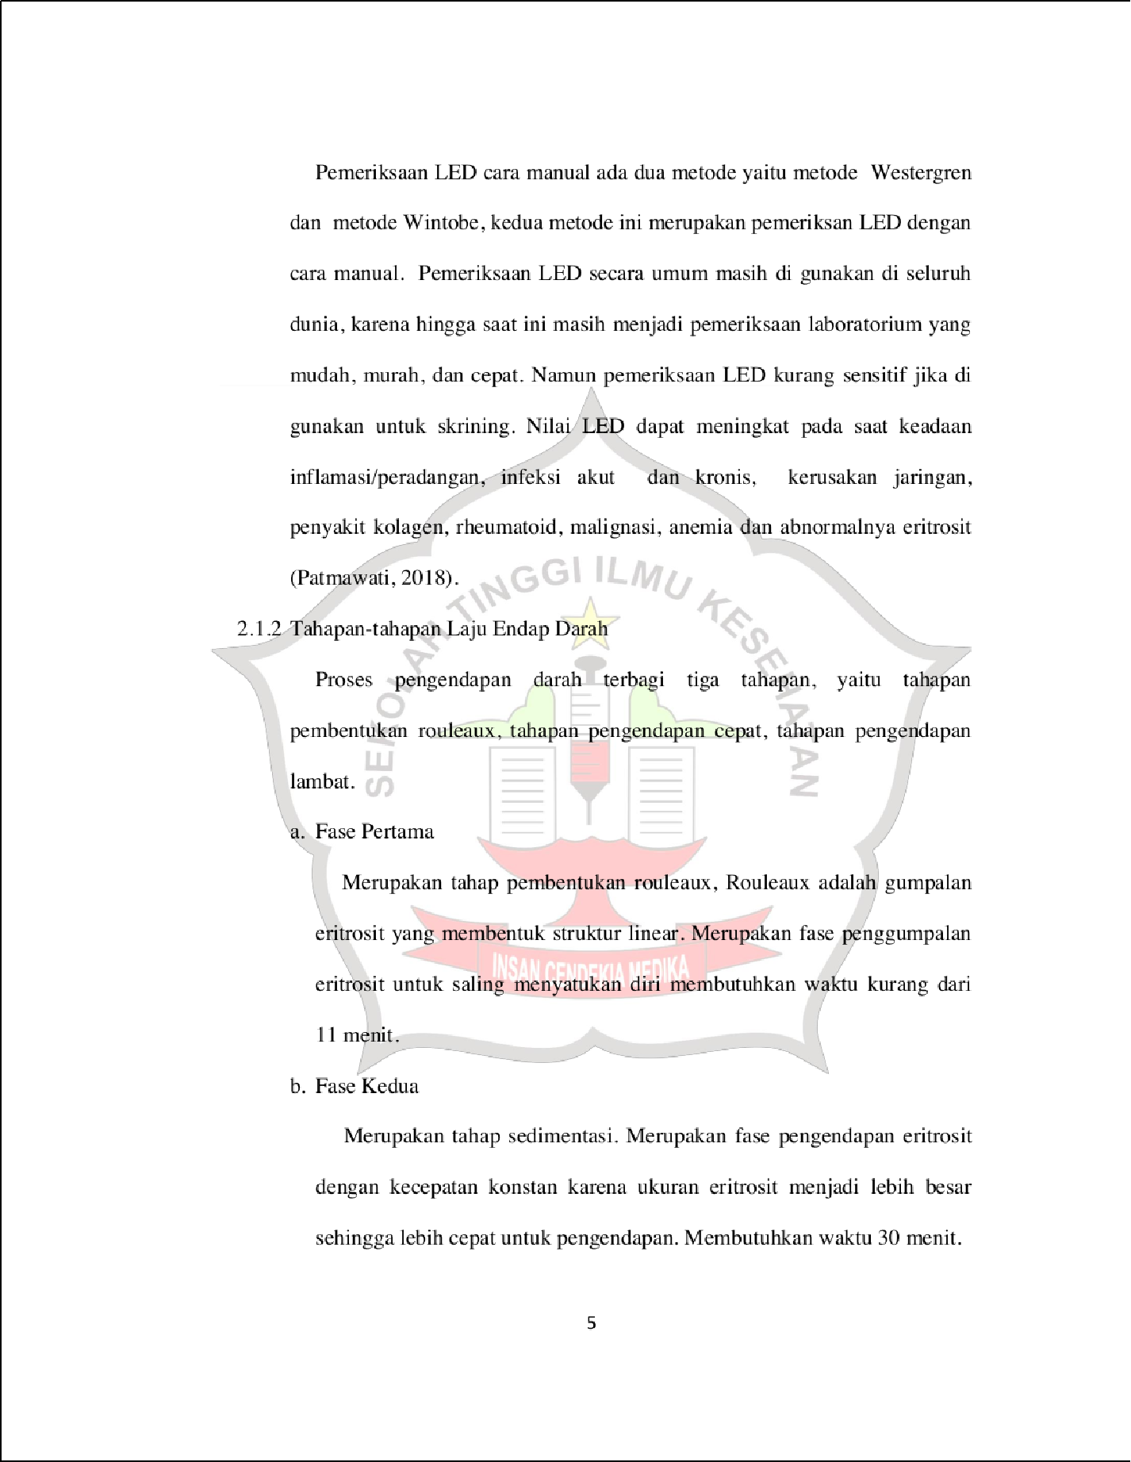

13

13

41

10

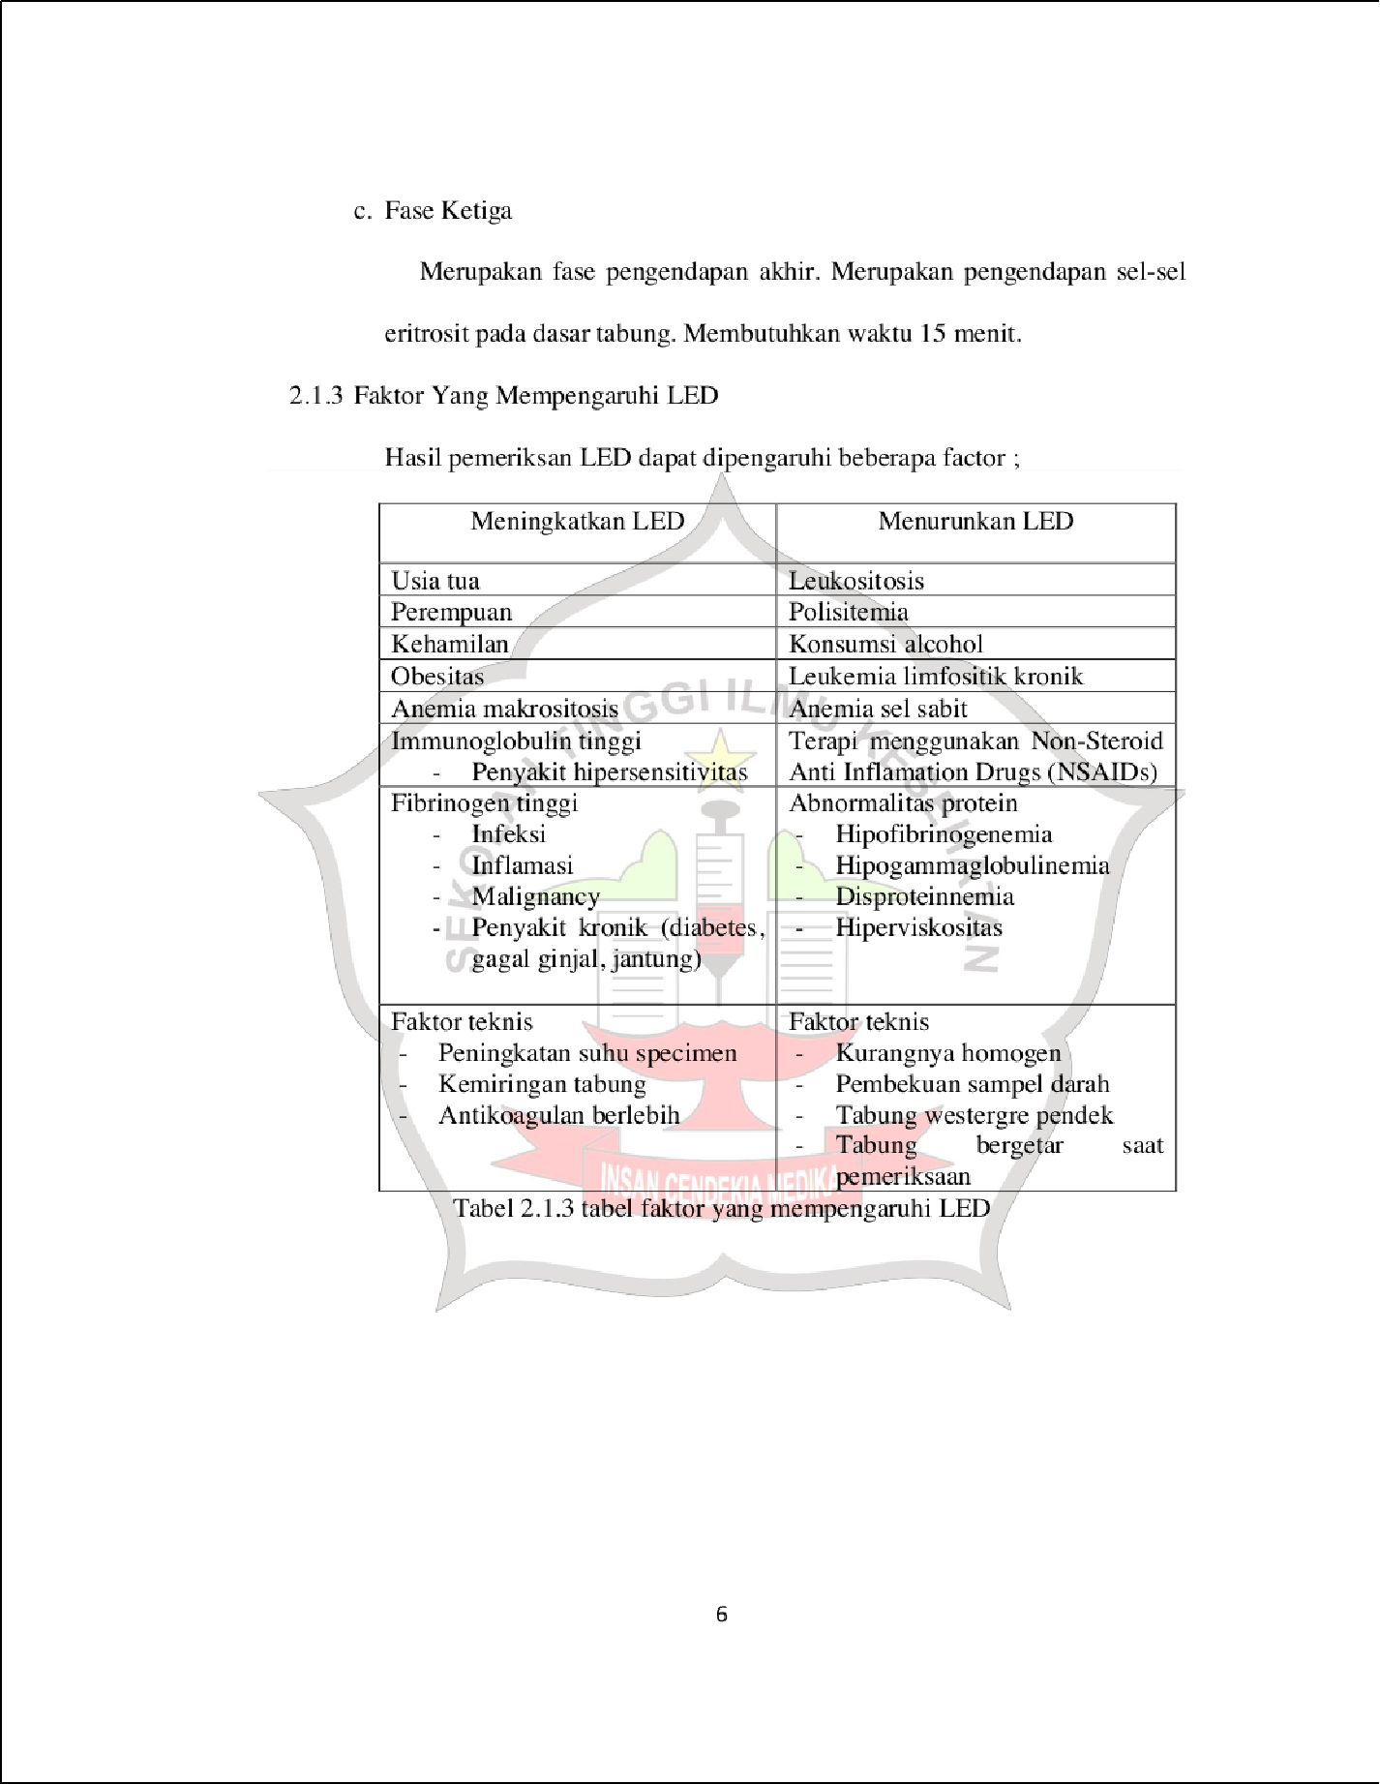

10

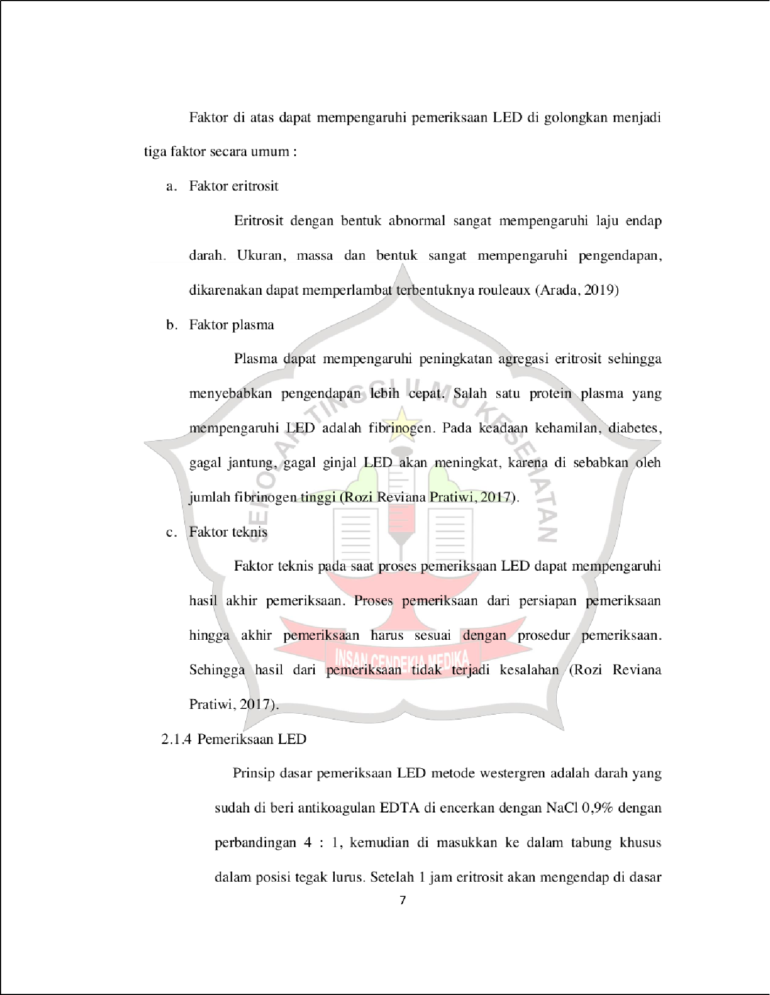

4

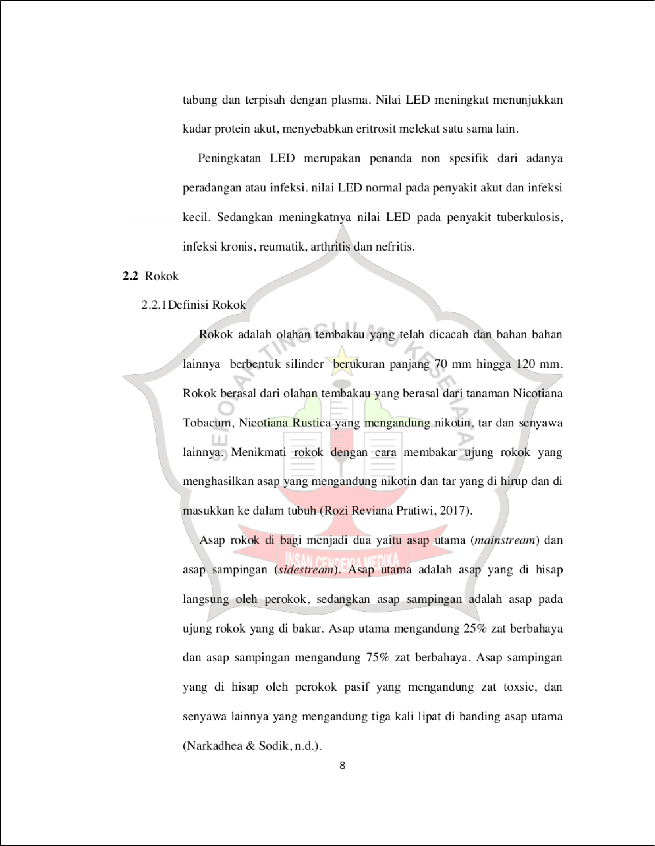

23

51

15

28

2

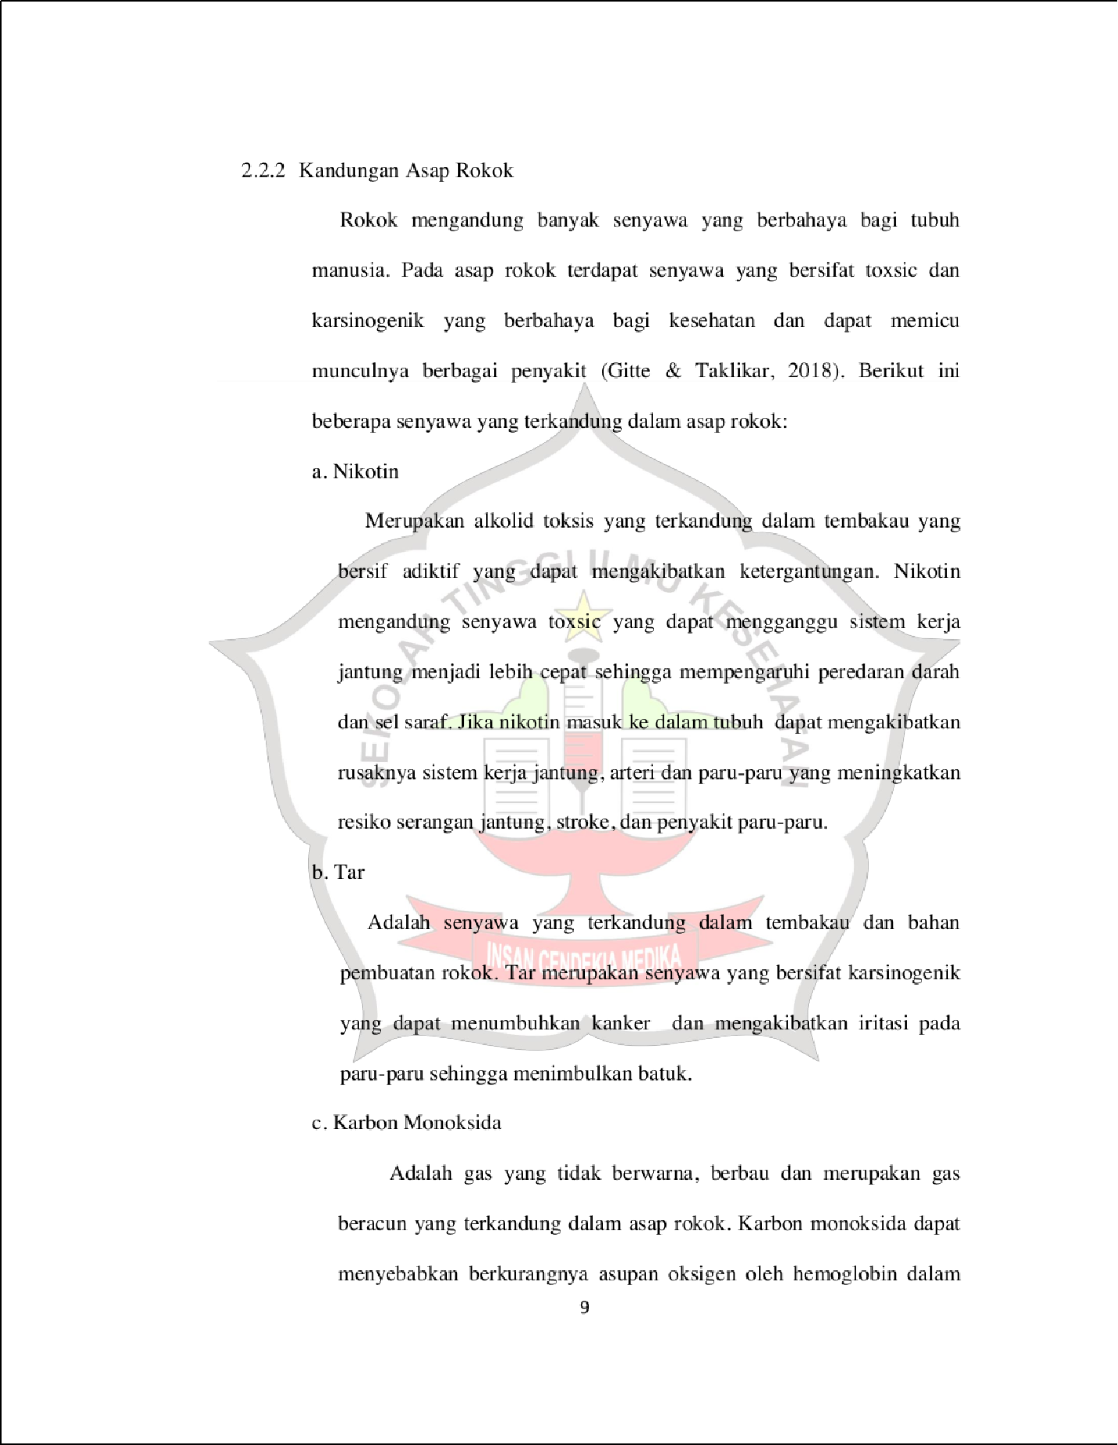

46

2

2

2

40

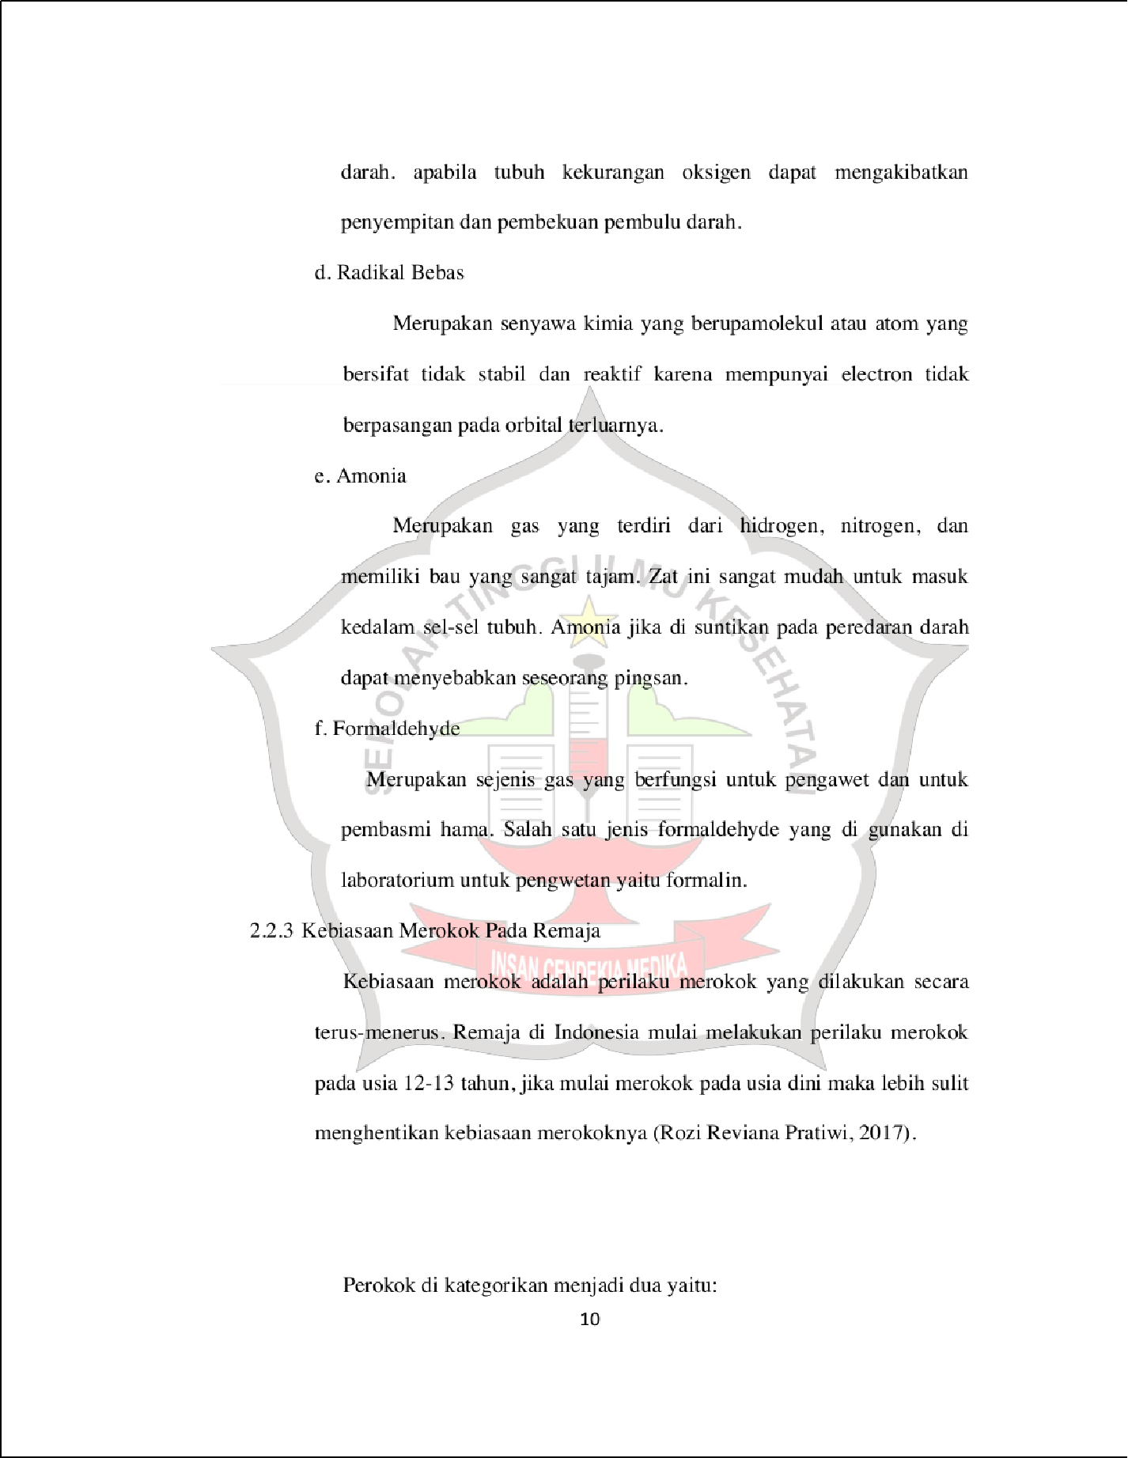

36

48

3

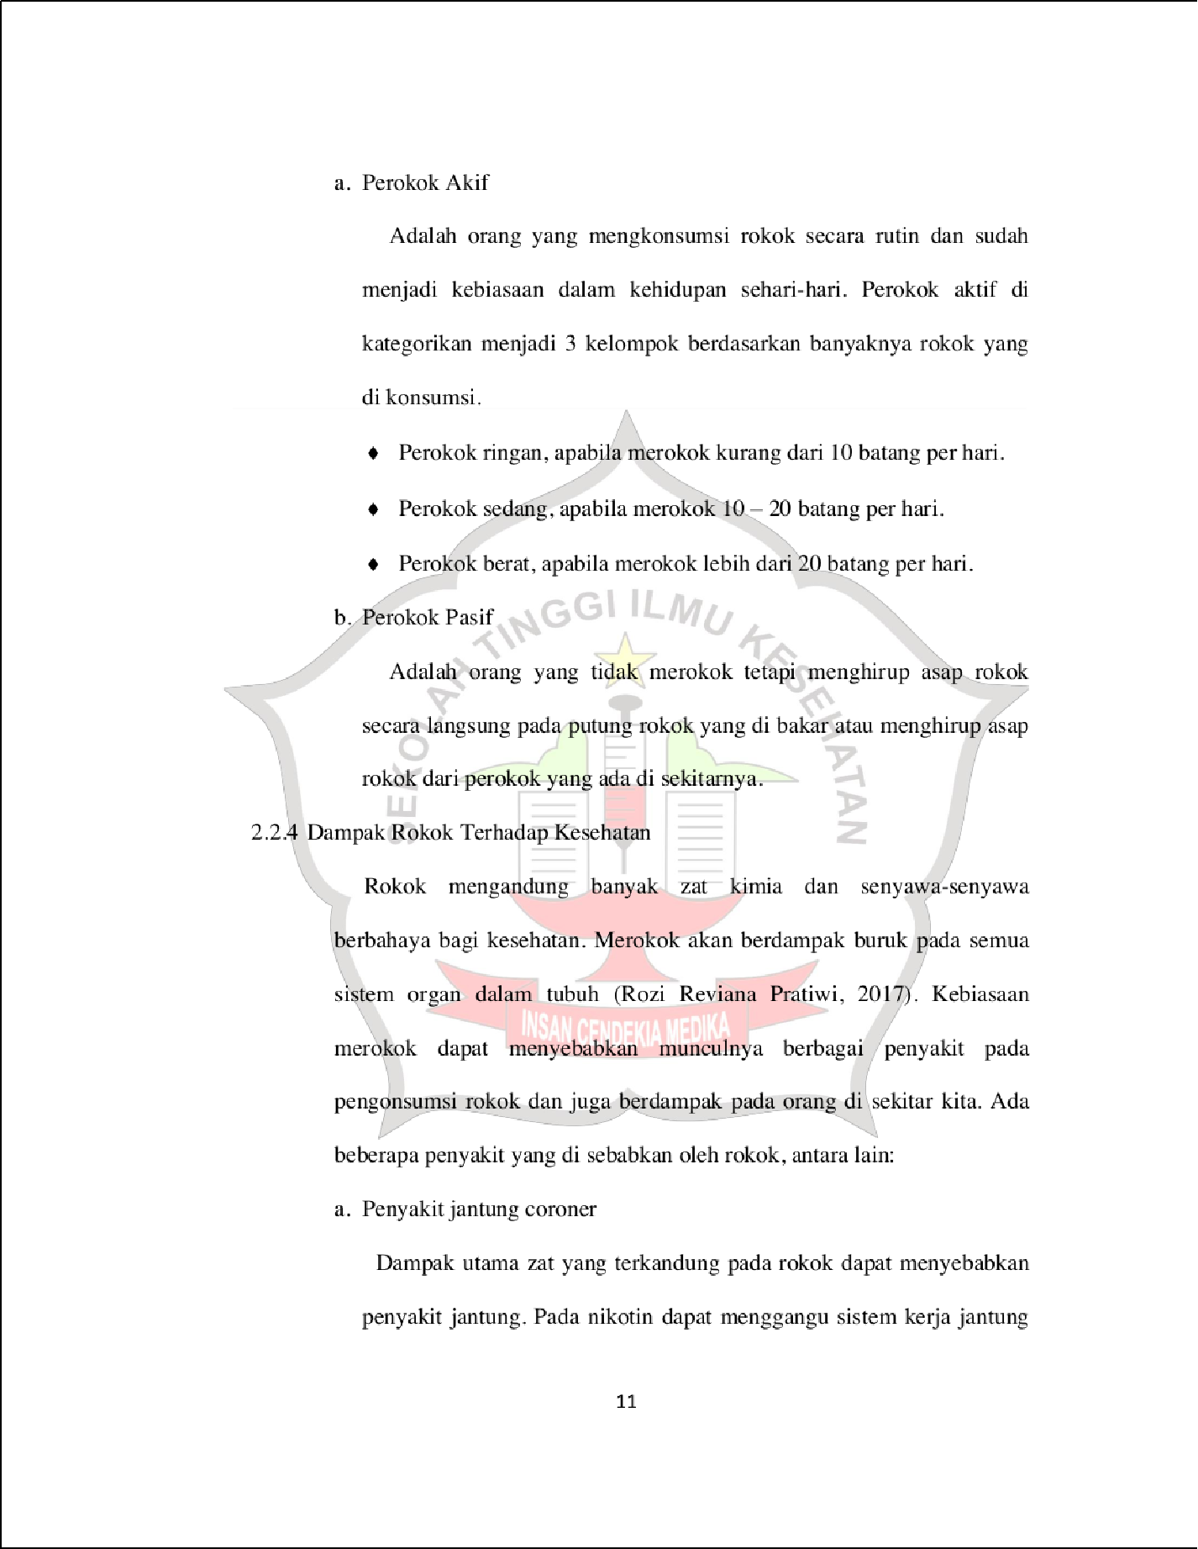

49

3

3

54

2

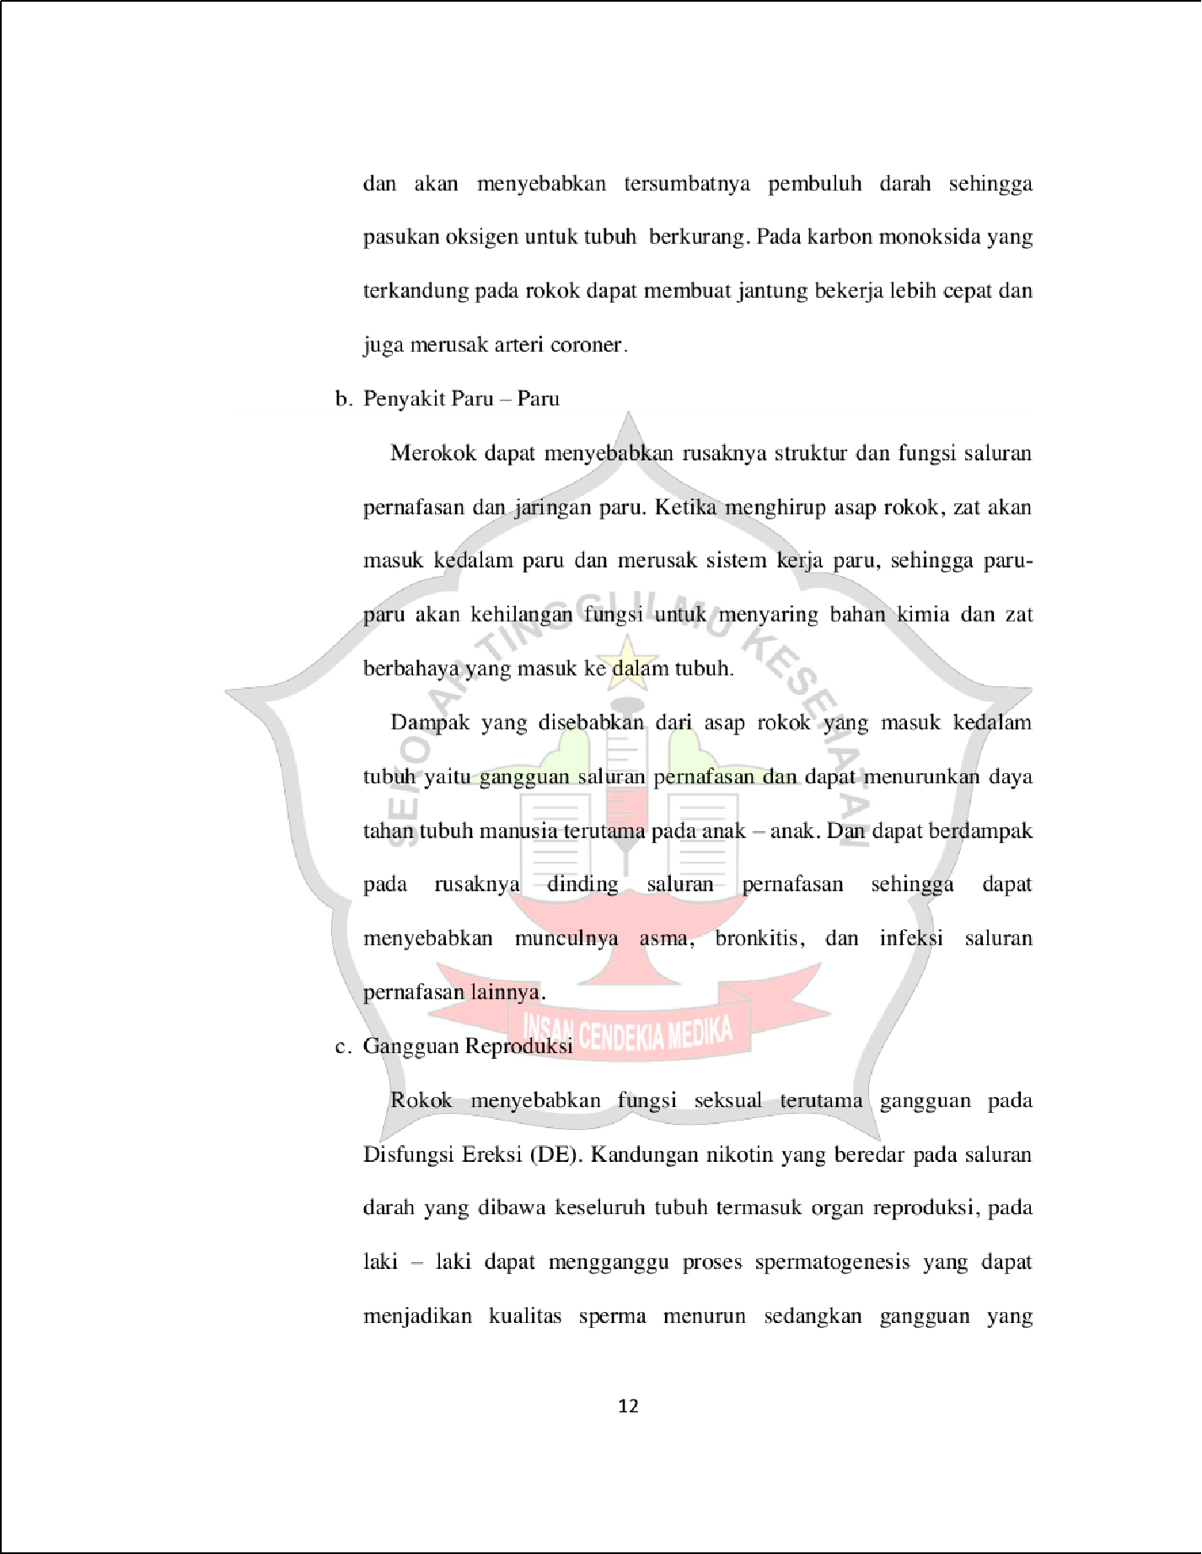

34

3

2

2

2

2

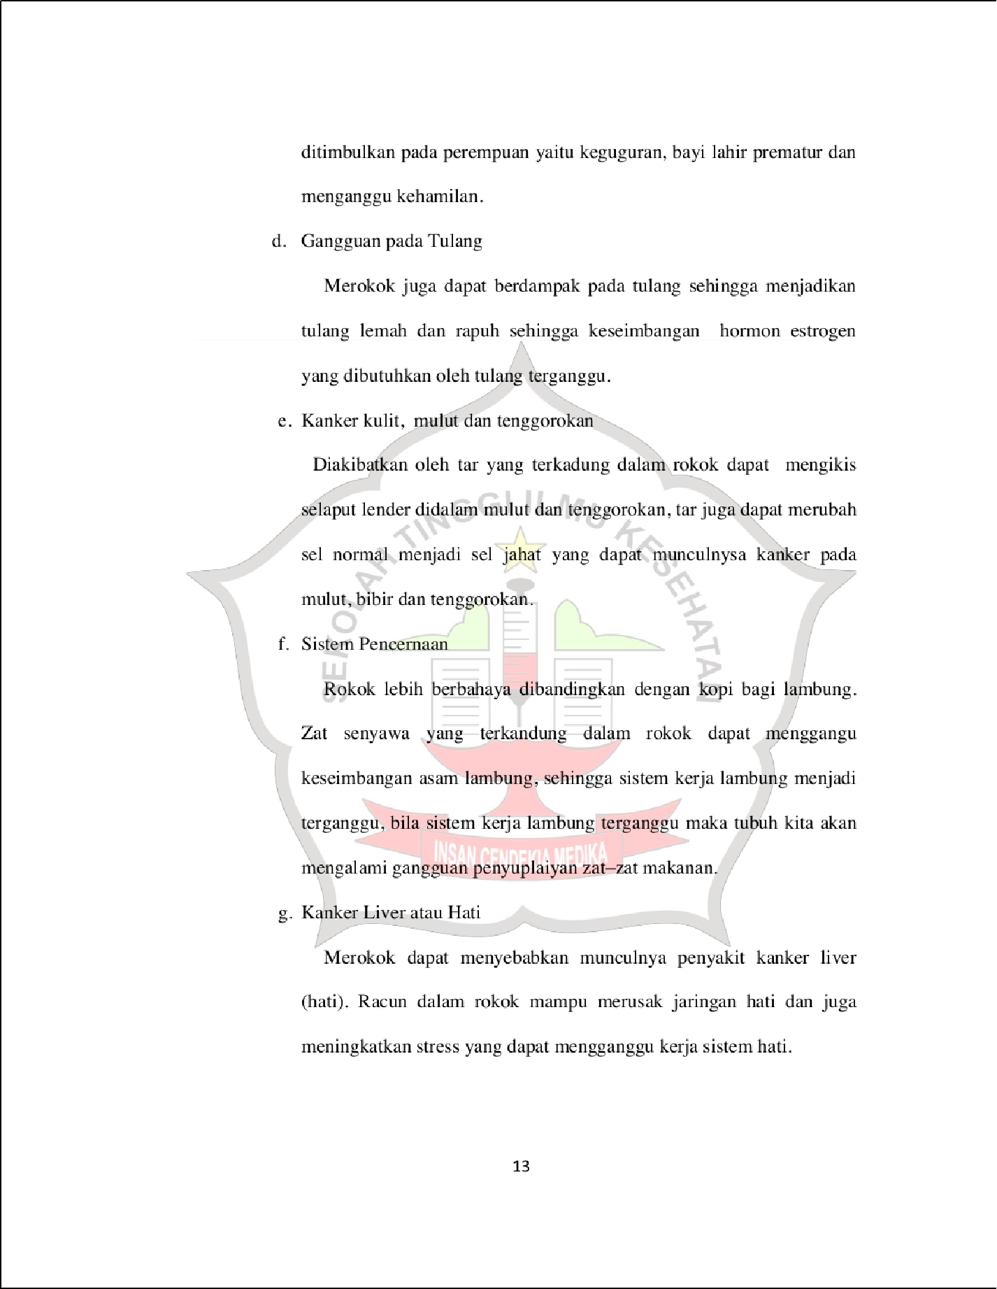

18

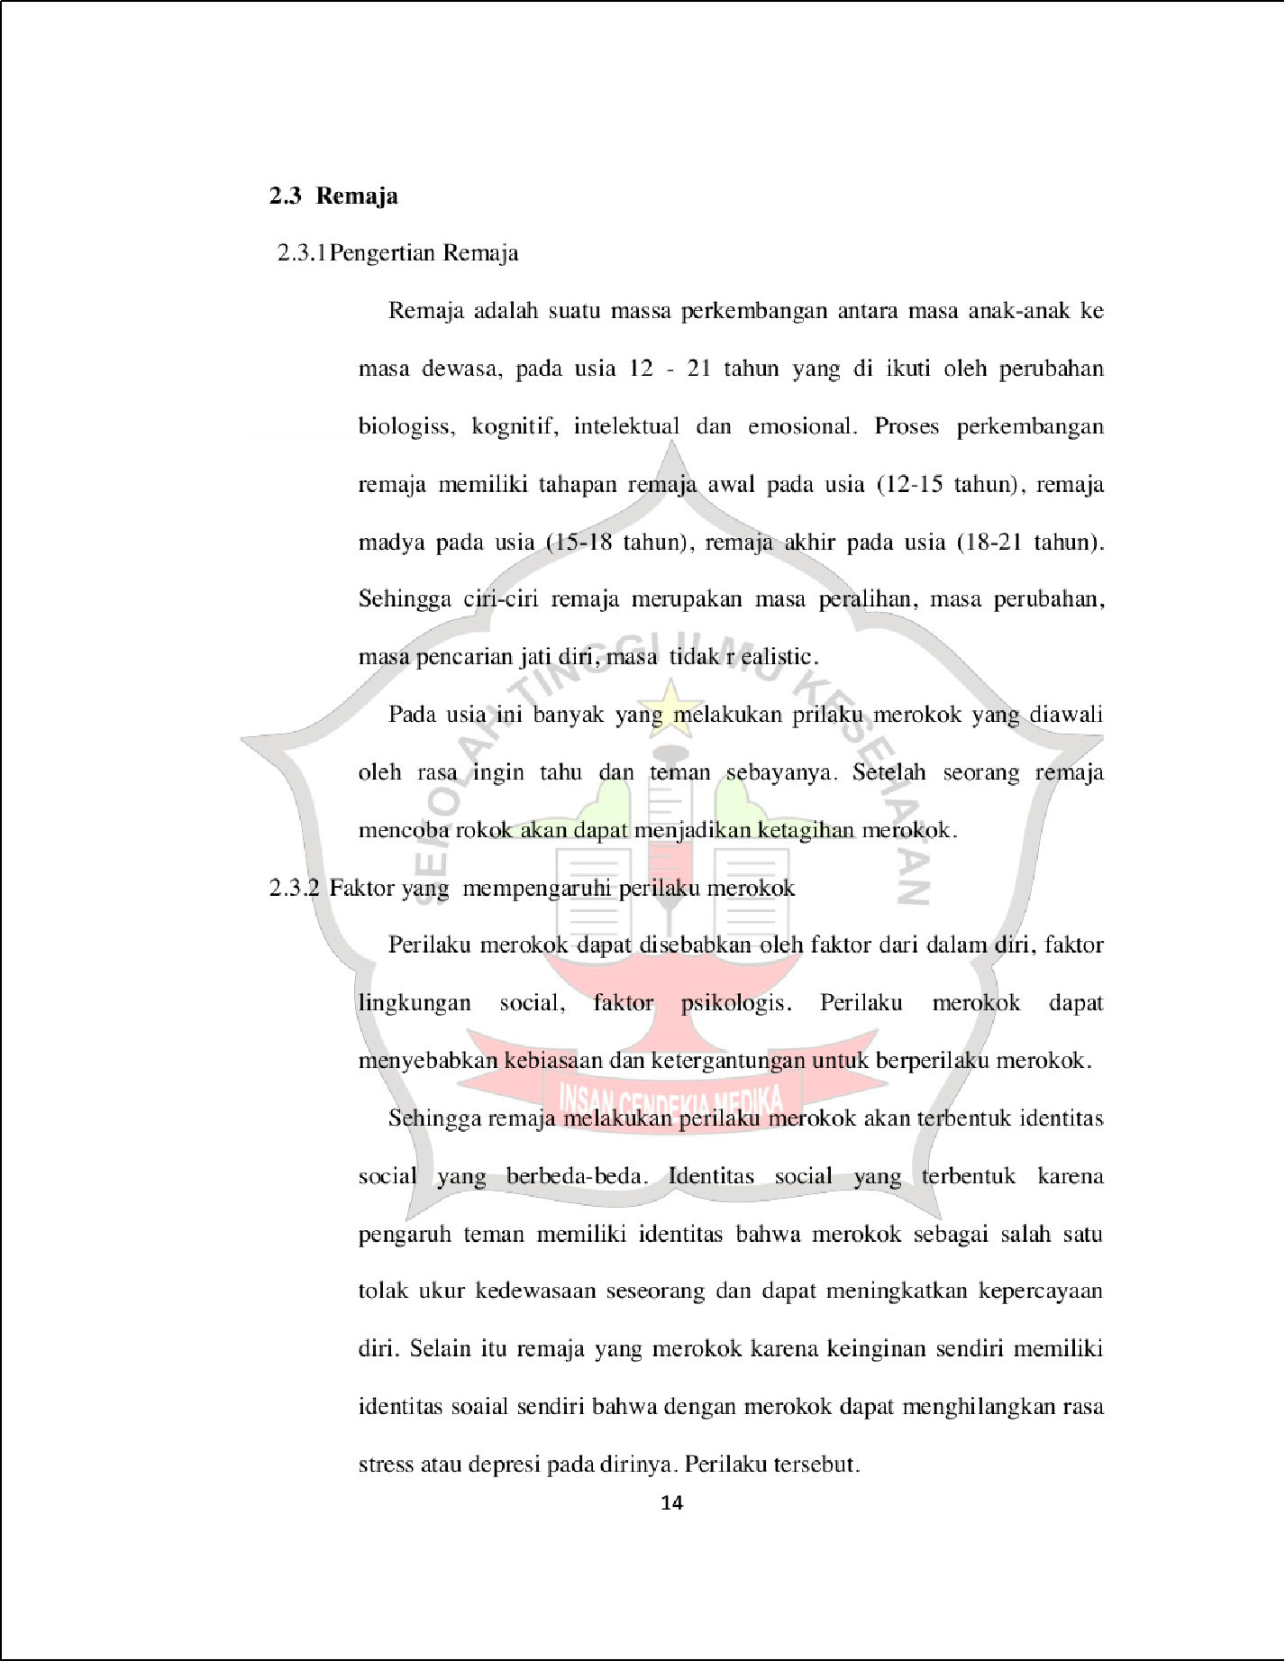

32

25

9

9

58

15

16

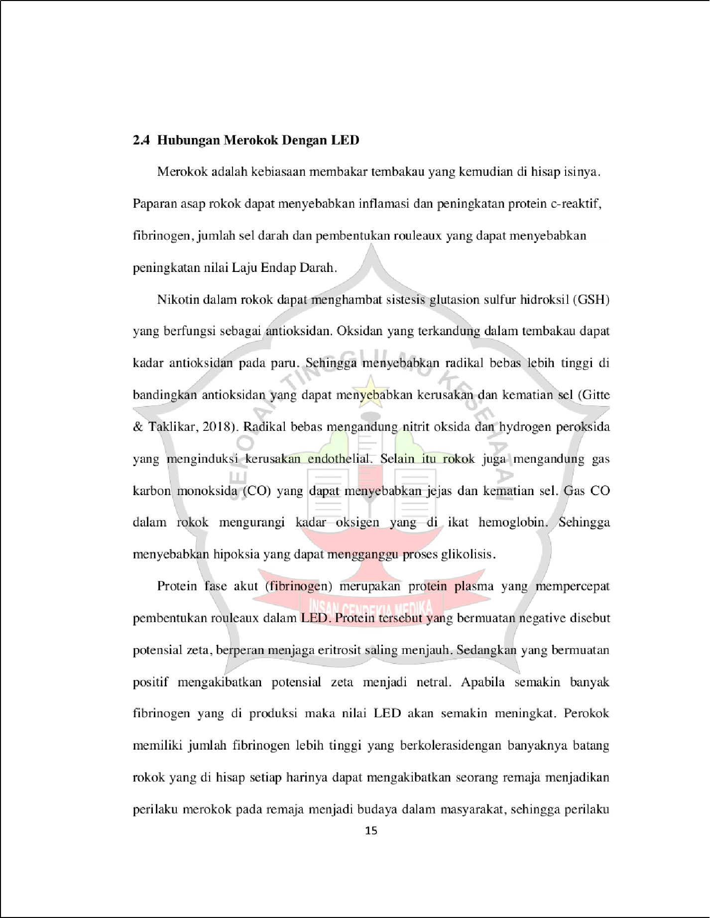

55

47

35

16

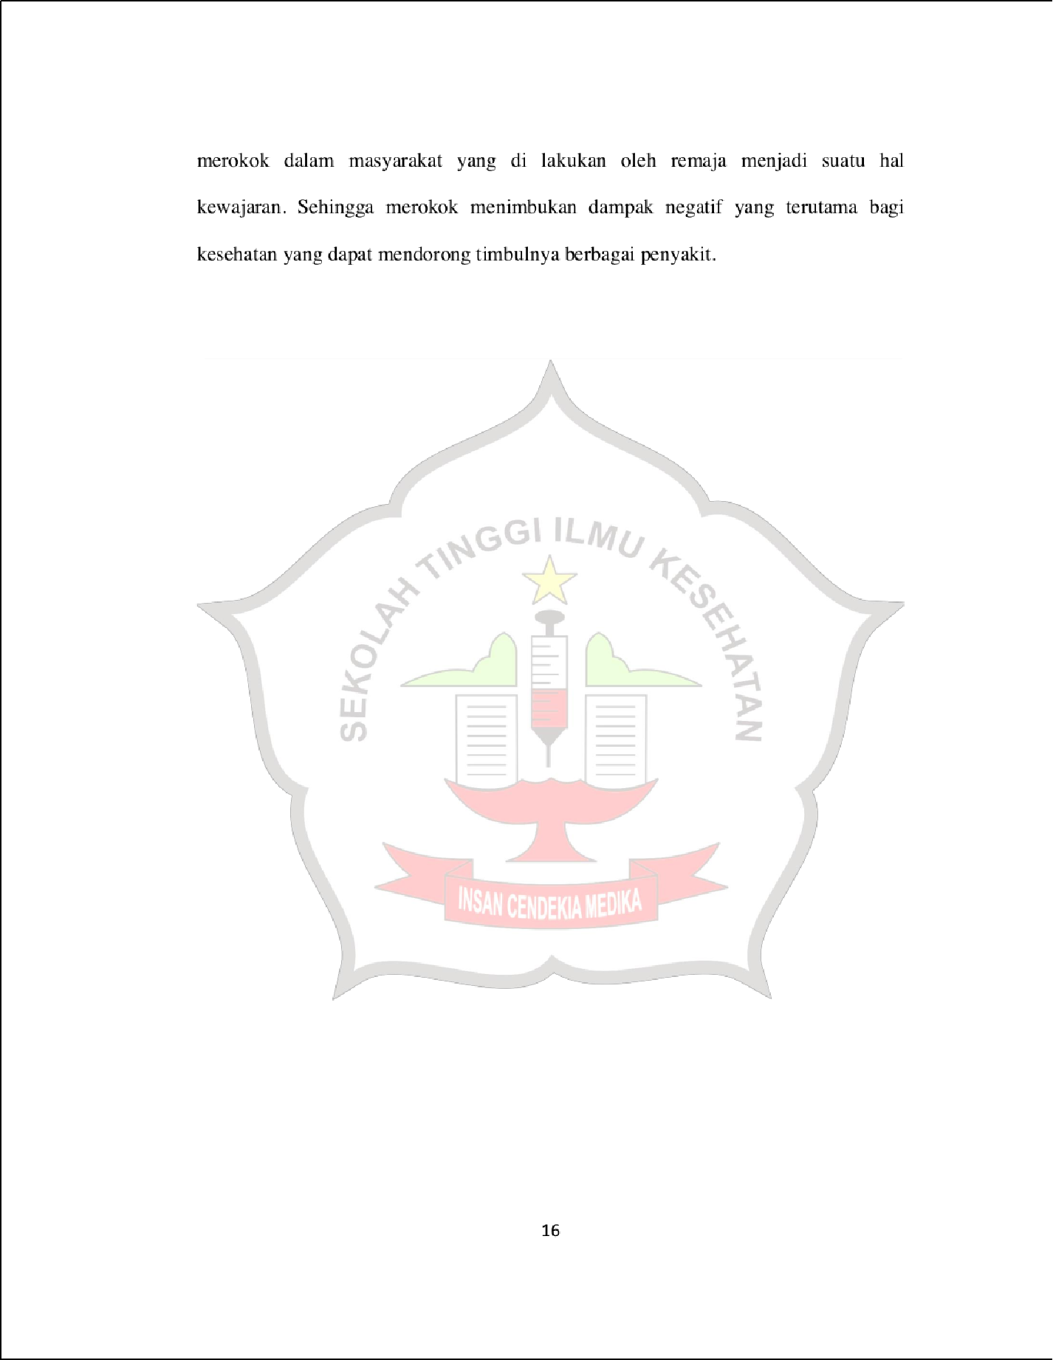

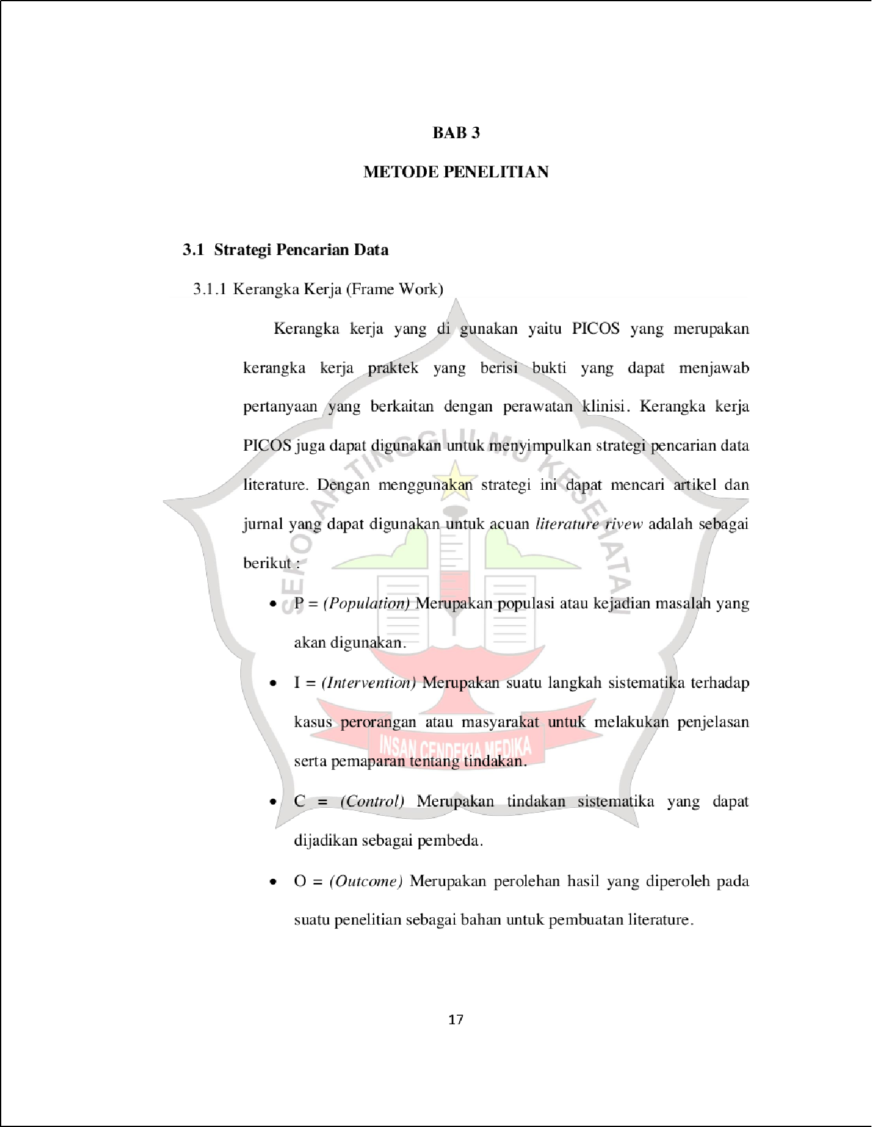

1

1

1

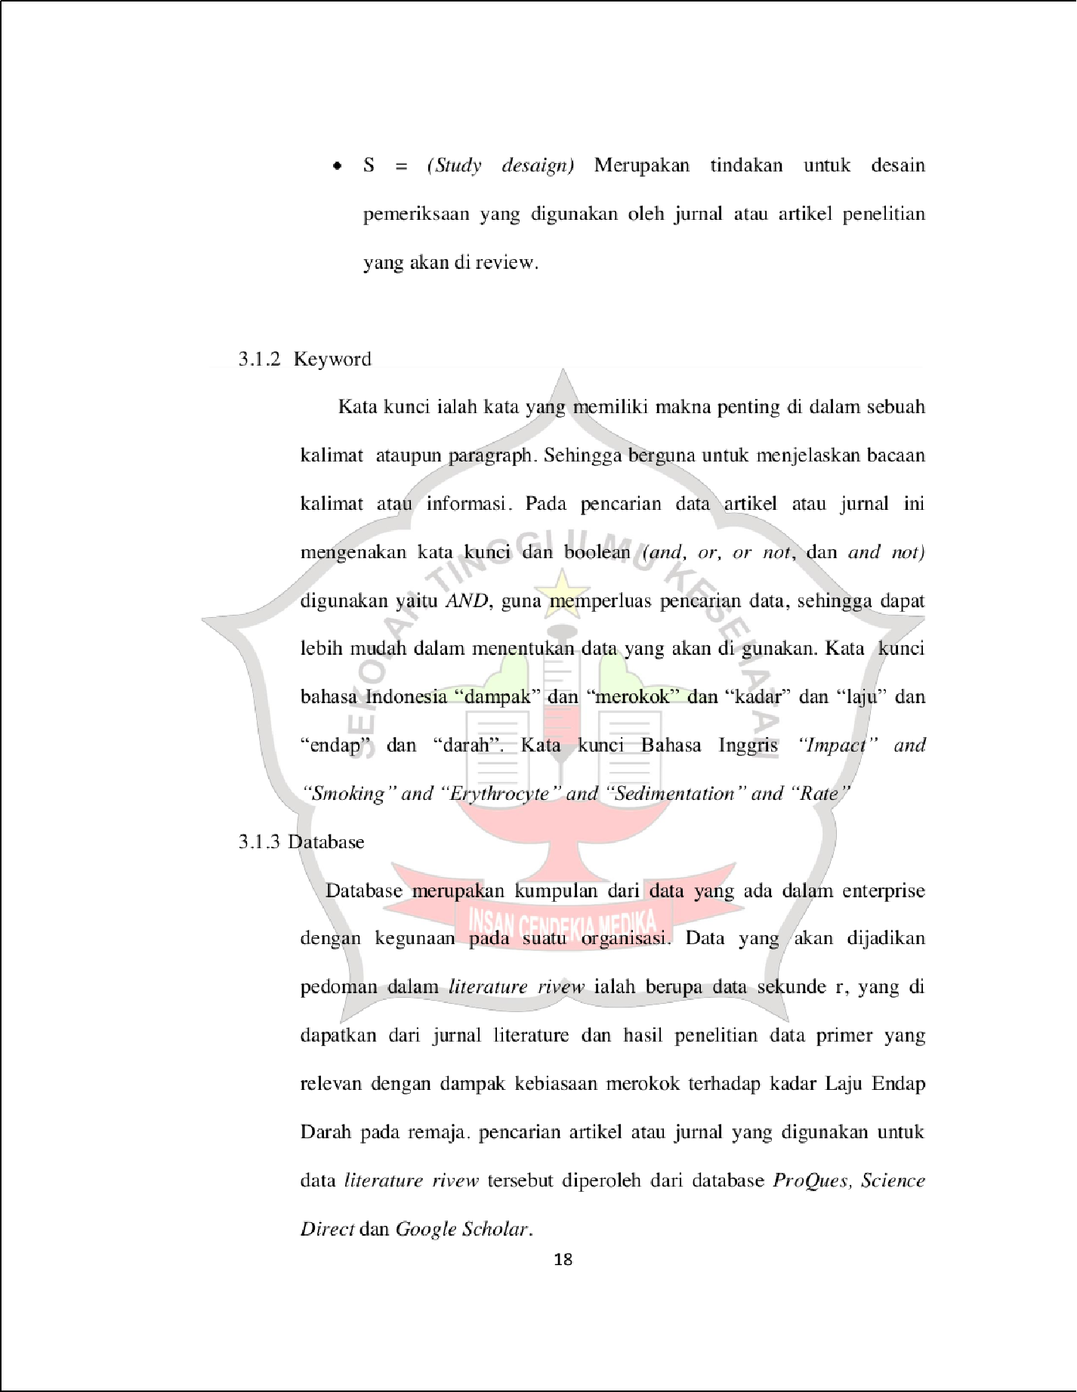

1

1

43

1

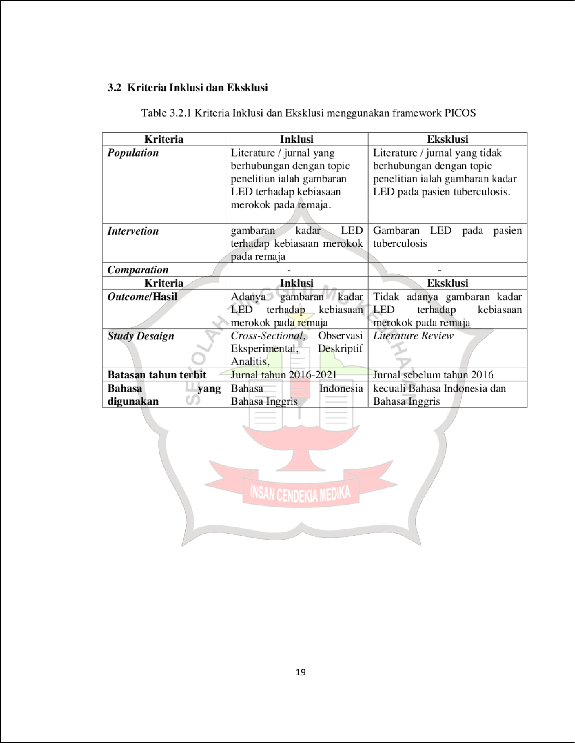

1

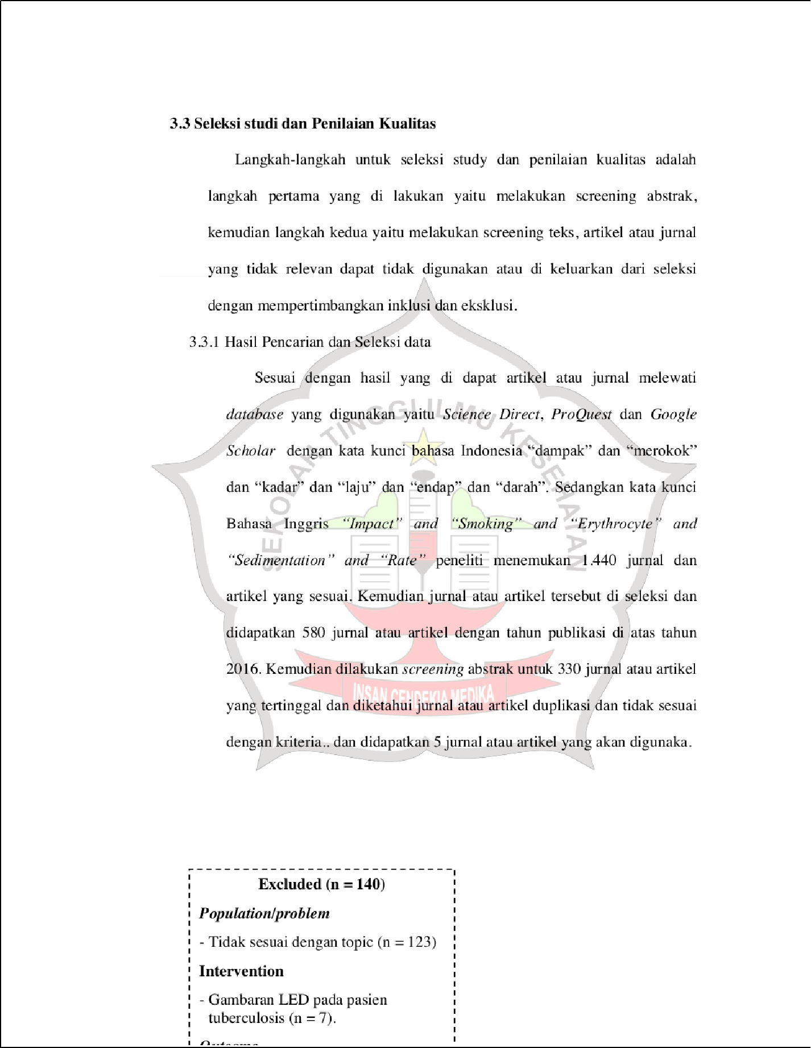

1

39

1

1

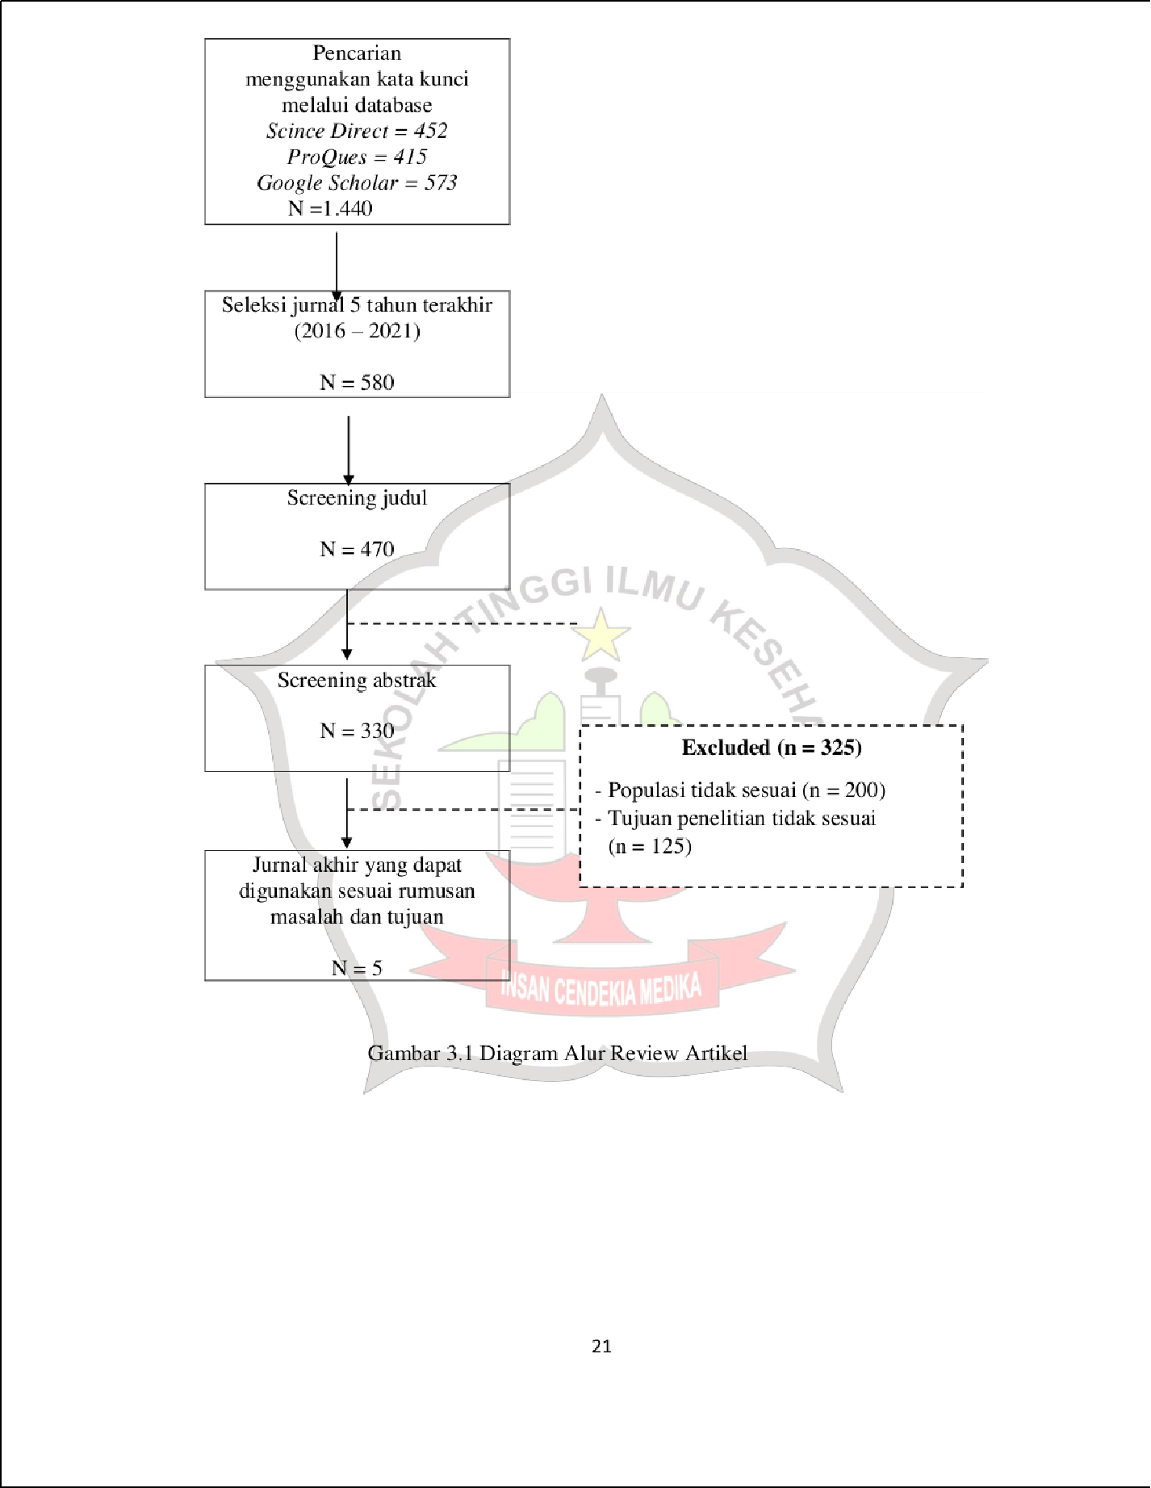

1

1

1

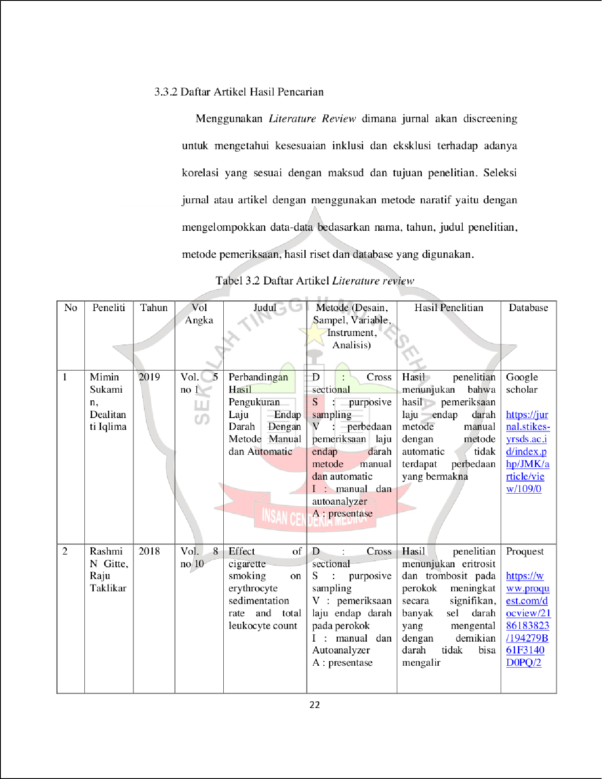

1

33

12

12

21

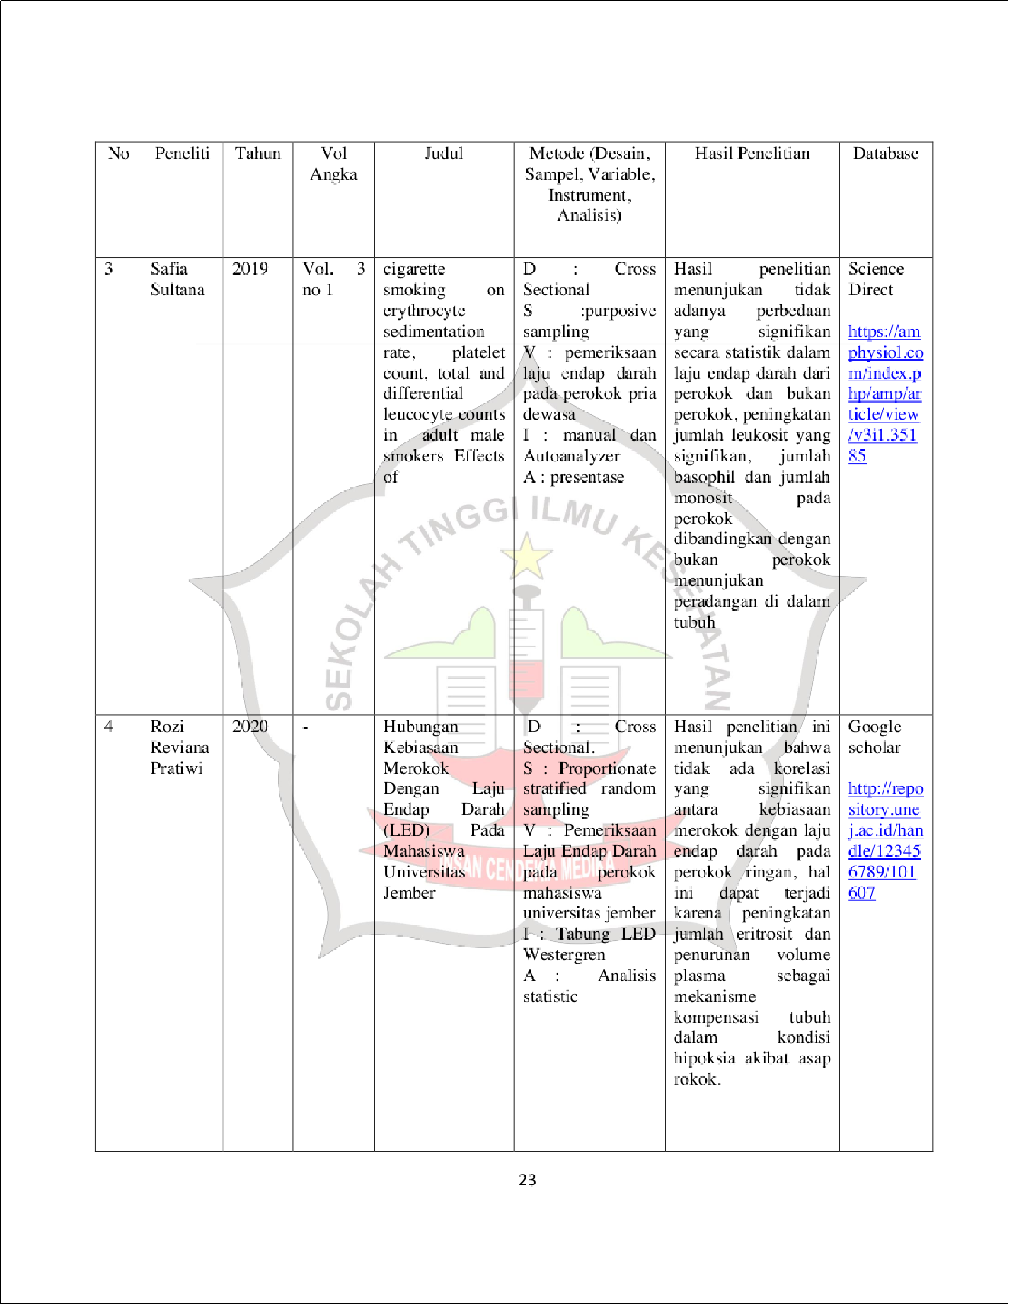

1

8 50

7 37

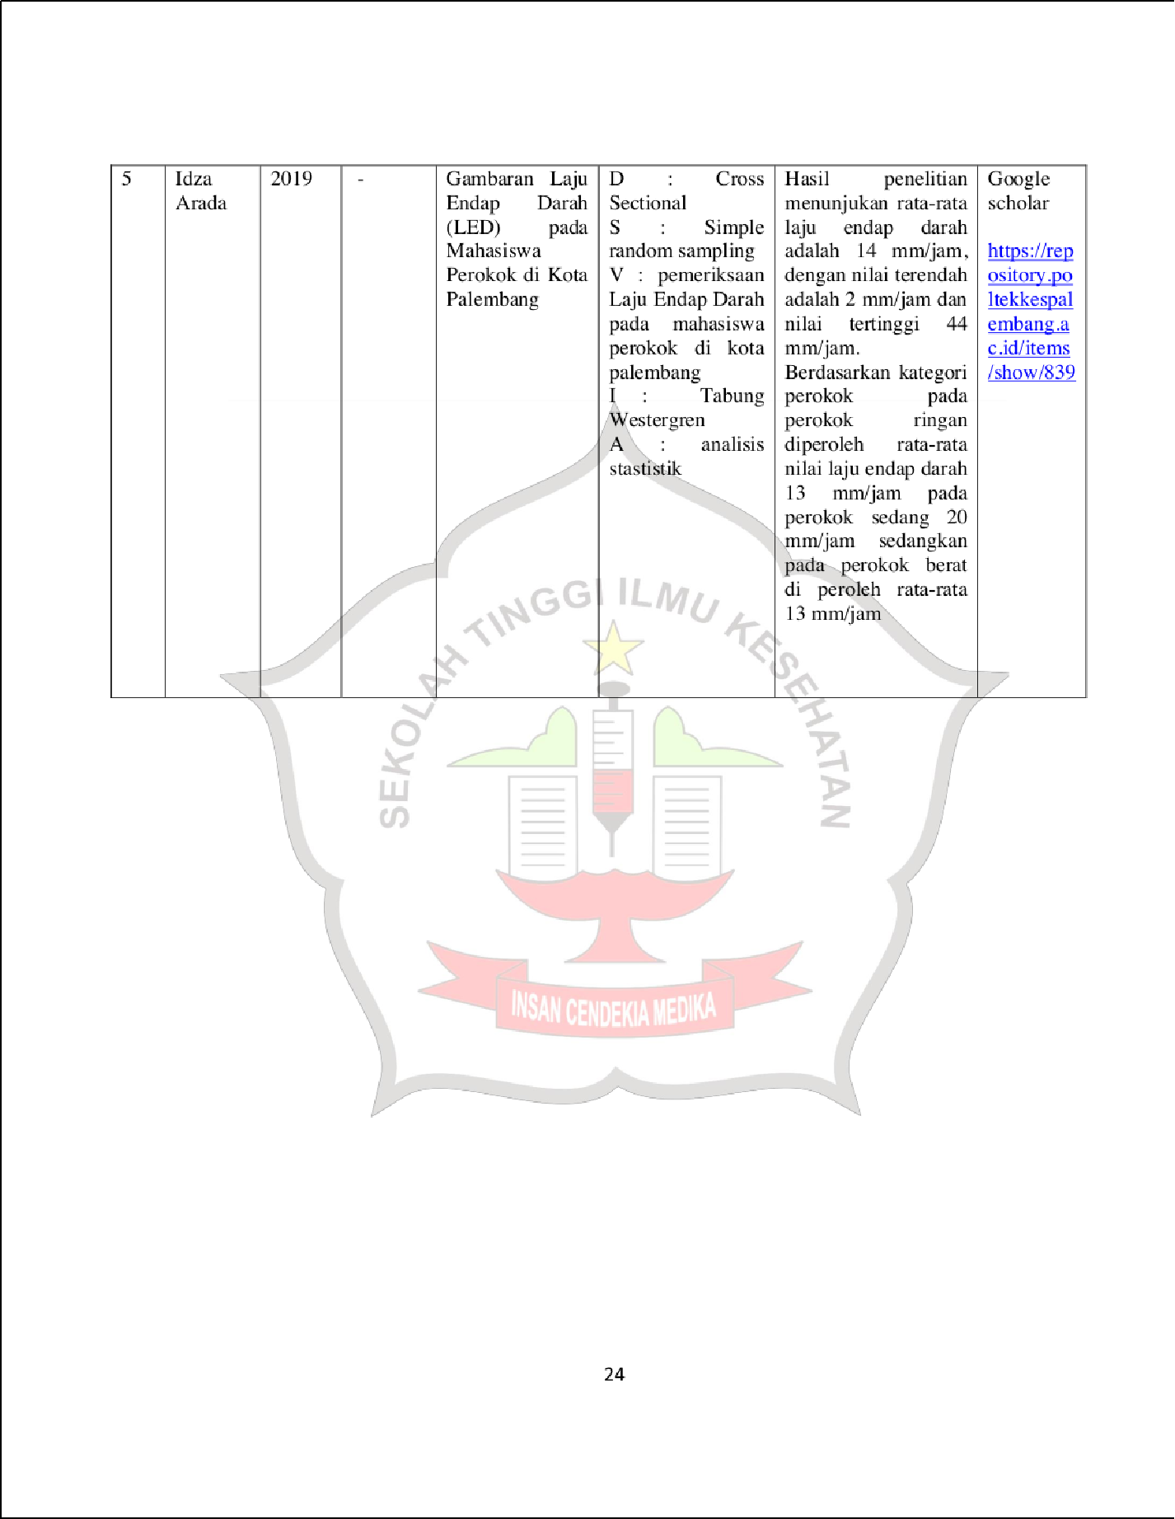

1

42

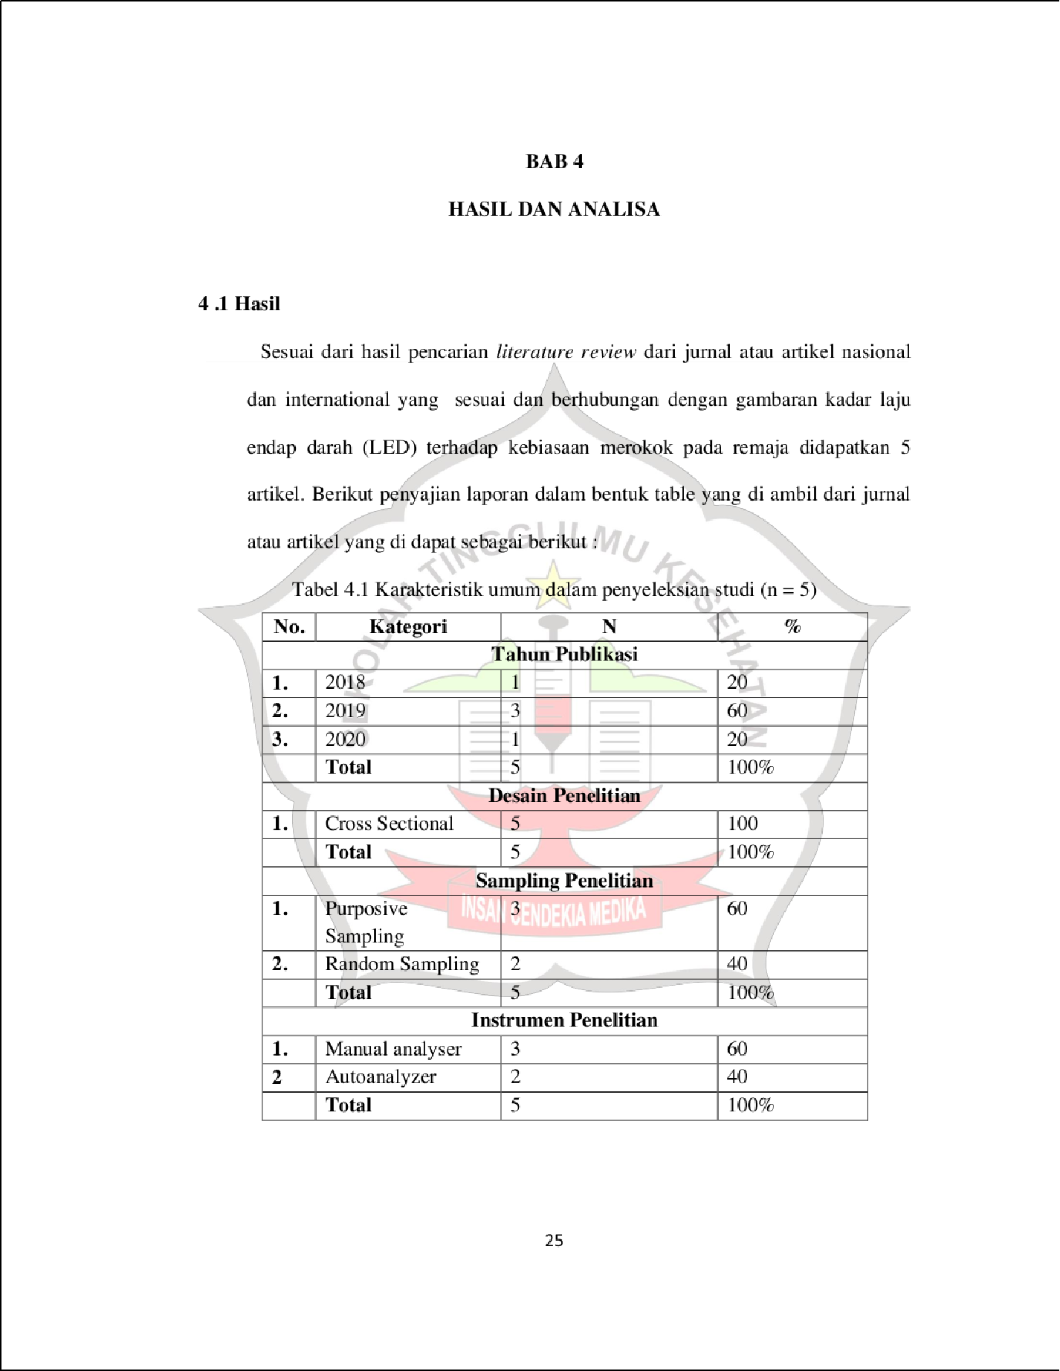

1

1

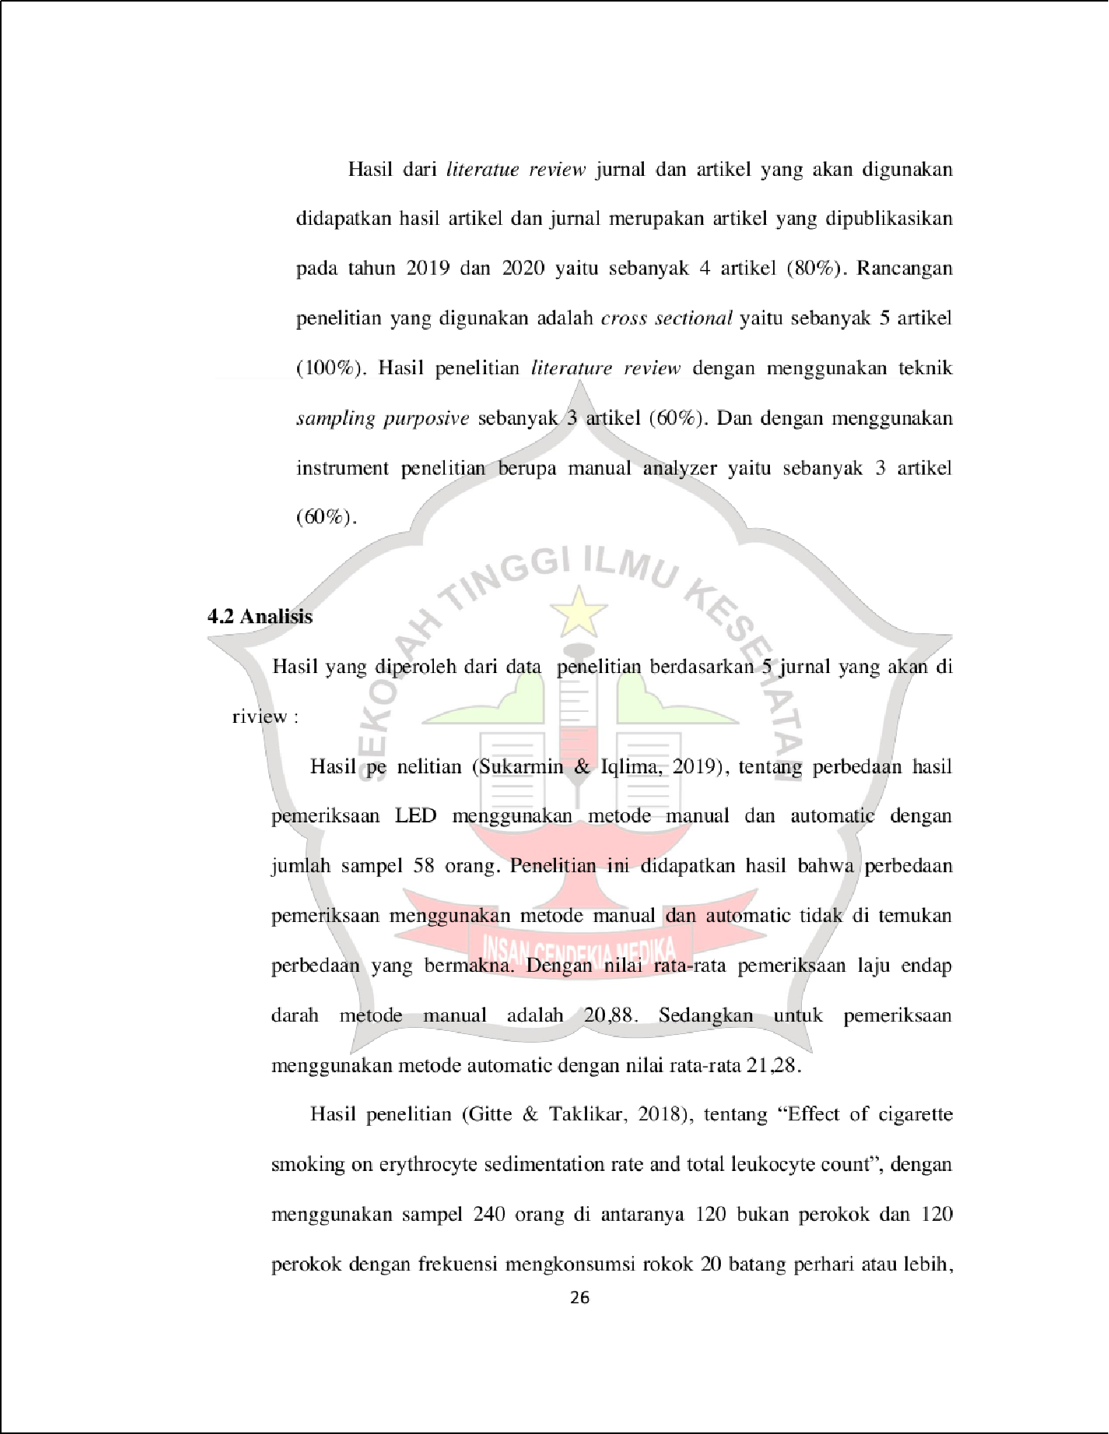

3

5

5

12

21

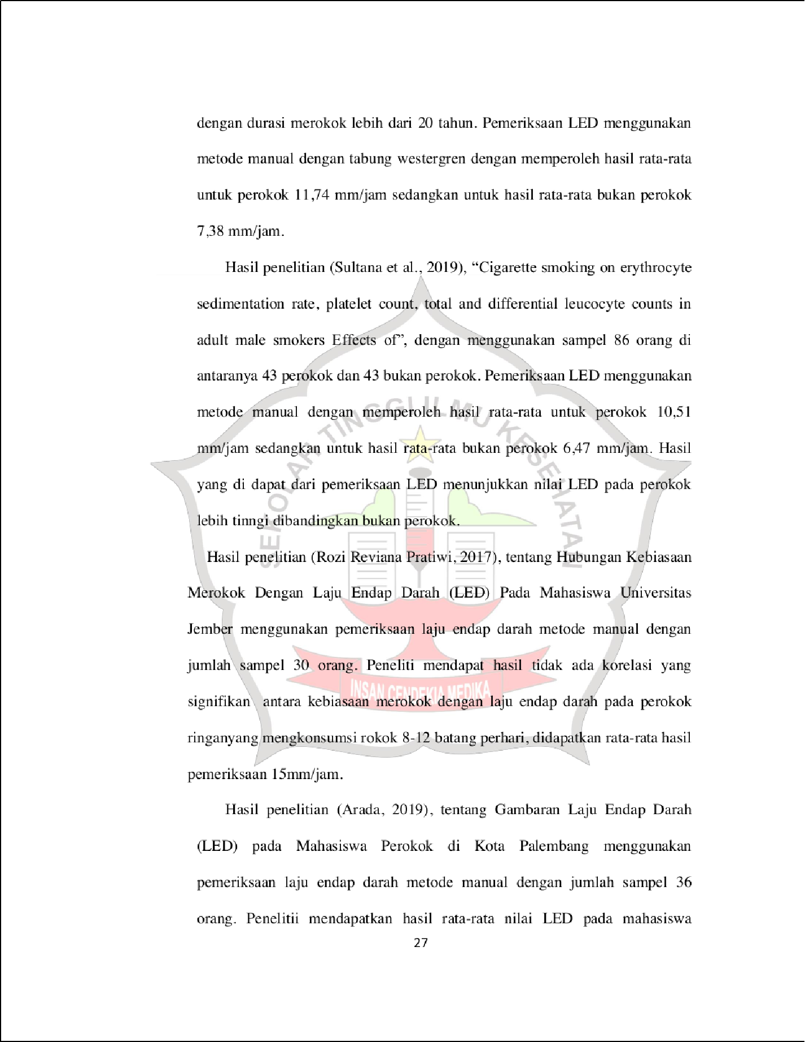

8

7

5

3

5

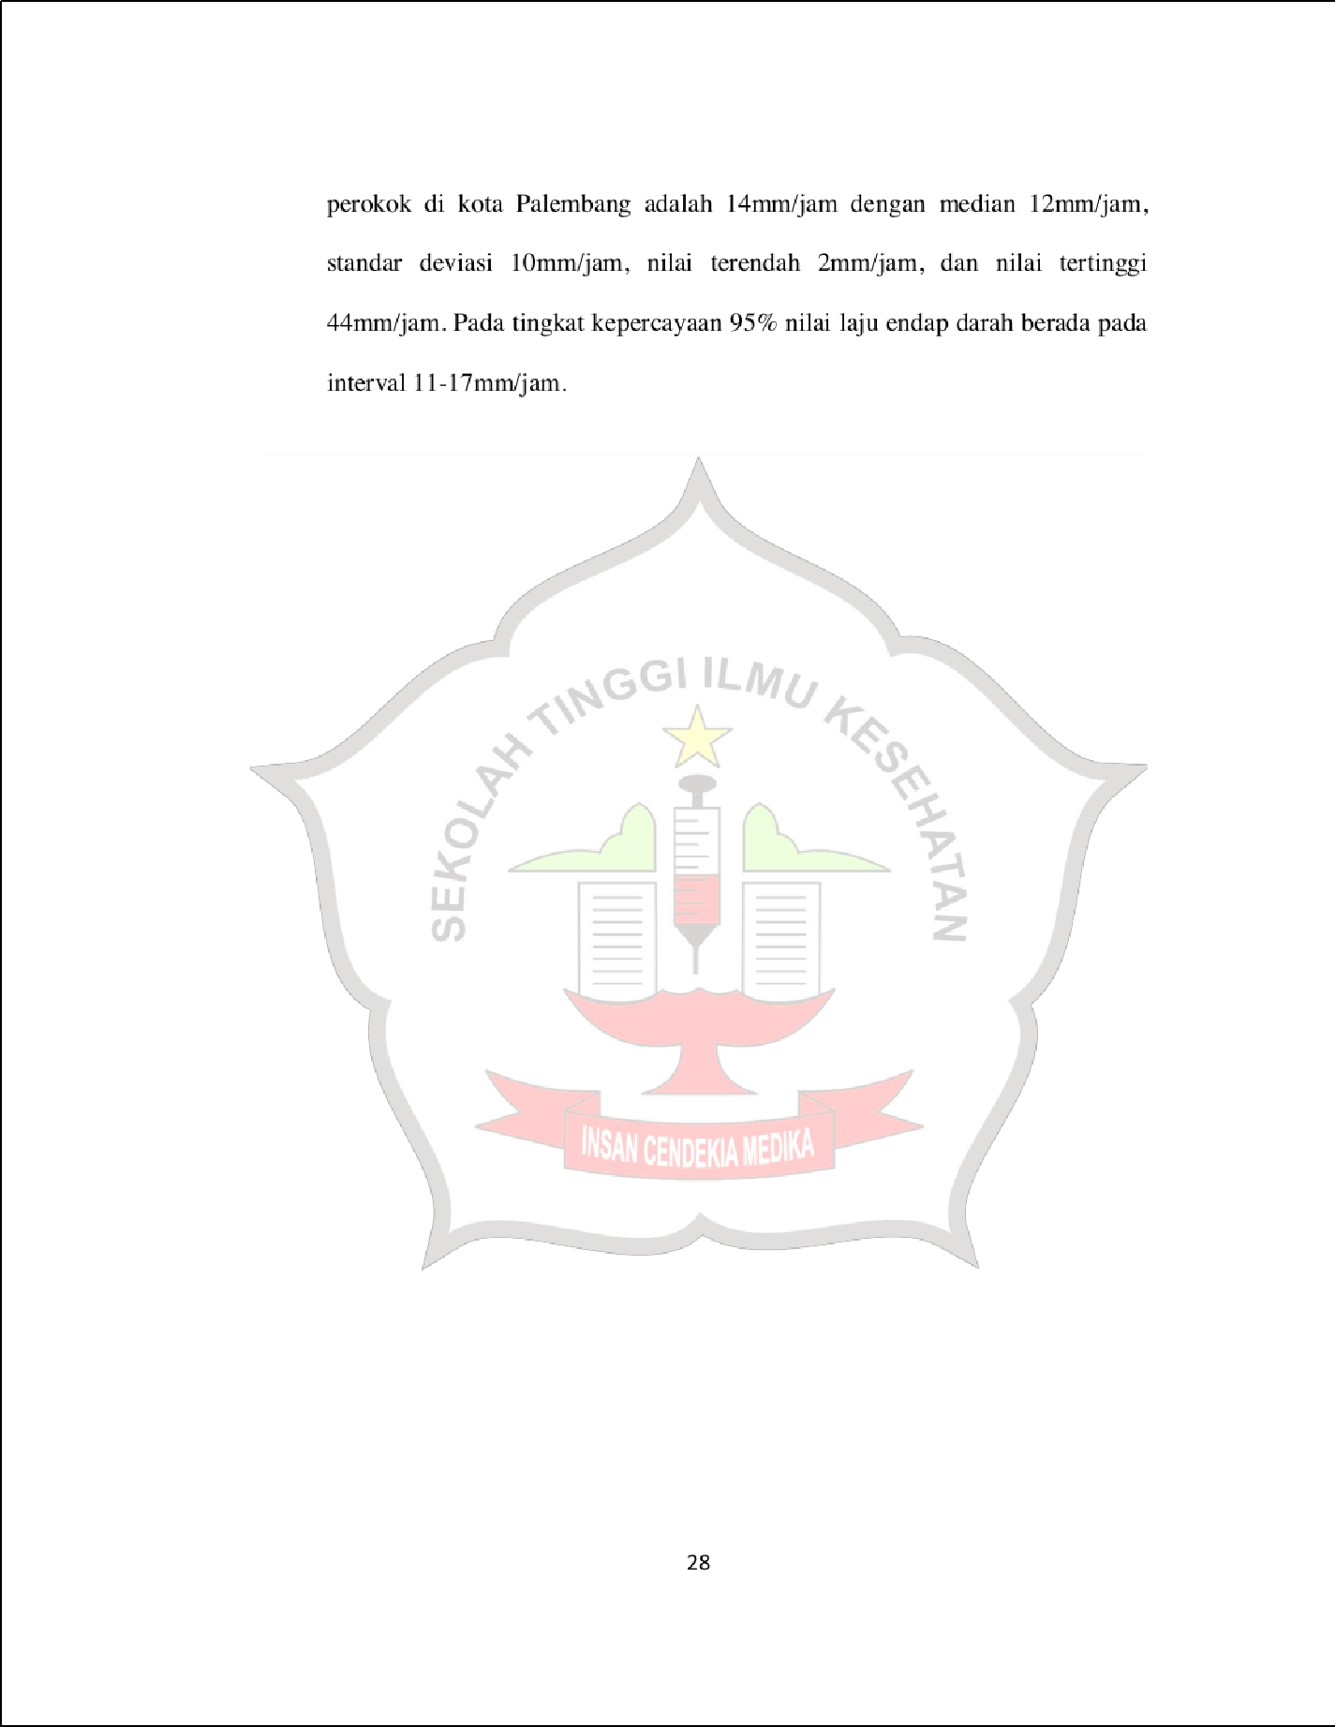

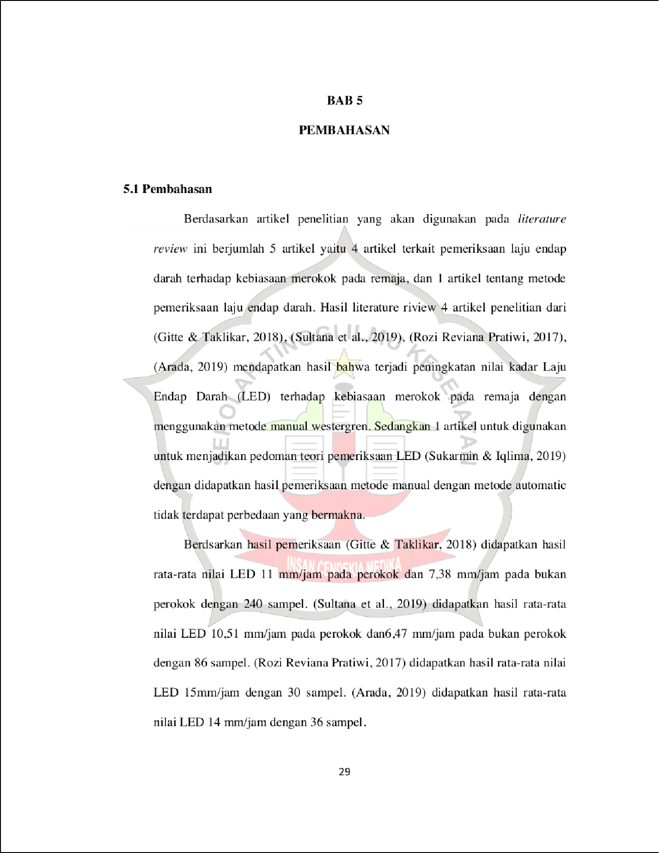

5

5

57

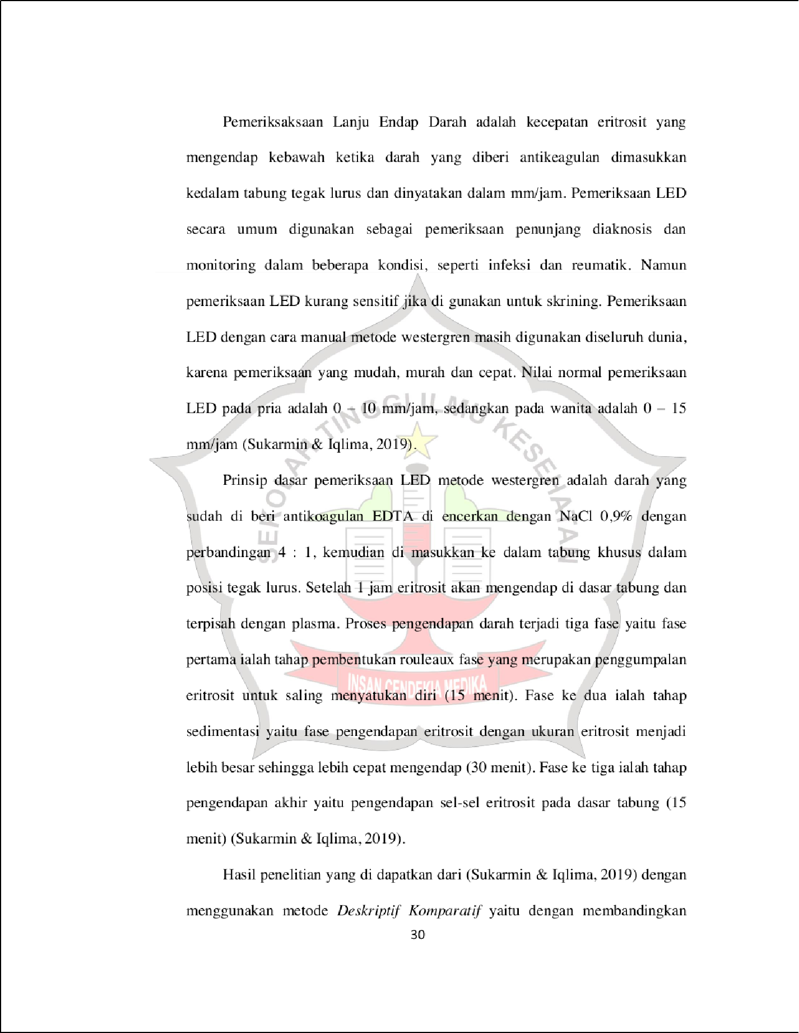

27

4

1

12

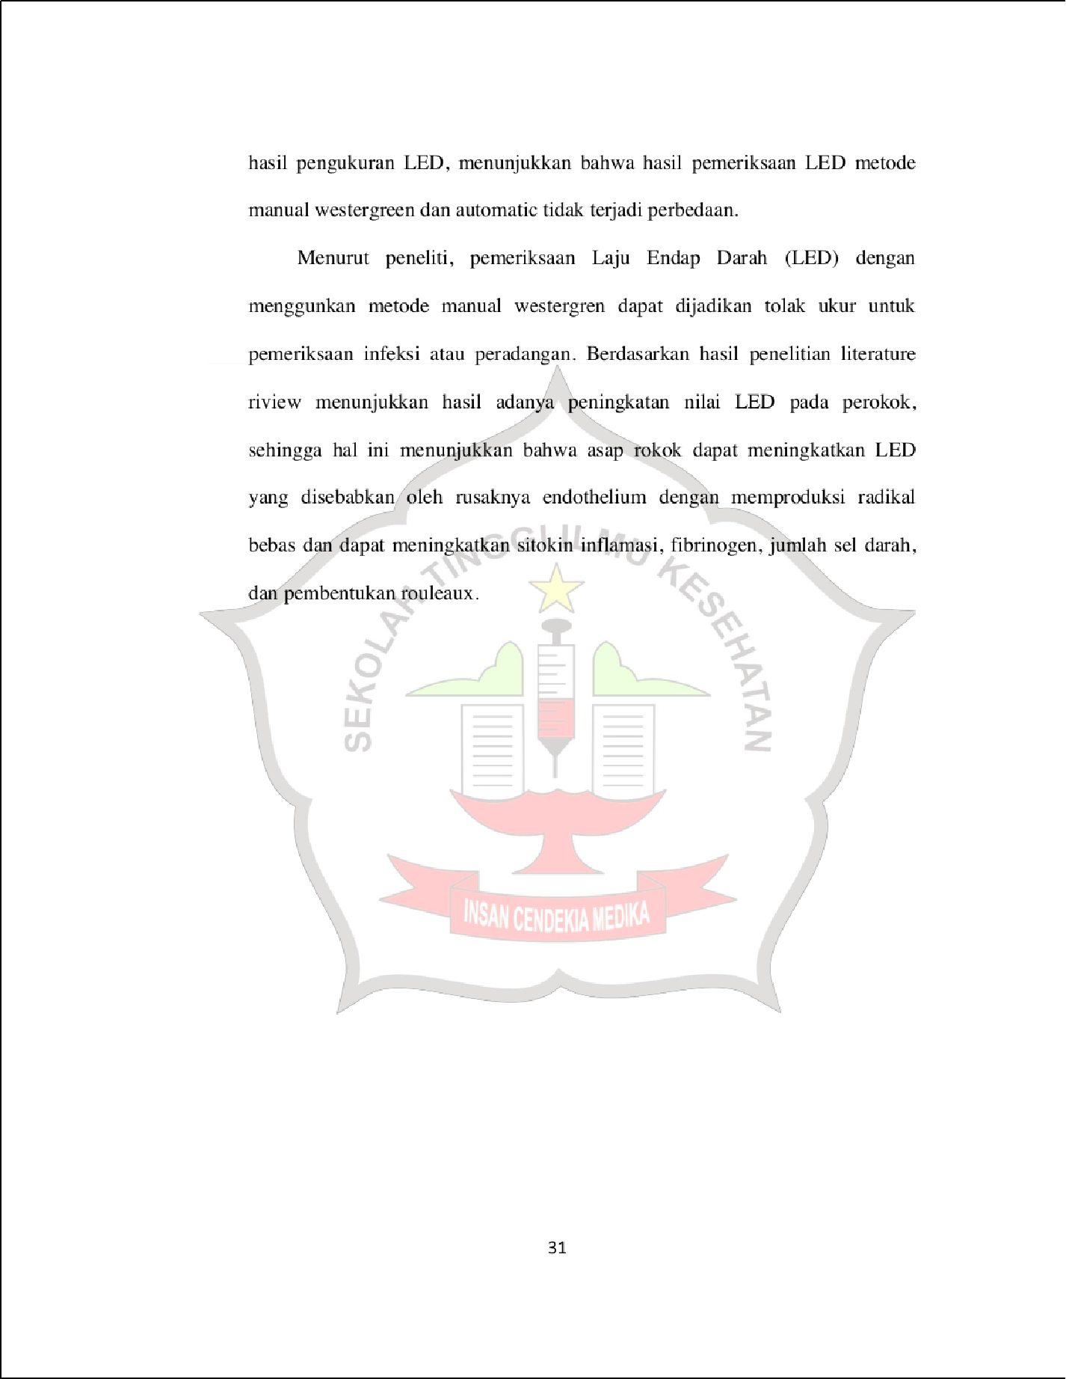

5

9

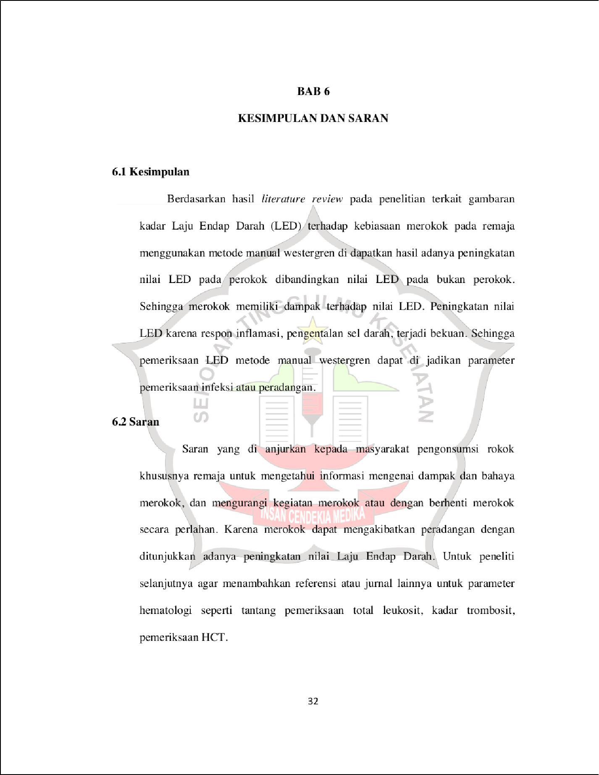

1

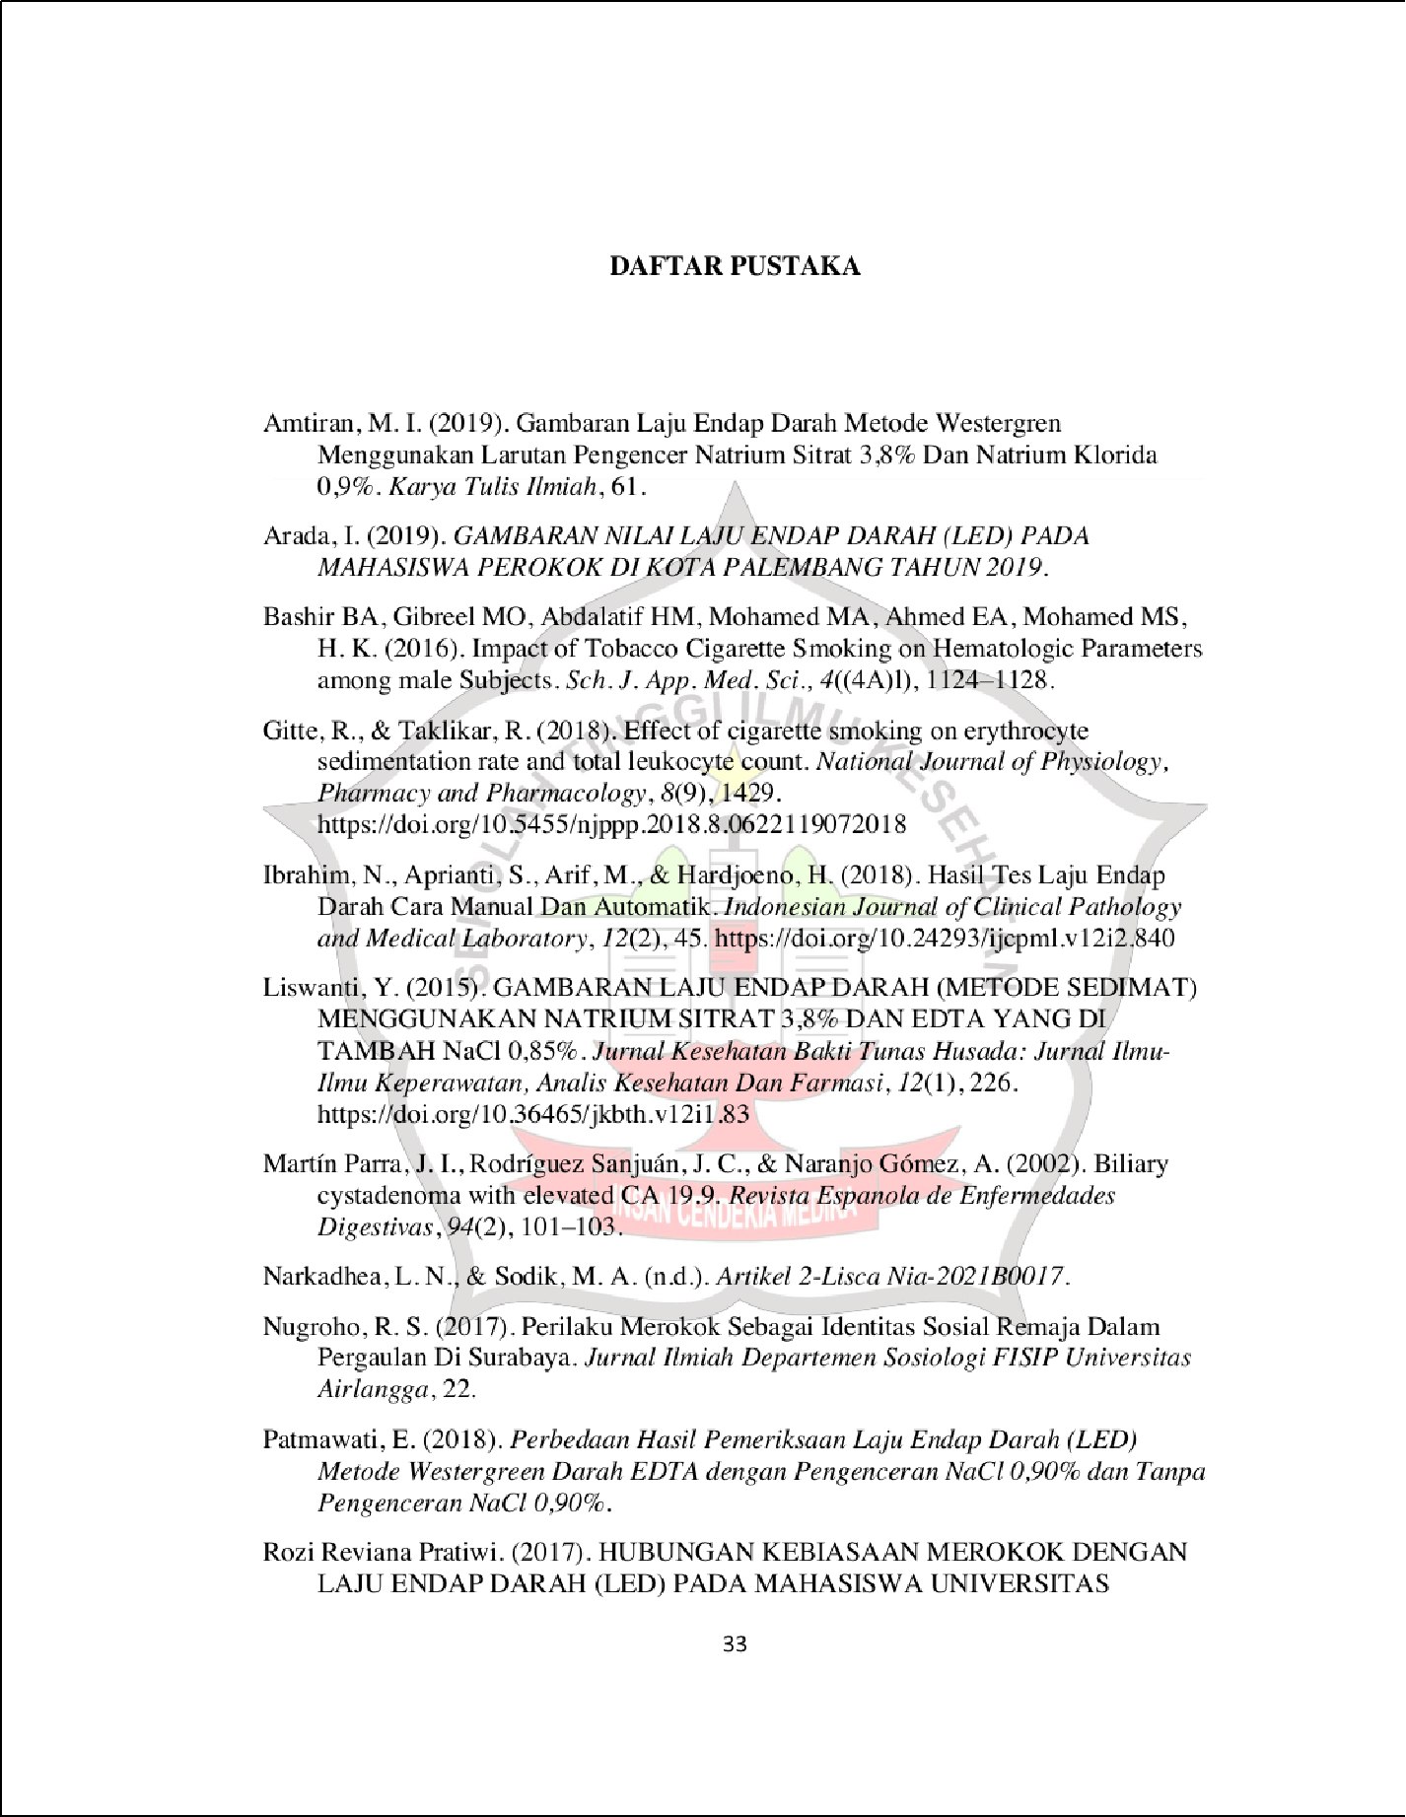

10

6

24
56

17

53

22
59

11

30

26

1

7

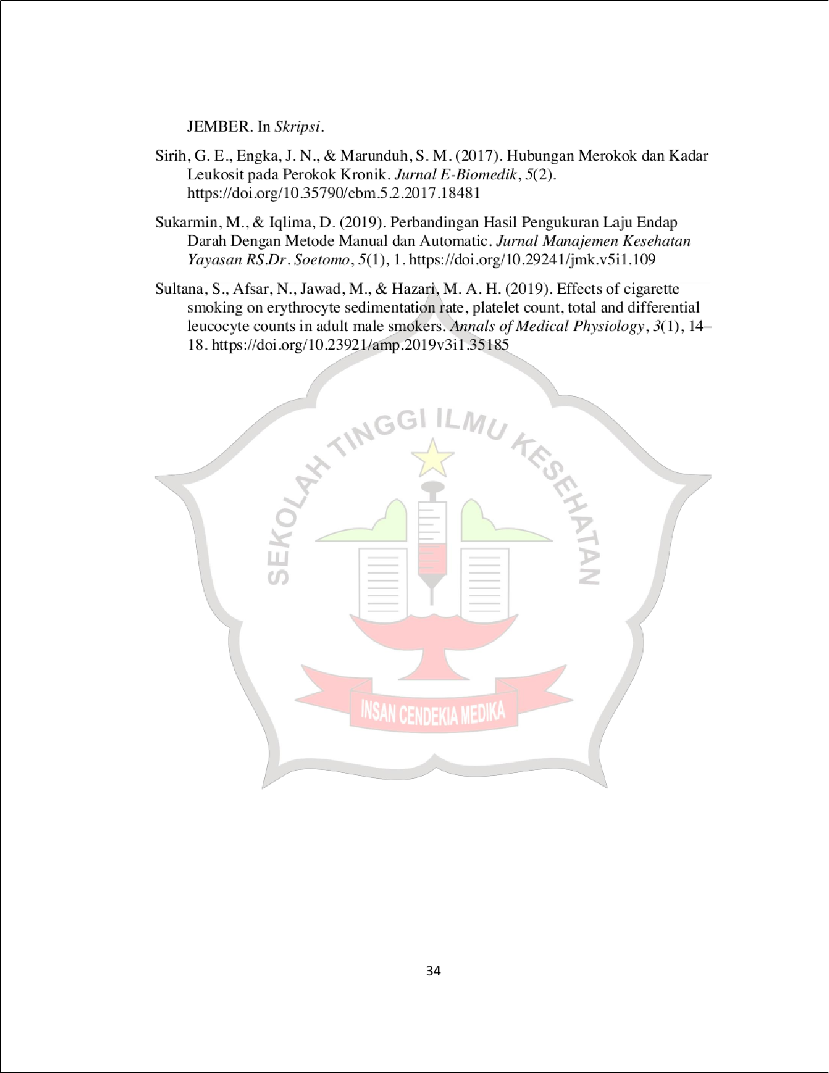

6
38

19

14
8

GAMBARAN KADAR LAJU ENDAP DARAH (LED) TERHADAP KEBIASAAN MEROKOK PADA REMAJA

ORIGINALITY REPORT
29

%
SIMILARITY INDEX
27%
INTERNET SOURCES
10%
PUBLICATIONS
9%
STUDENT PAPERS

PRIMARY SOURCES
repo.stikesicme-jbg.ac.id
Internet Source %
1
5
2

repository.unimus.ac.id
Internet Source %
2
1

es.scribd.com
Internet Source %
3
1

jhenatalicha.blogspot.com
Internet Source %
4
1%

5 Mimin Sukarmin, Dealitanti Iqlima. "Perbandingan Hasil Pengukuran Laju Endap Darah Dengan Metode Manual dan Automatic", Jurnal Manajemen Kesehatan Yayasan RS.Dr. Soetomo, 2019
Publication
1

repository.setiabudi.ac.id
Internet Source %
6
1

repository.unej.ac.id
Internet Source %
7

8

9

10

11

12

13

14

15

16

17

18

19
amphysiol.com
Internet Source

123dok.com
Internet Source

repository.poltekeskupang.ac.id
Internet Source

ejurnal.stikes-bth.ac.id
Internet Source

jurnal.stikes-yrsds.ac.id
Internet Source

look-better.icu
Internet Source

Submitted to University of Greenwich
Student Paper

docplayer.info
Internet Source

repository.unair.ac.id
Internet Source

Submitted to RMIT University
Student Paper

Submitted to University of Muhammadiyah Malang
Student Paper

www.ejurnalmalahayati.ac.id
1%
1%
1%
1%
1%
1%
1%
1%
<1%
<1%
<1%

20

21

22

23

24

25

26

27

28
Internet Source

ejournal.unsrat.ac.id
Internet Source

en.thefreedictionary.com
Internet Source

openjournal.masda.ac.id
Internet Source

rhamlaharieefblog.blogspot.com
Internet Source

MALES, Healthy and AHMED, Osamah Awad. "Sağlıklı Erkeklerde Sigara İçiminin Eritrosit Parametreleri ve Glukoz Düzeyine olan Etkisi", Gazi Üniversitesi, 2017.
Publication

Submitted to Universitas Negeri Surabaya The State University of Surabaya
Student Paper

eprints.poltekkesjogja.ac.id
Internet Source

repository.uinjkt.ac.id
Internet Source

Submitted to Sriwijaya University
Student Paper

adoc.pub
<1%
<1%
<1%
<1%
<1%
<1%

<1%
<1%
<1%
<1%

29

30

31

32

33

34

35

36

37

38
Internet Source

Izaskun Rubio Ollo, Cristina Prieto Valtuille, Arantza Arza Ruesga, Amaia García de Vicuña et al. "Cistoadenoma hepatobiliar y elevación progresiva del marcador tumoral CA 19.9", Revista del Laboratorio Clínico, 2010
Publication

Submitted to Universitas Muhammadiyah Surakarta
Student Paper

Submitted to Universitas Negeri Jakarta
Student Paper

core.ac.uk
Internet Source

hollashop.com
Internet Source

id.scribd.com
Internet Source

Submitted to James Monroe High School
Student Paper

Submitted to iGroup
Student Paper

jurnal.umj.ac.id
Internet Source
<1%
<1%

<1%
<1%
<1%
<1%
<1%
<1%
<1%
<1%

39

40

41

42

43

44

45
Amalita Mannana, Stephanus J. Ch. Tangel, Eko Prasetyo. "Diagnosis Akut Abdomen akibat Peritonitis", e-CliniC, 2021
Publication

asisulkimia.blogspot.com
Internet Source

gugel-pinguin.blogspot.com
Internet Source

id.123dok.com
Internet Source

Eddy Triswanto Setyoadi. "PENERAPAN ALGORITMA GENETIK UNTUK OPTIMASI POLA PENYUSUNAN BARANG DALAM RUANG TIGA DIMENSI", Teknika, 2013
Publication

Submitted to Universitas Pelita Harapan
Student Paper

repo.poltekkes-medan.ac.id
Internet Source
<1%

<1%
<1%
<1%
<1%

<1%
<1%

46
tipsperawatankecantikandankesehatan.blogspot.<co1m

47

48
Internet Source

digilib.unhas.ac.id
Internet Source

ecampus.poltekkes-medan.ac.id
Internet Source
%

<1%
<1%

49

50

51

52

53

54

55

56

57

58
idr.uin-antasari.ac.id
Internet Source

jurnalduniakesmas11.blogspot.com
Internet Source

look-better.fun
Internet Source

mulpix.com
Internet Source

repository.udca.edu.co
Internet Source

text-id.123dok.com
Internet Source

www.coursehero.com
Internet Source

Mely Purnadianti, Nita Ermawati, Rere Nadhif Berlian. "Comparison of Smoking Habits and Coﬀee Consumption In Adolescents Against Hemoglobin Levels In Mojoroto Kediri City", Medicra (Journal of Medical Laboratory Science/Technology), 2021
Publication

aakmalang.blogspot.com
Internet Source

repository.iainpurwokerto.ac.id
Internet Source
<1%
<1%
<1%
<1%
<1%
<1%
<1%
<1%

<1%
<1%

59
repository.radenintan.ac.id
Internet Source
<1%

Exclude quotes Oﬀ Exclude bibliography Oﬀ
Exclude matches Oﬀ

