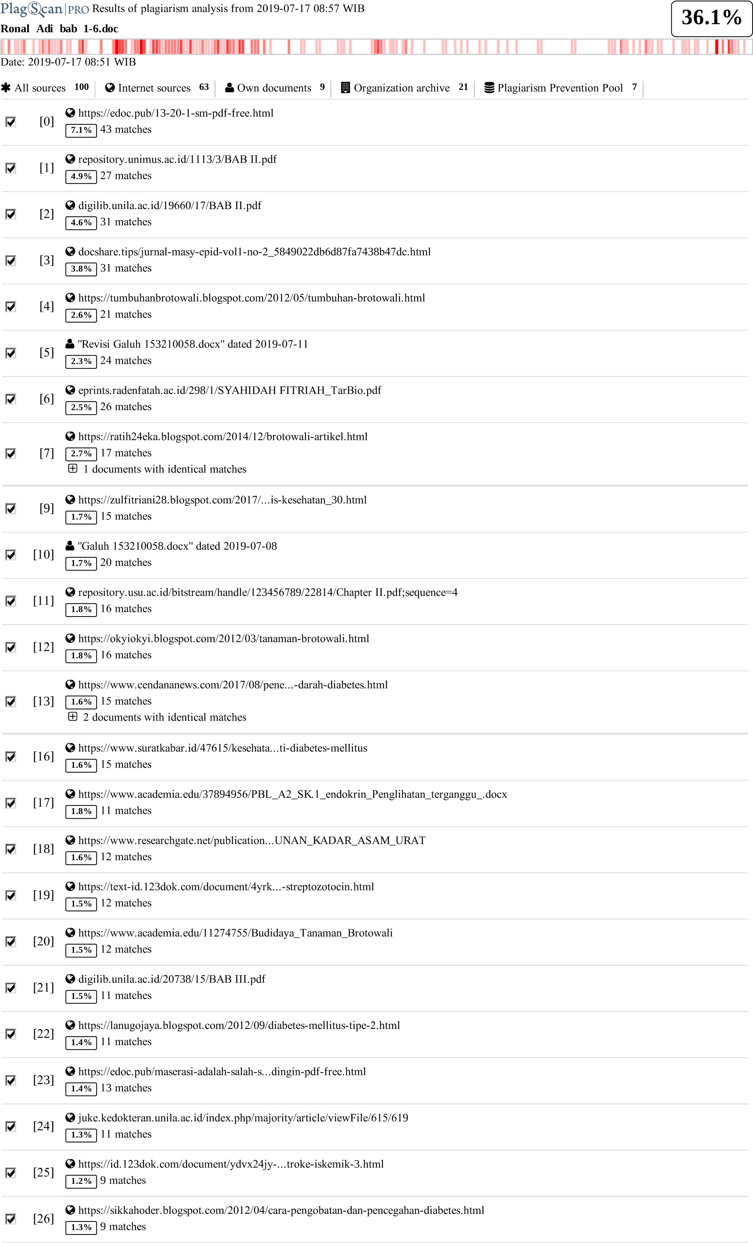

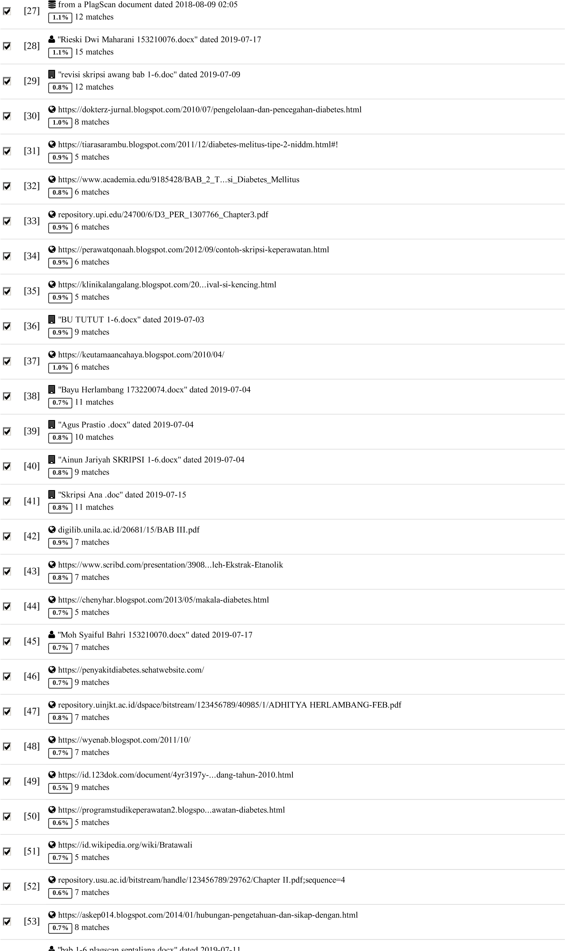

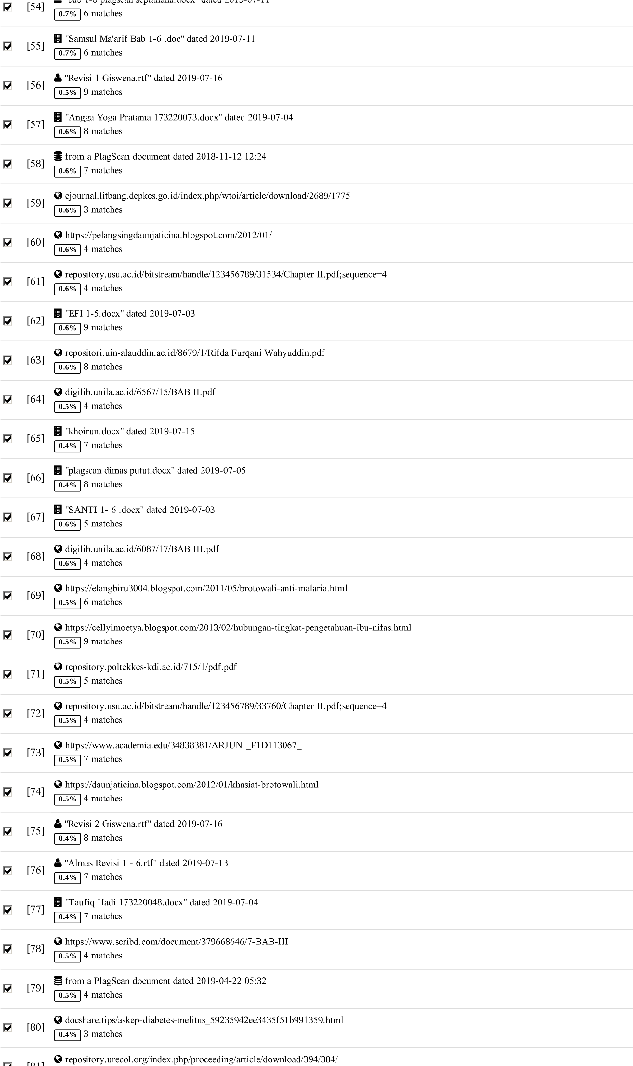

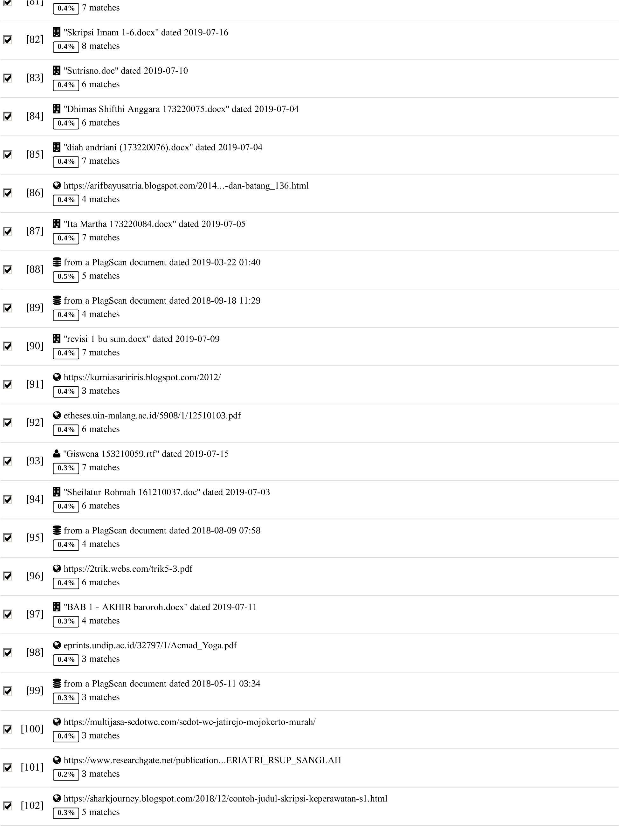

**61 pages, 9122 words**

**PlagLevel: 36.1% selected / 36.4% overall**

252 matches from 103 sources, of which 66 are online sources.

**Settings**

Data policy: *C*omparewithwebsources, *C*heckagainstmydocuments, *C*heckagainstmydocumentsintheorgani*z*ation repository, *C*heckagainstorgani*z*ationrepository, *C*heckagainstthePlagiarismPre*v*entionPool

Sensitivity: *M*edium

Bibliography: *C*onsiderte*x*t

Citation detection: *R*educePlagLe*v*el

Whitelist: *--*

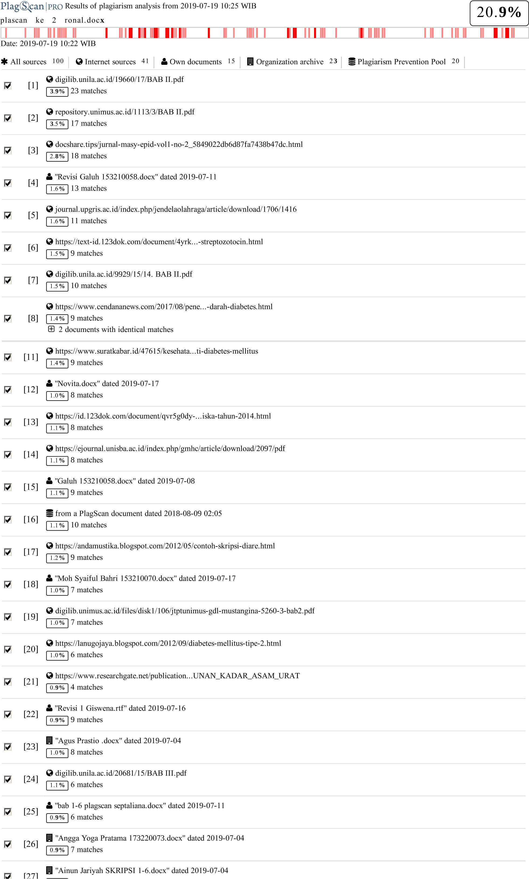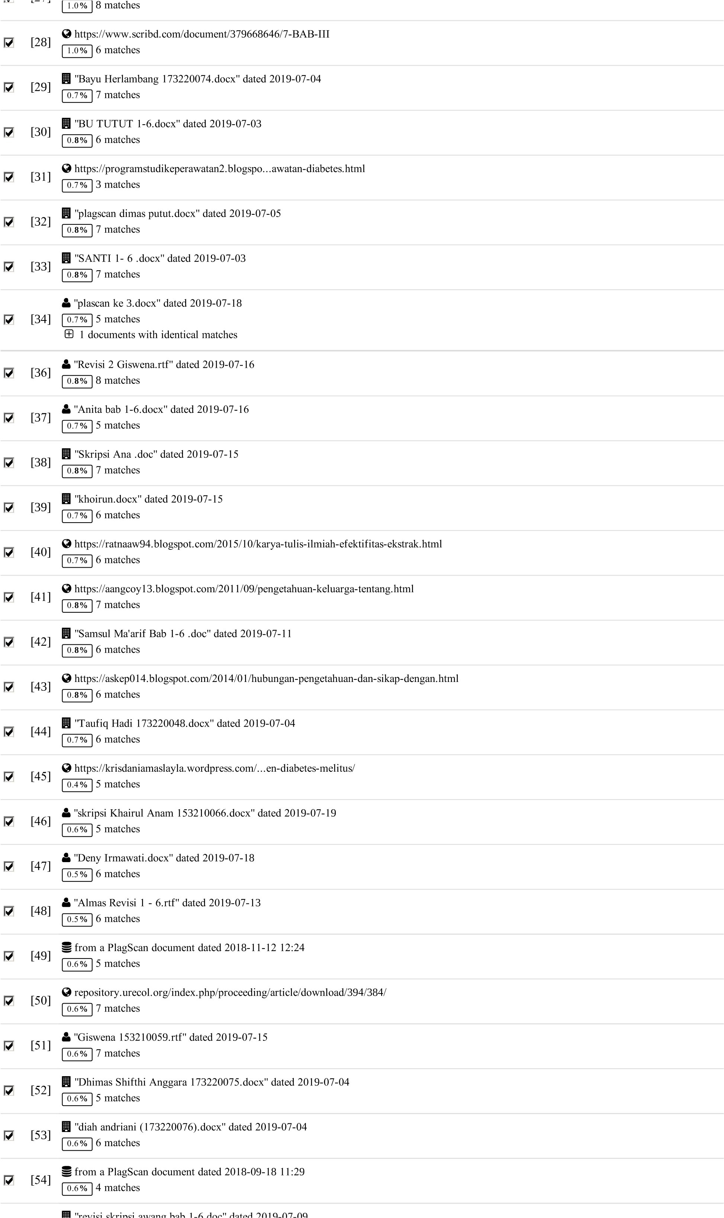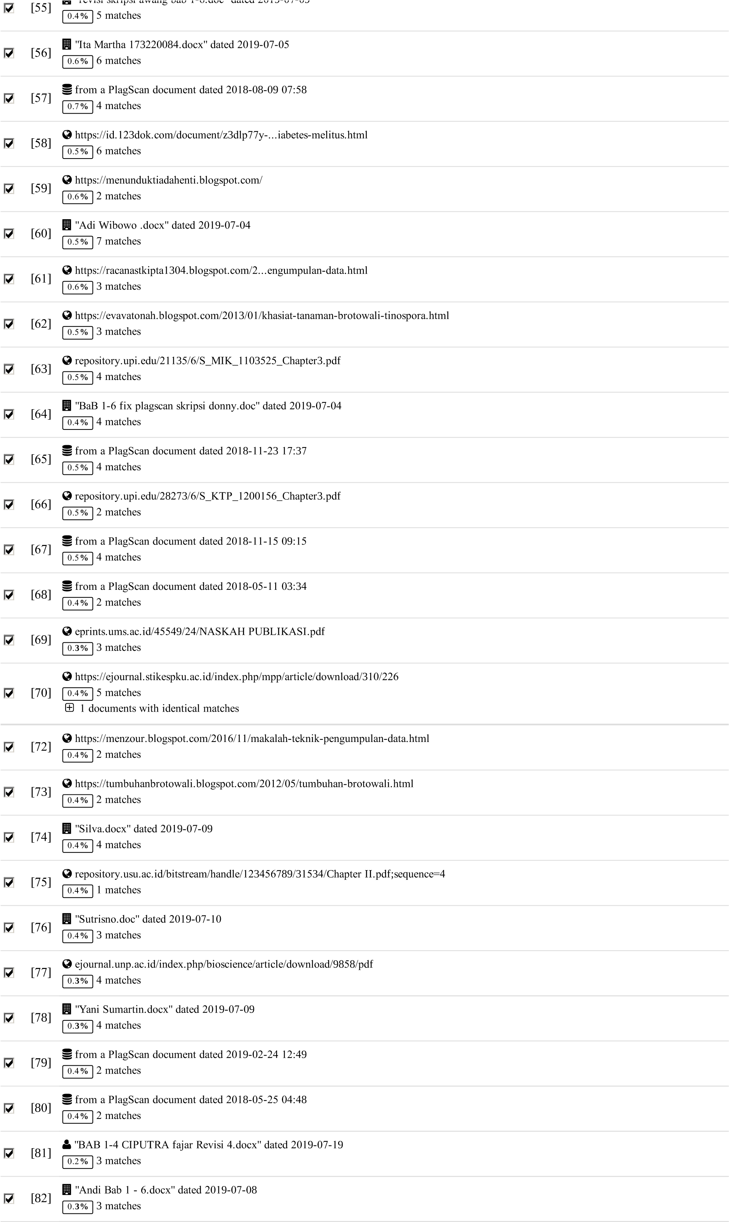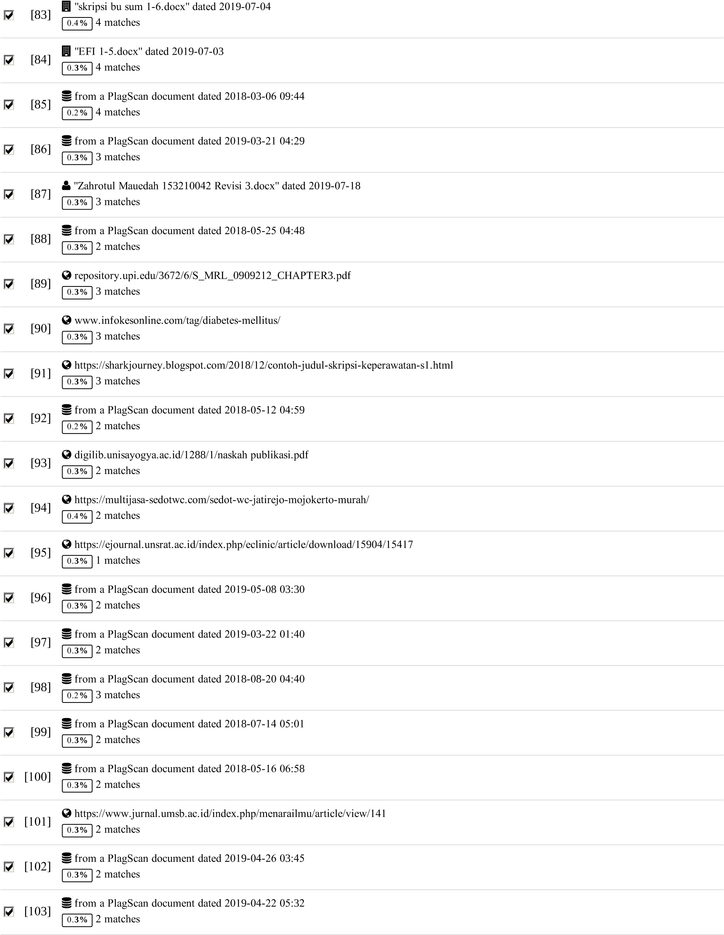

**39** pages,5**9**2**9** words

PlagLevel:20.**9%** selected/7**8**.2**%** overall

294 matches from 104 sources, of which 44 are online sources.

Settings

Data policy: *C*omparewithwebsources, *C*heckagainstmydocuments, *C*heckagainstmydocumentsintheorgani*z*ation repository, *C*heckagainstorgani*z*ationrepository, *C*heckagainstthePlagiarismPreventionPool

Sensitivity: Medium

Bibliography: *C*onsiderte*x*t

Citation detection: ReducePlagLevel

Whitelist: *--*