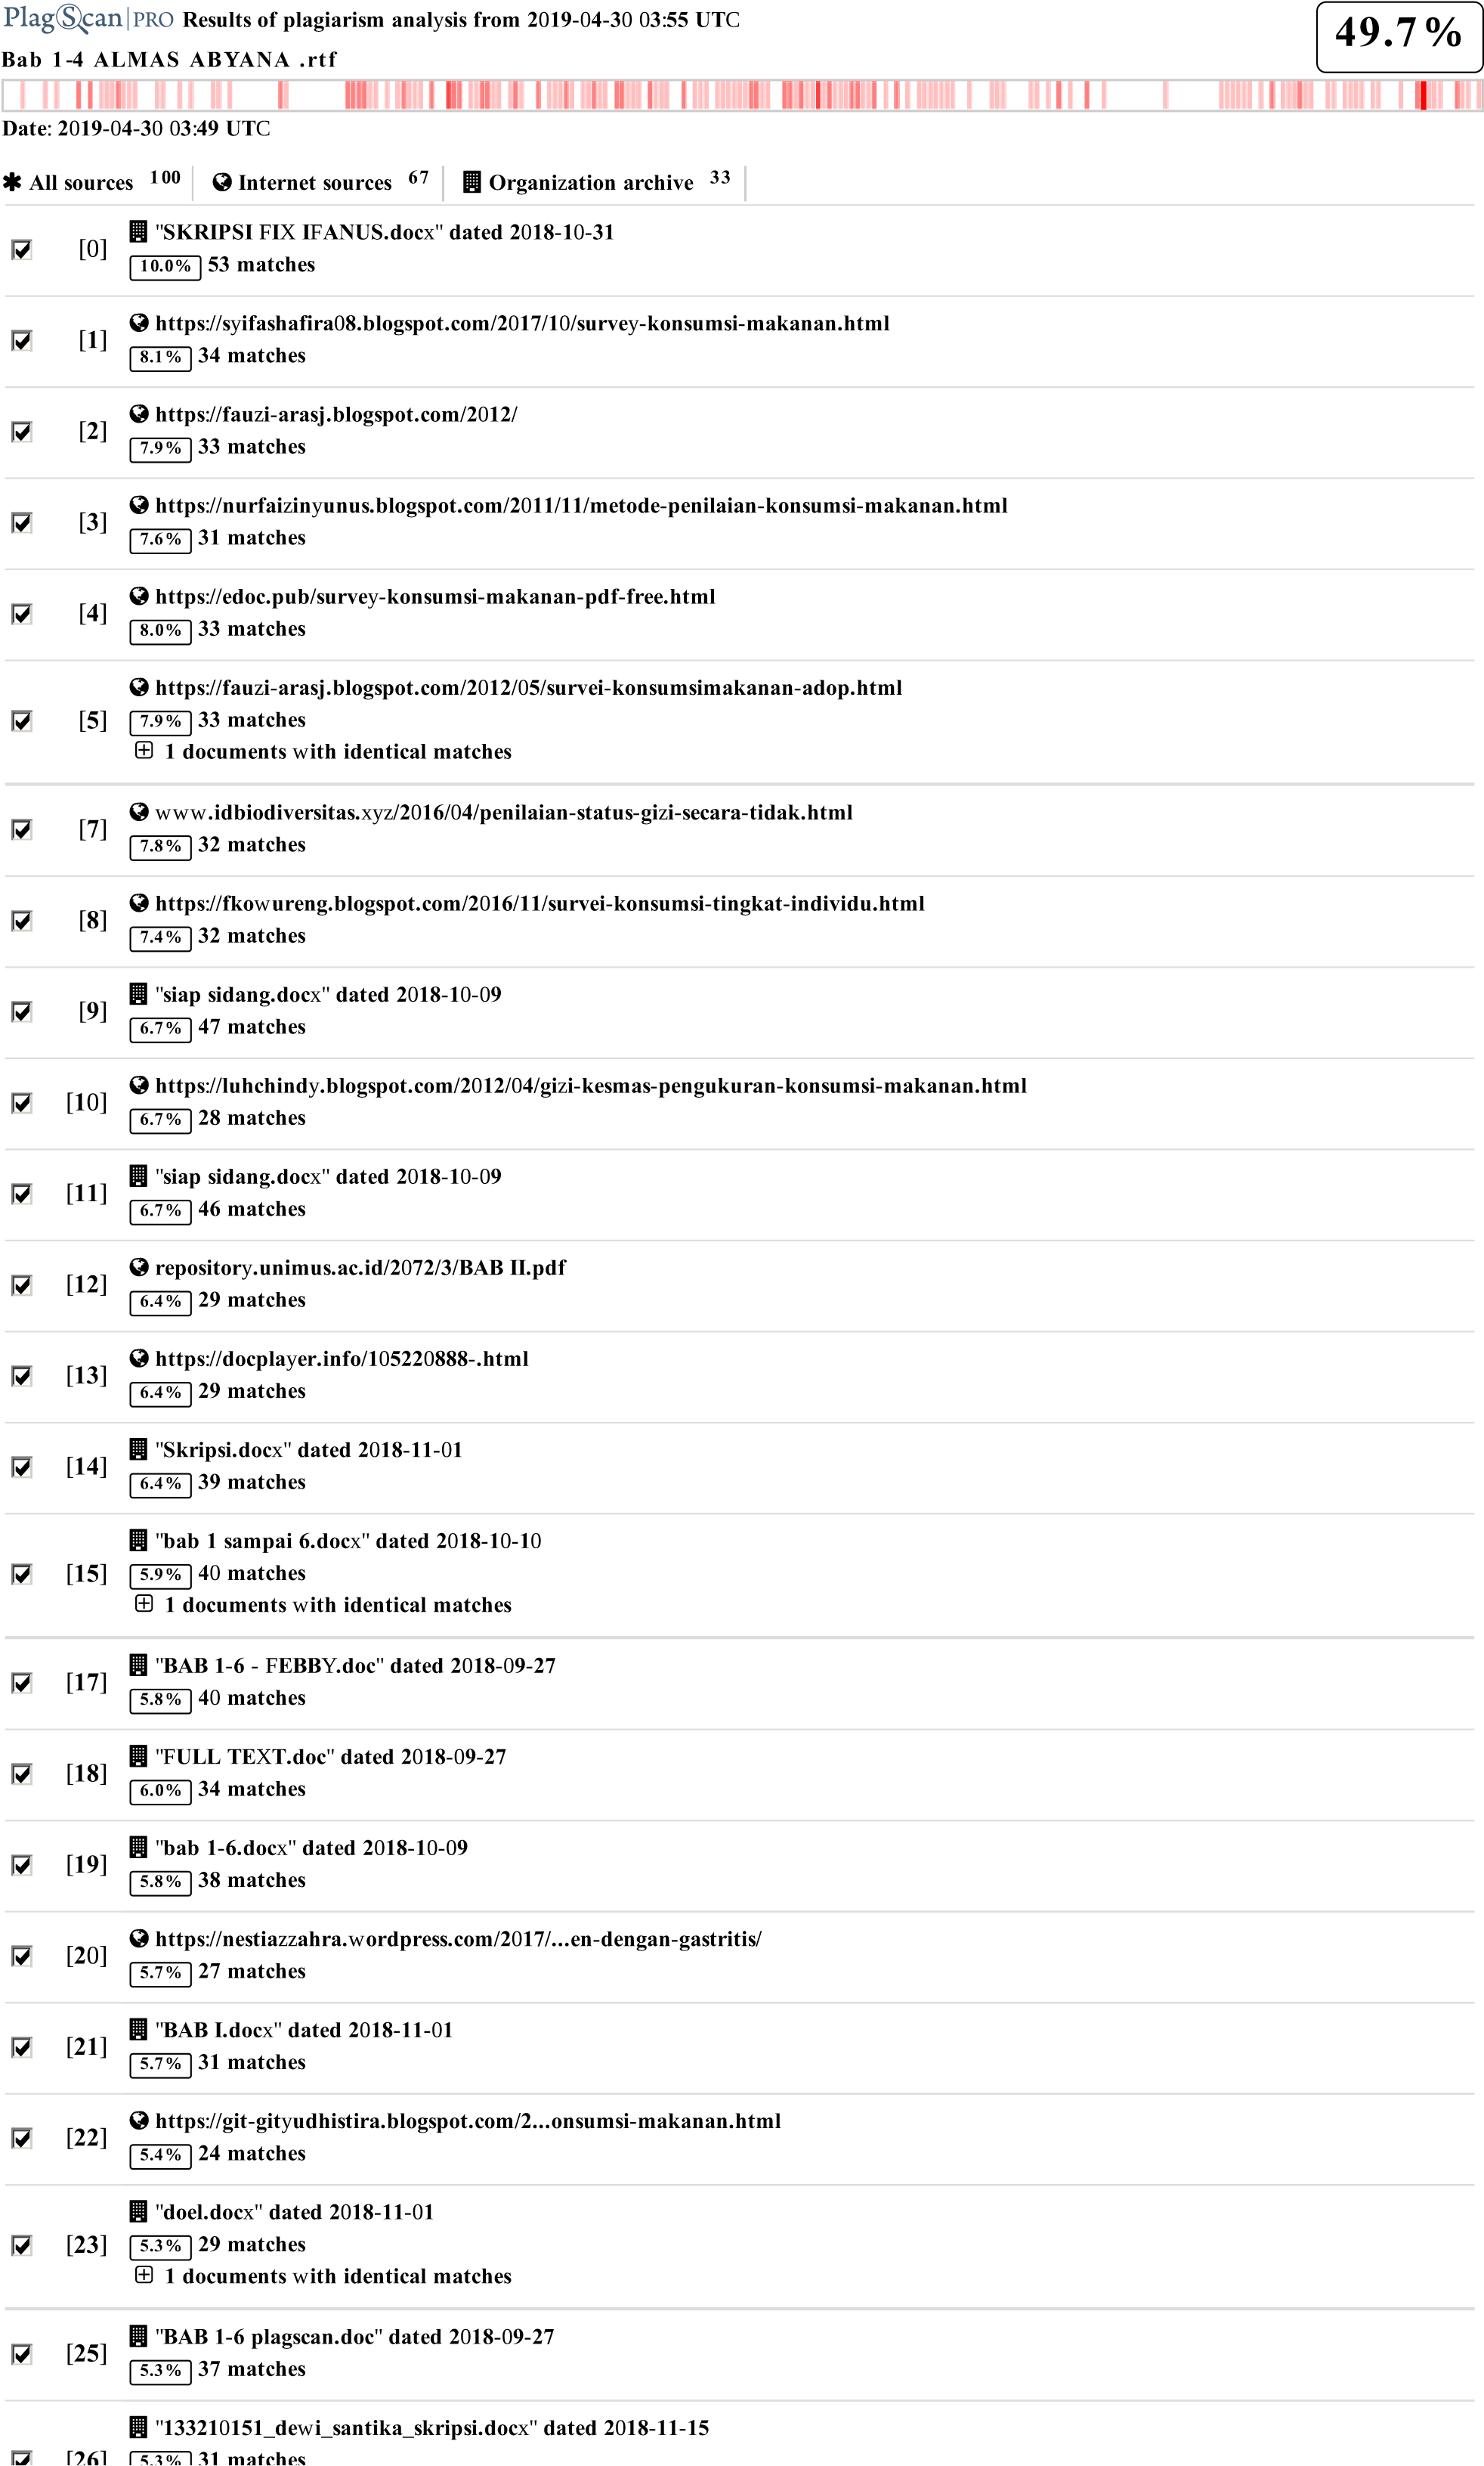

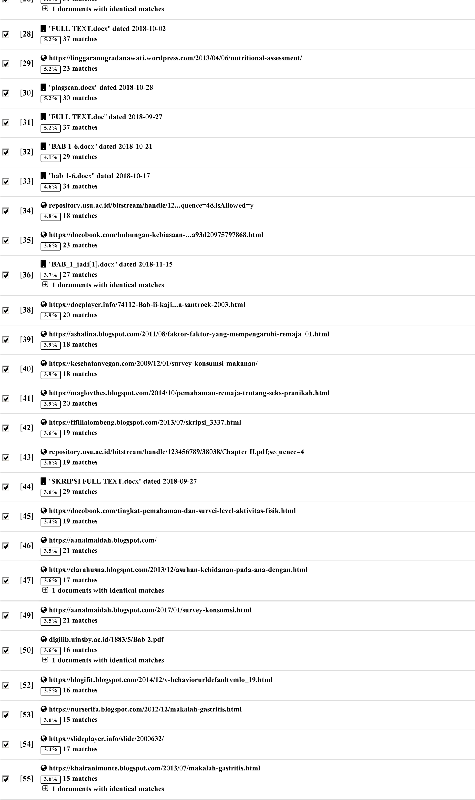

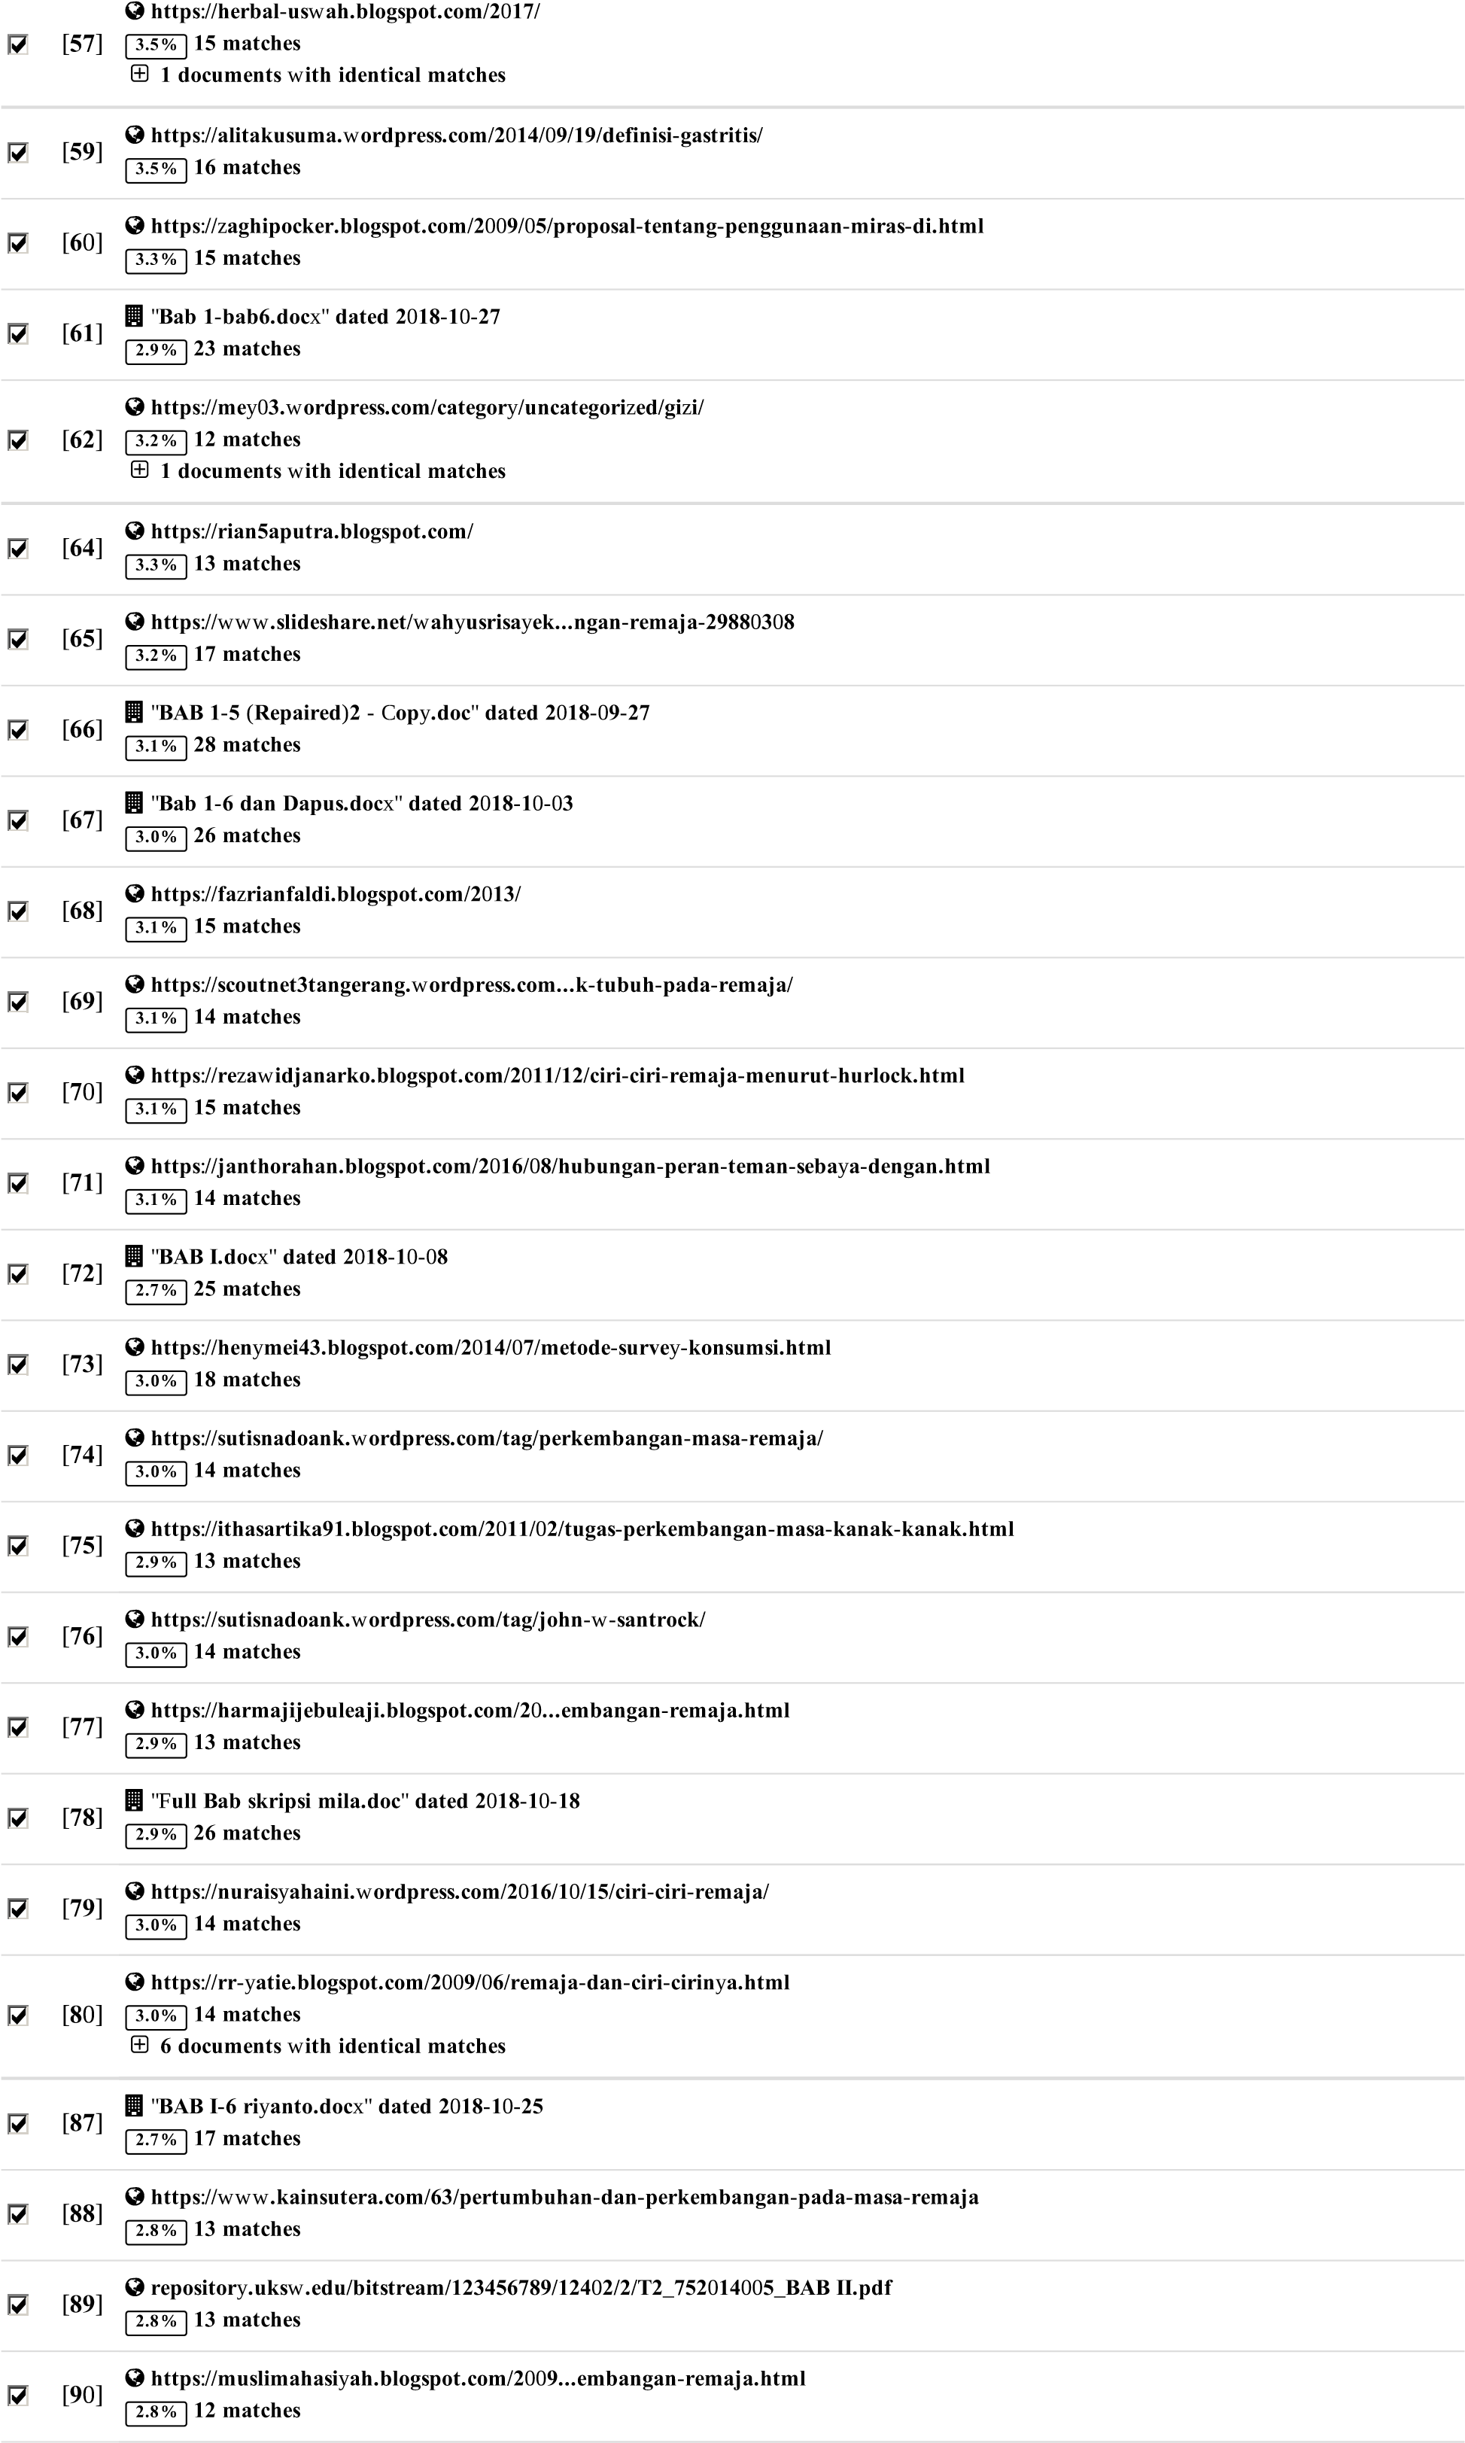

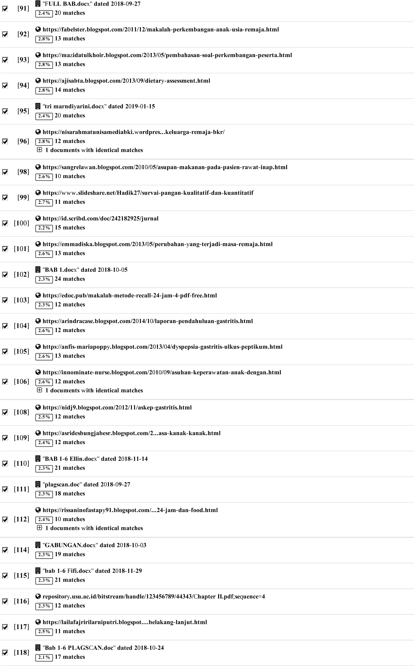

**44 pages, 6540 words**

**PlagLevel: 49.7% selected / 49.9% overall**

**234 matches from 119 sources, of** w**hich 82 are online sources.**

**Settings**

**Data polic**y:*Compare with web sources, Check against my documents, Check against my documents in the organization repository, Check against organization repository, Check against the Plagiarism Prevention Pool*

**Sensitivit**y:*Medium*

**Bibliograph**y:*Bibliography excluded*

C**itation detection**:*Reduce PlagLevel*

**Whitelist**:*--*

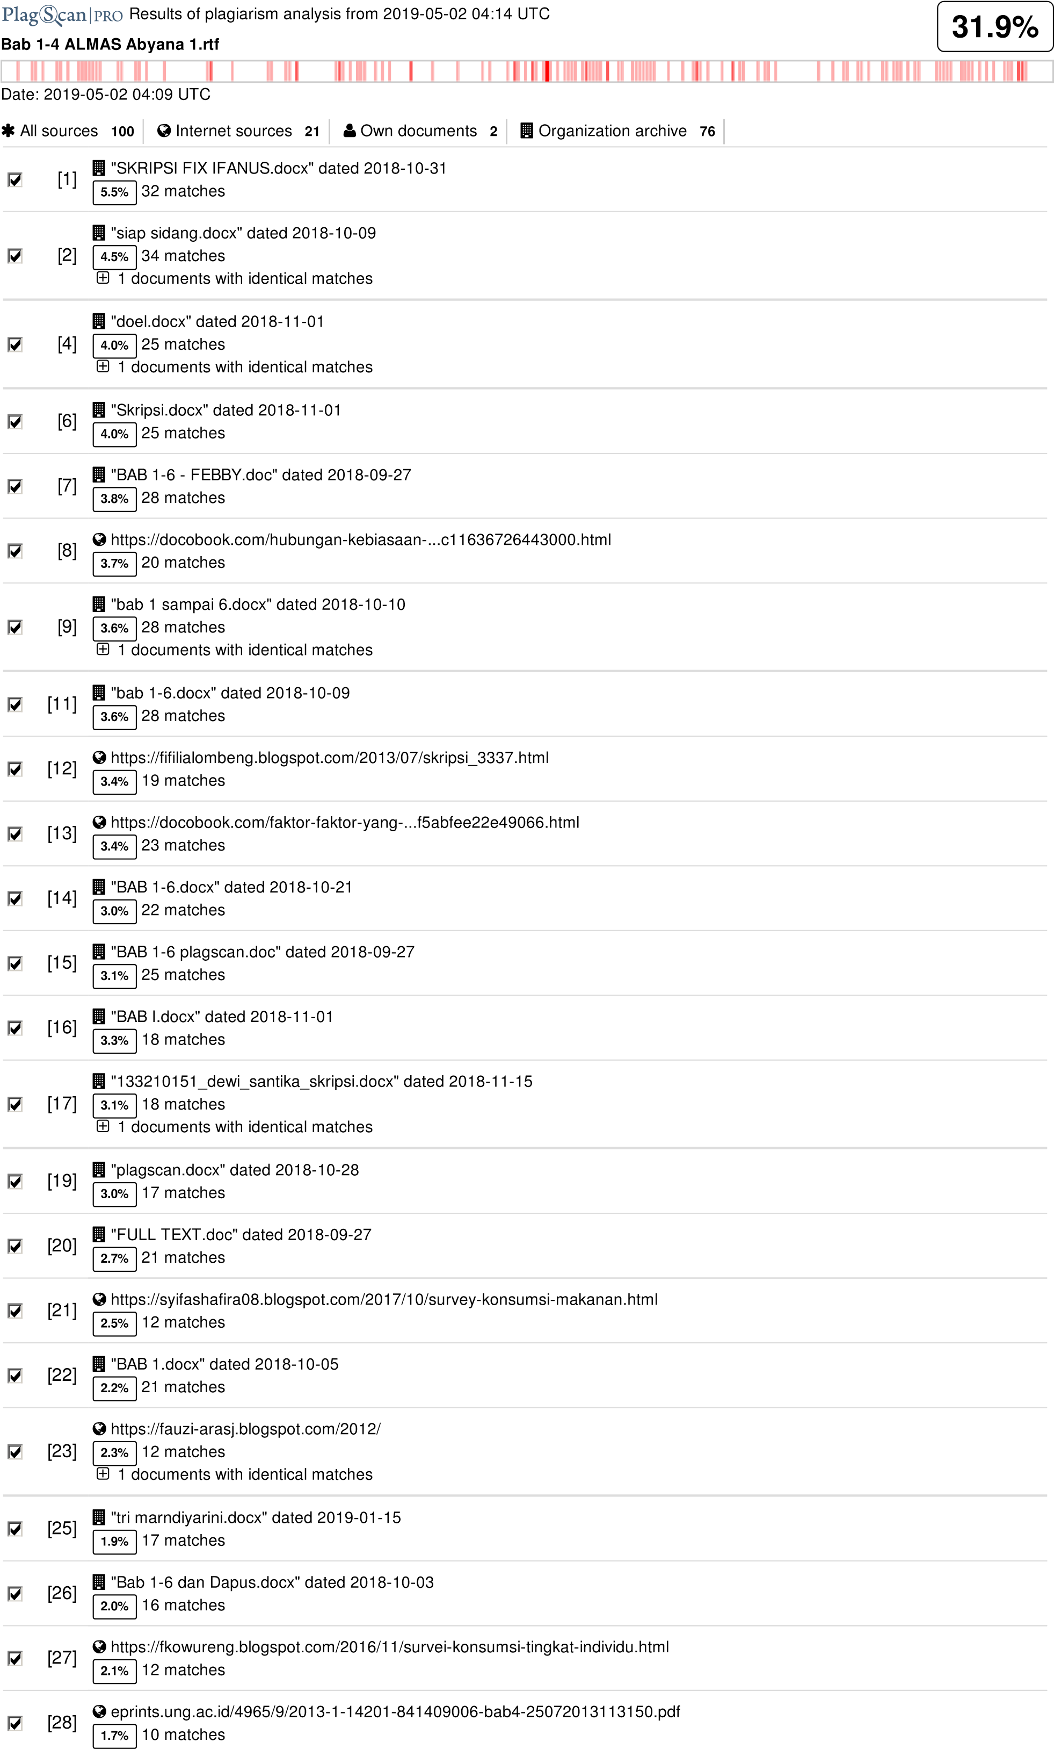

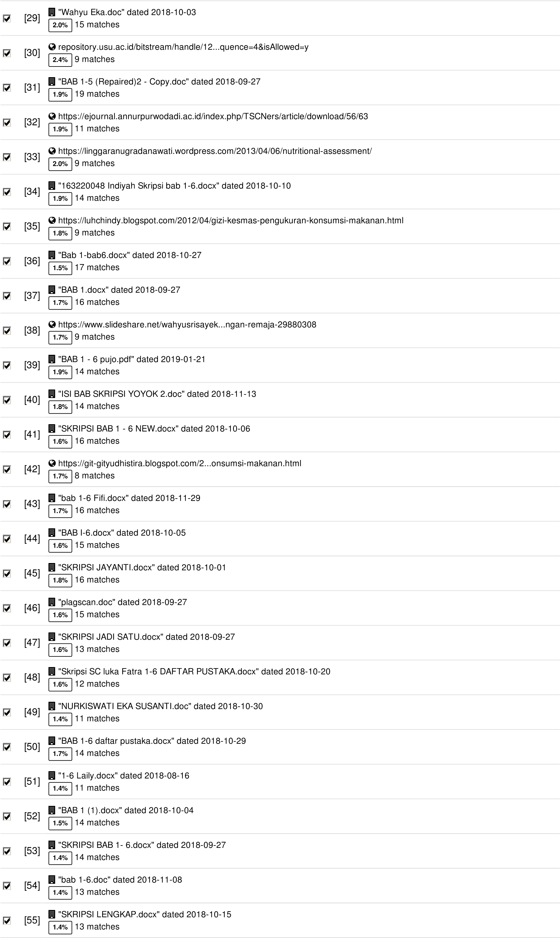

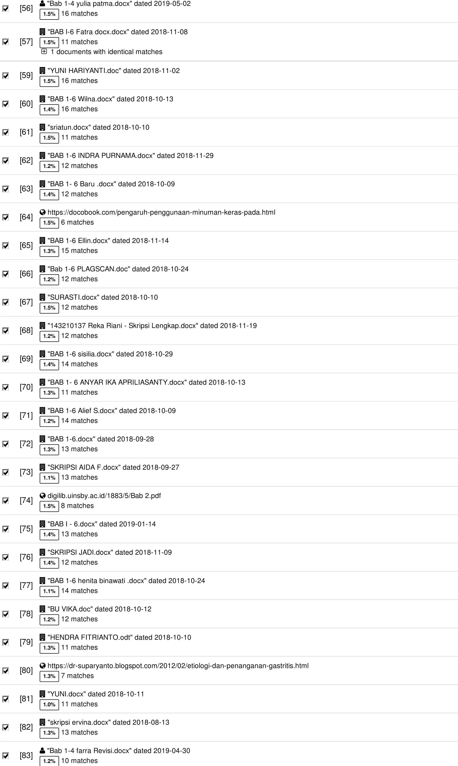

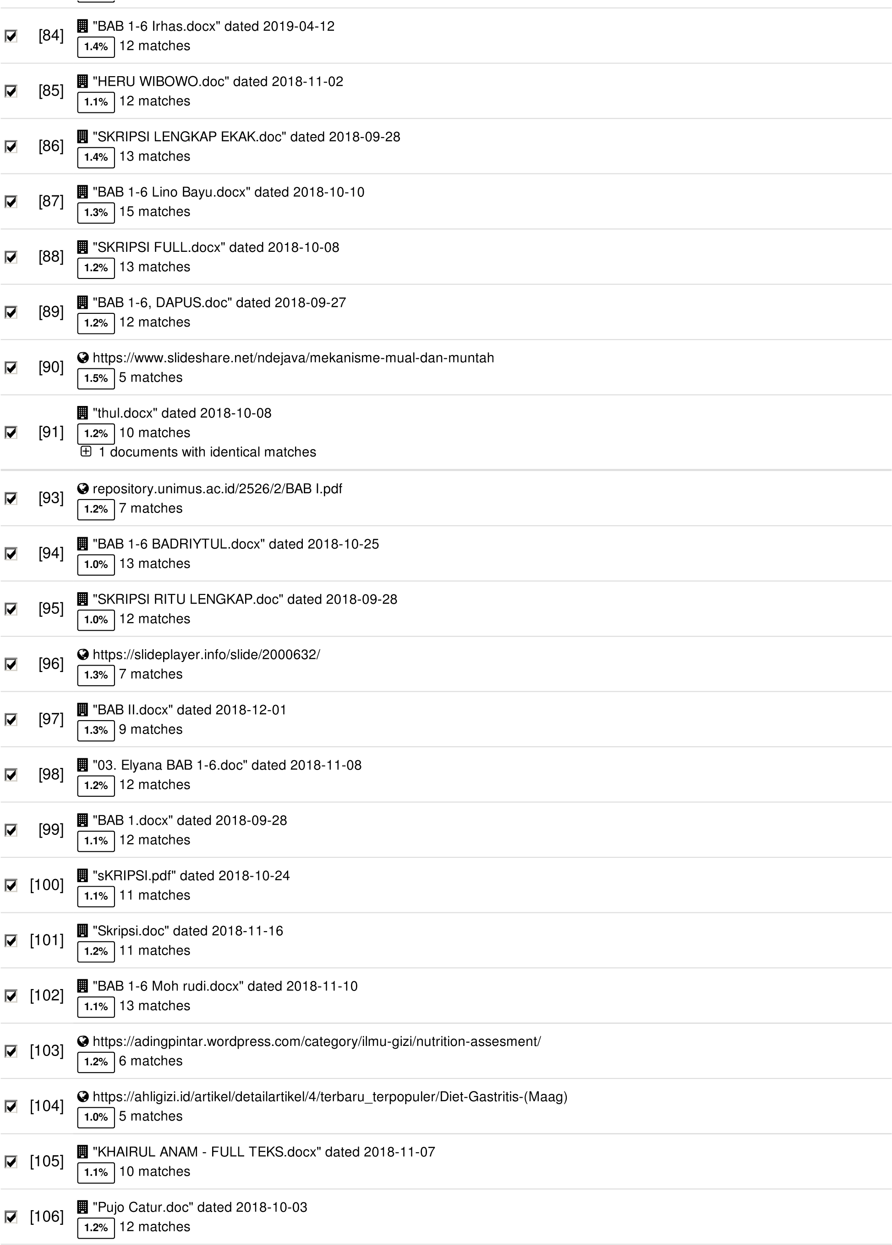

**42 pages, 6039 words**

**PlagLevel: 31.9% selected / 77.9% overall**

294 matches from 107 sources, of which 22 are online sources.

**Settings**

Data policy: *Compare with web sources, Check against my documents, Check against my documents in the organization repository, Check against organization repository, Check against the Plagiarism Prevention Pool*

Sensitivity: *Medium*

Bibliography: *Bibliography excluded*

Citation detection: *Reduce PlagLevel*

Whitelist: *--*

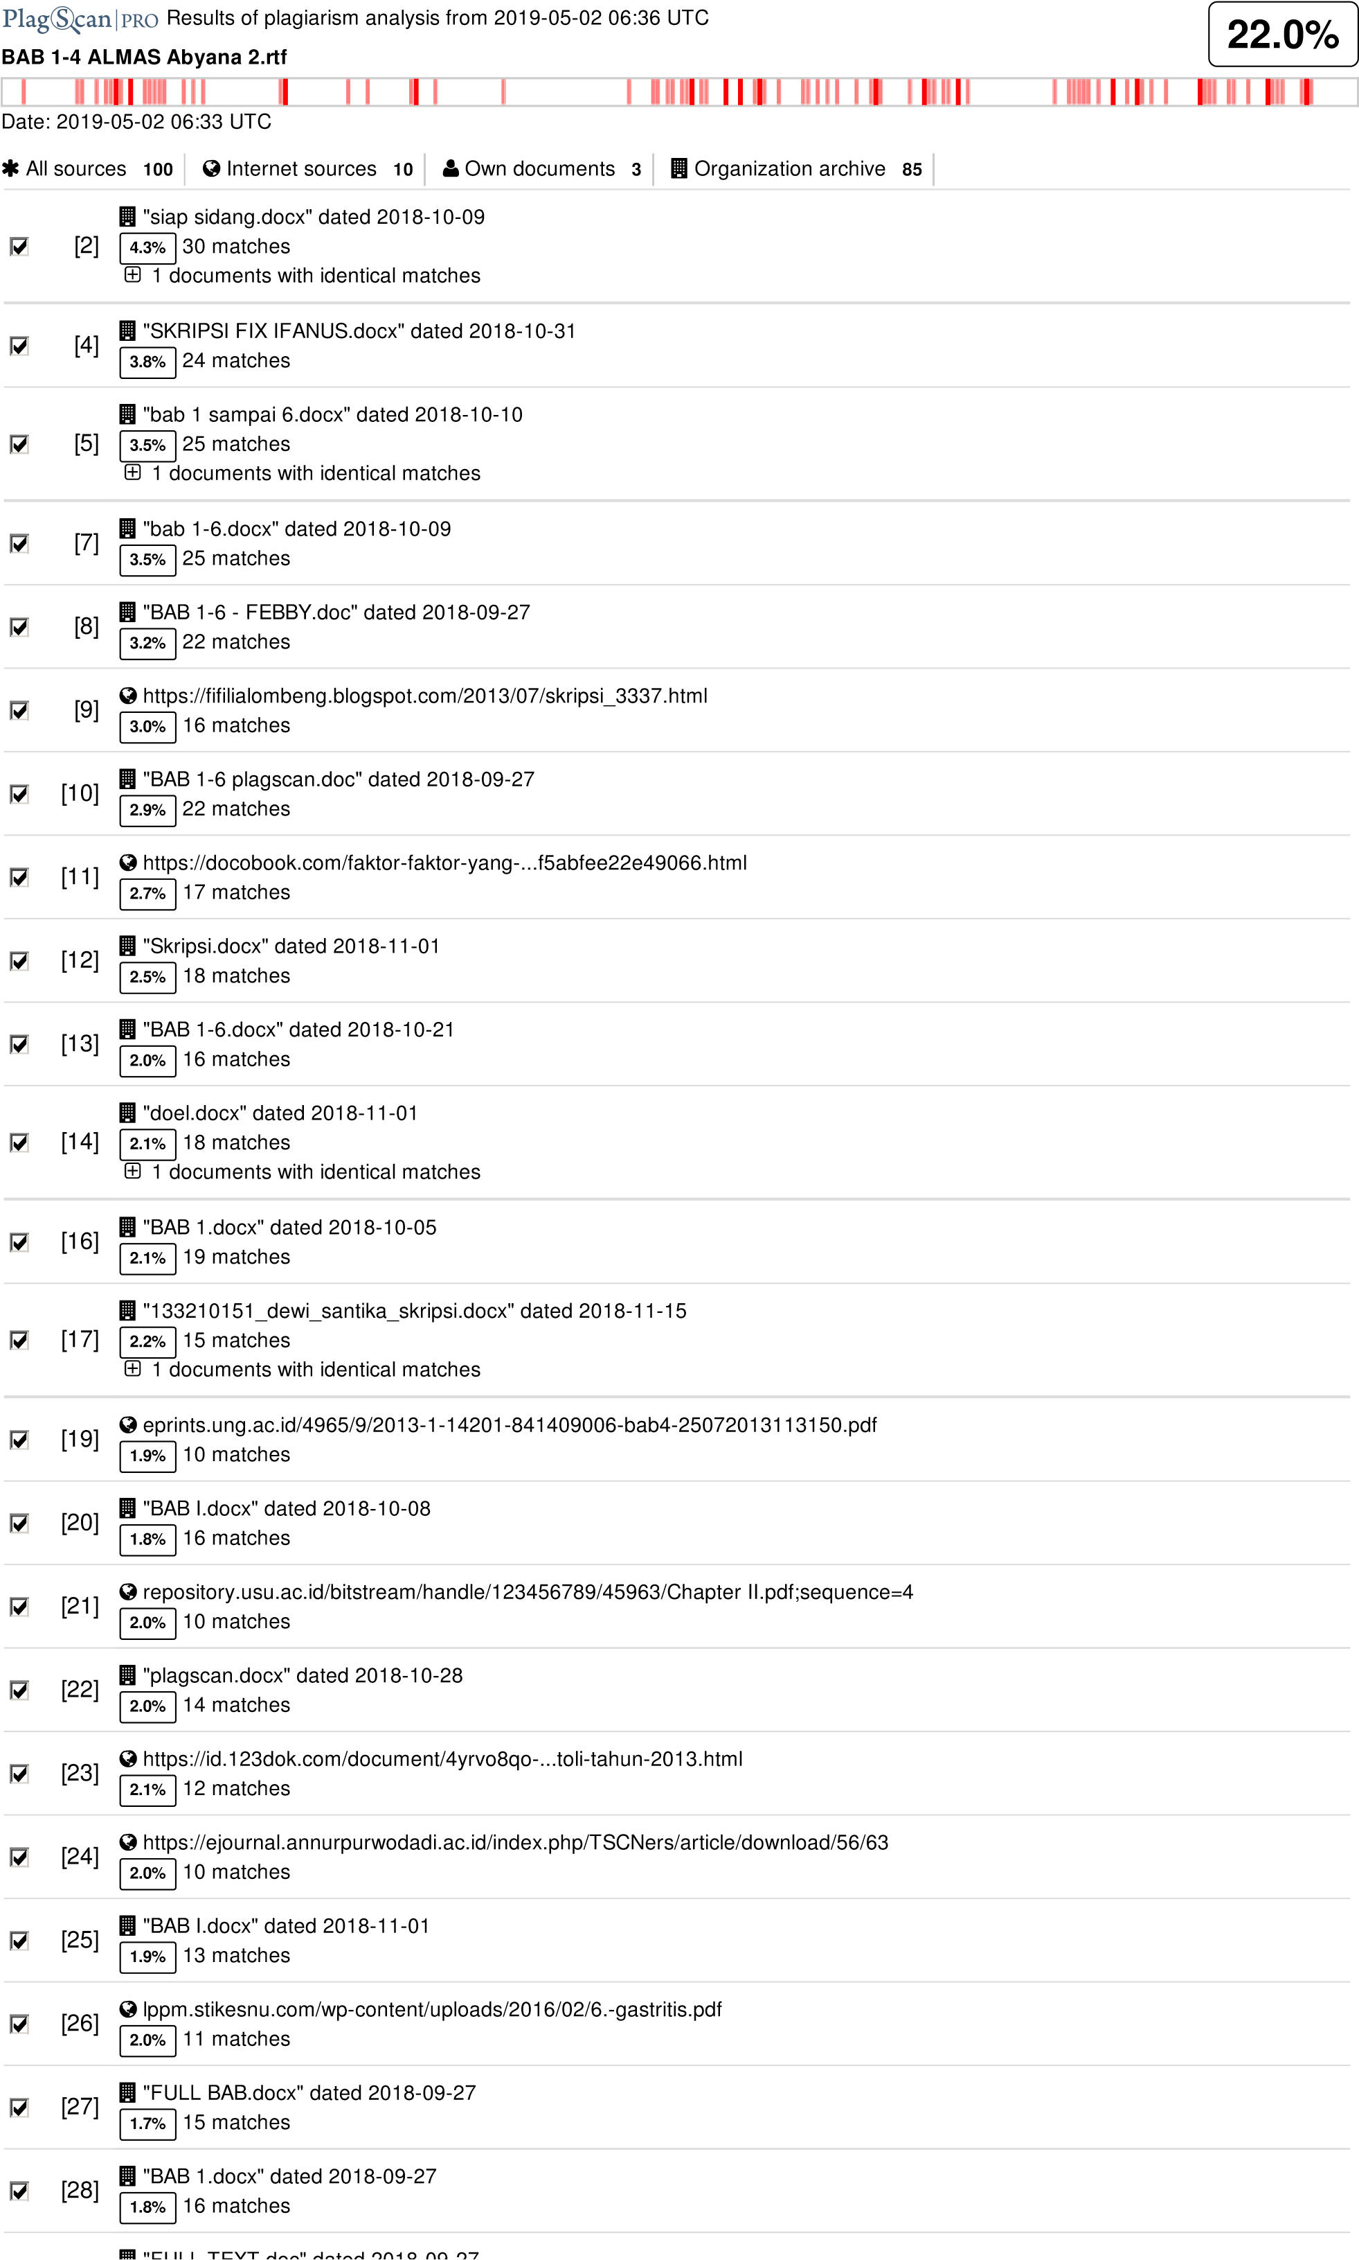

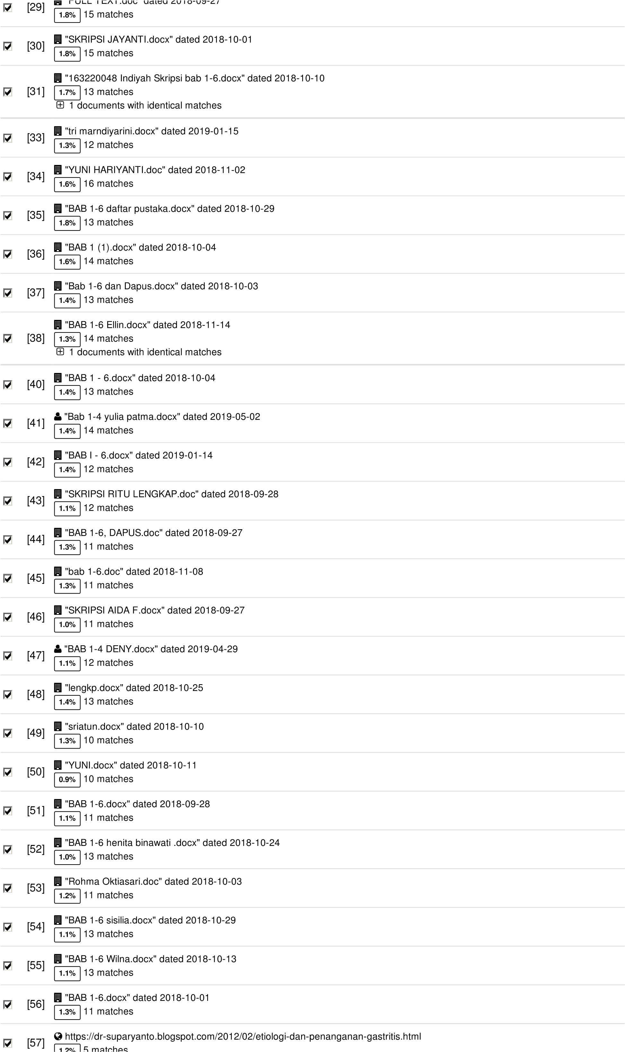

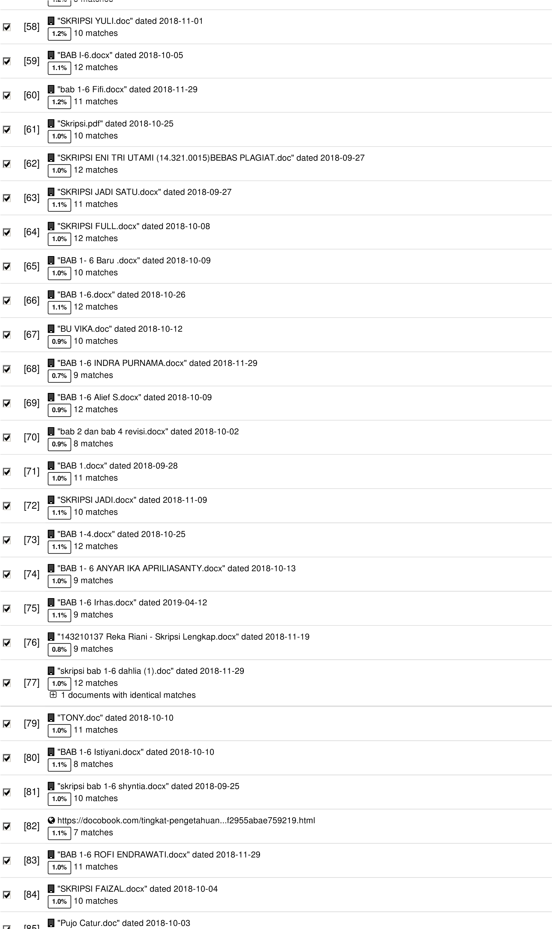

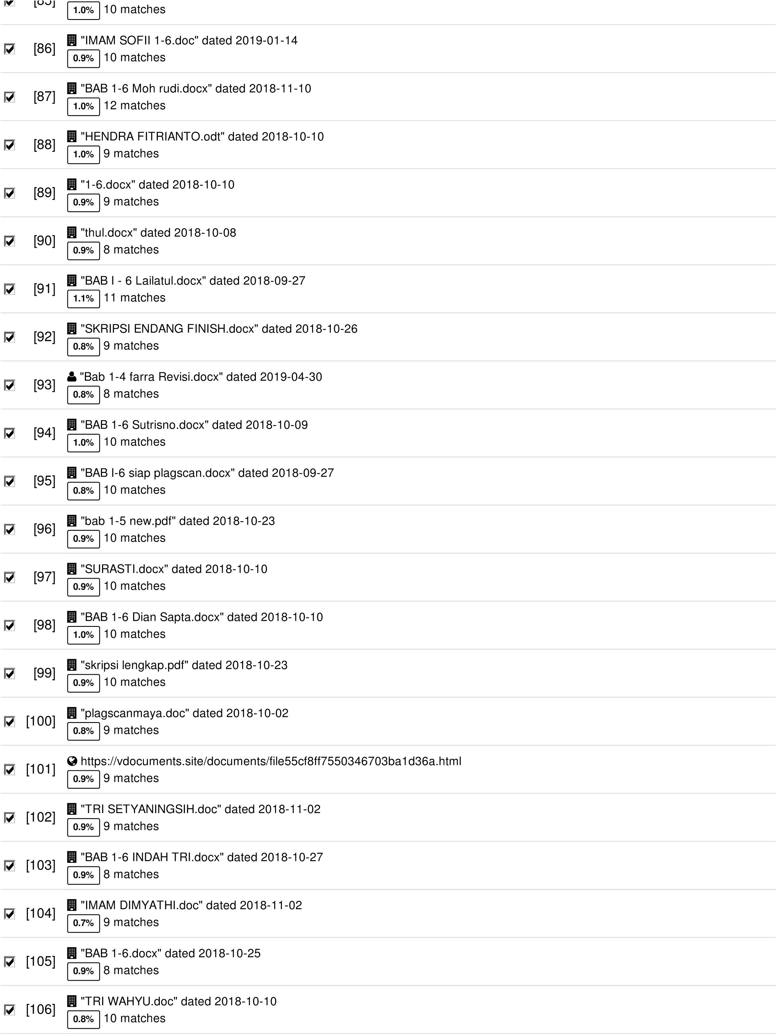

**40 pages, 5496 words**

**PlagLevel: 22.0% selected / 92.6% overall**

315 matches from 107 sources, of which 10 are online sources.

**Settings**

Data policy: *Compare with web sources, Check against my documents, Check against my documents in the organization repository, Check against organization repository, Check against the Plagiarism Prevention Pool*

Sensitivity: *Medium*

Bibliography: *Bibliography excluded*

Citation detection: *Reduce PlagLevel*

Whitelist: *--*

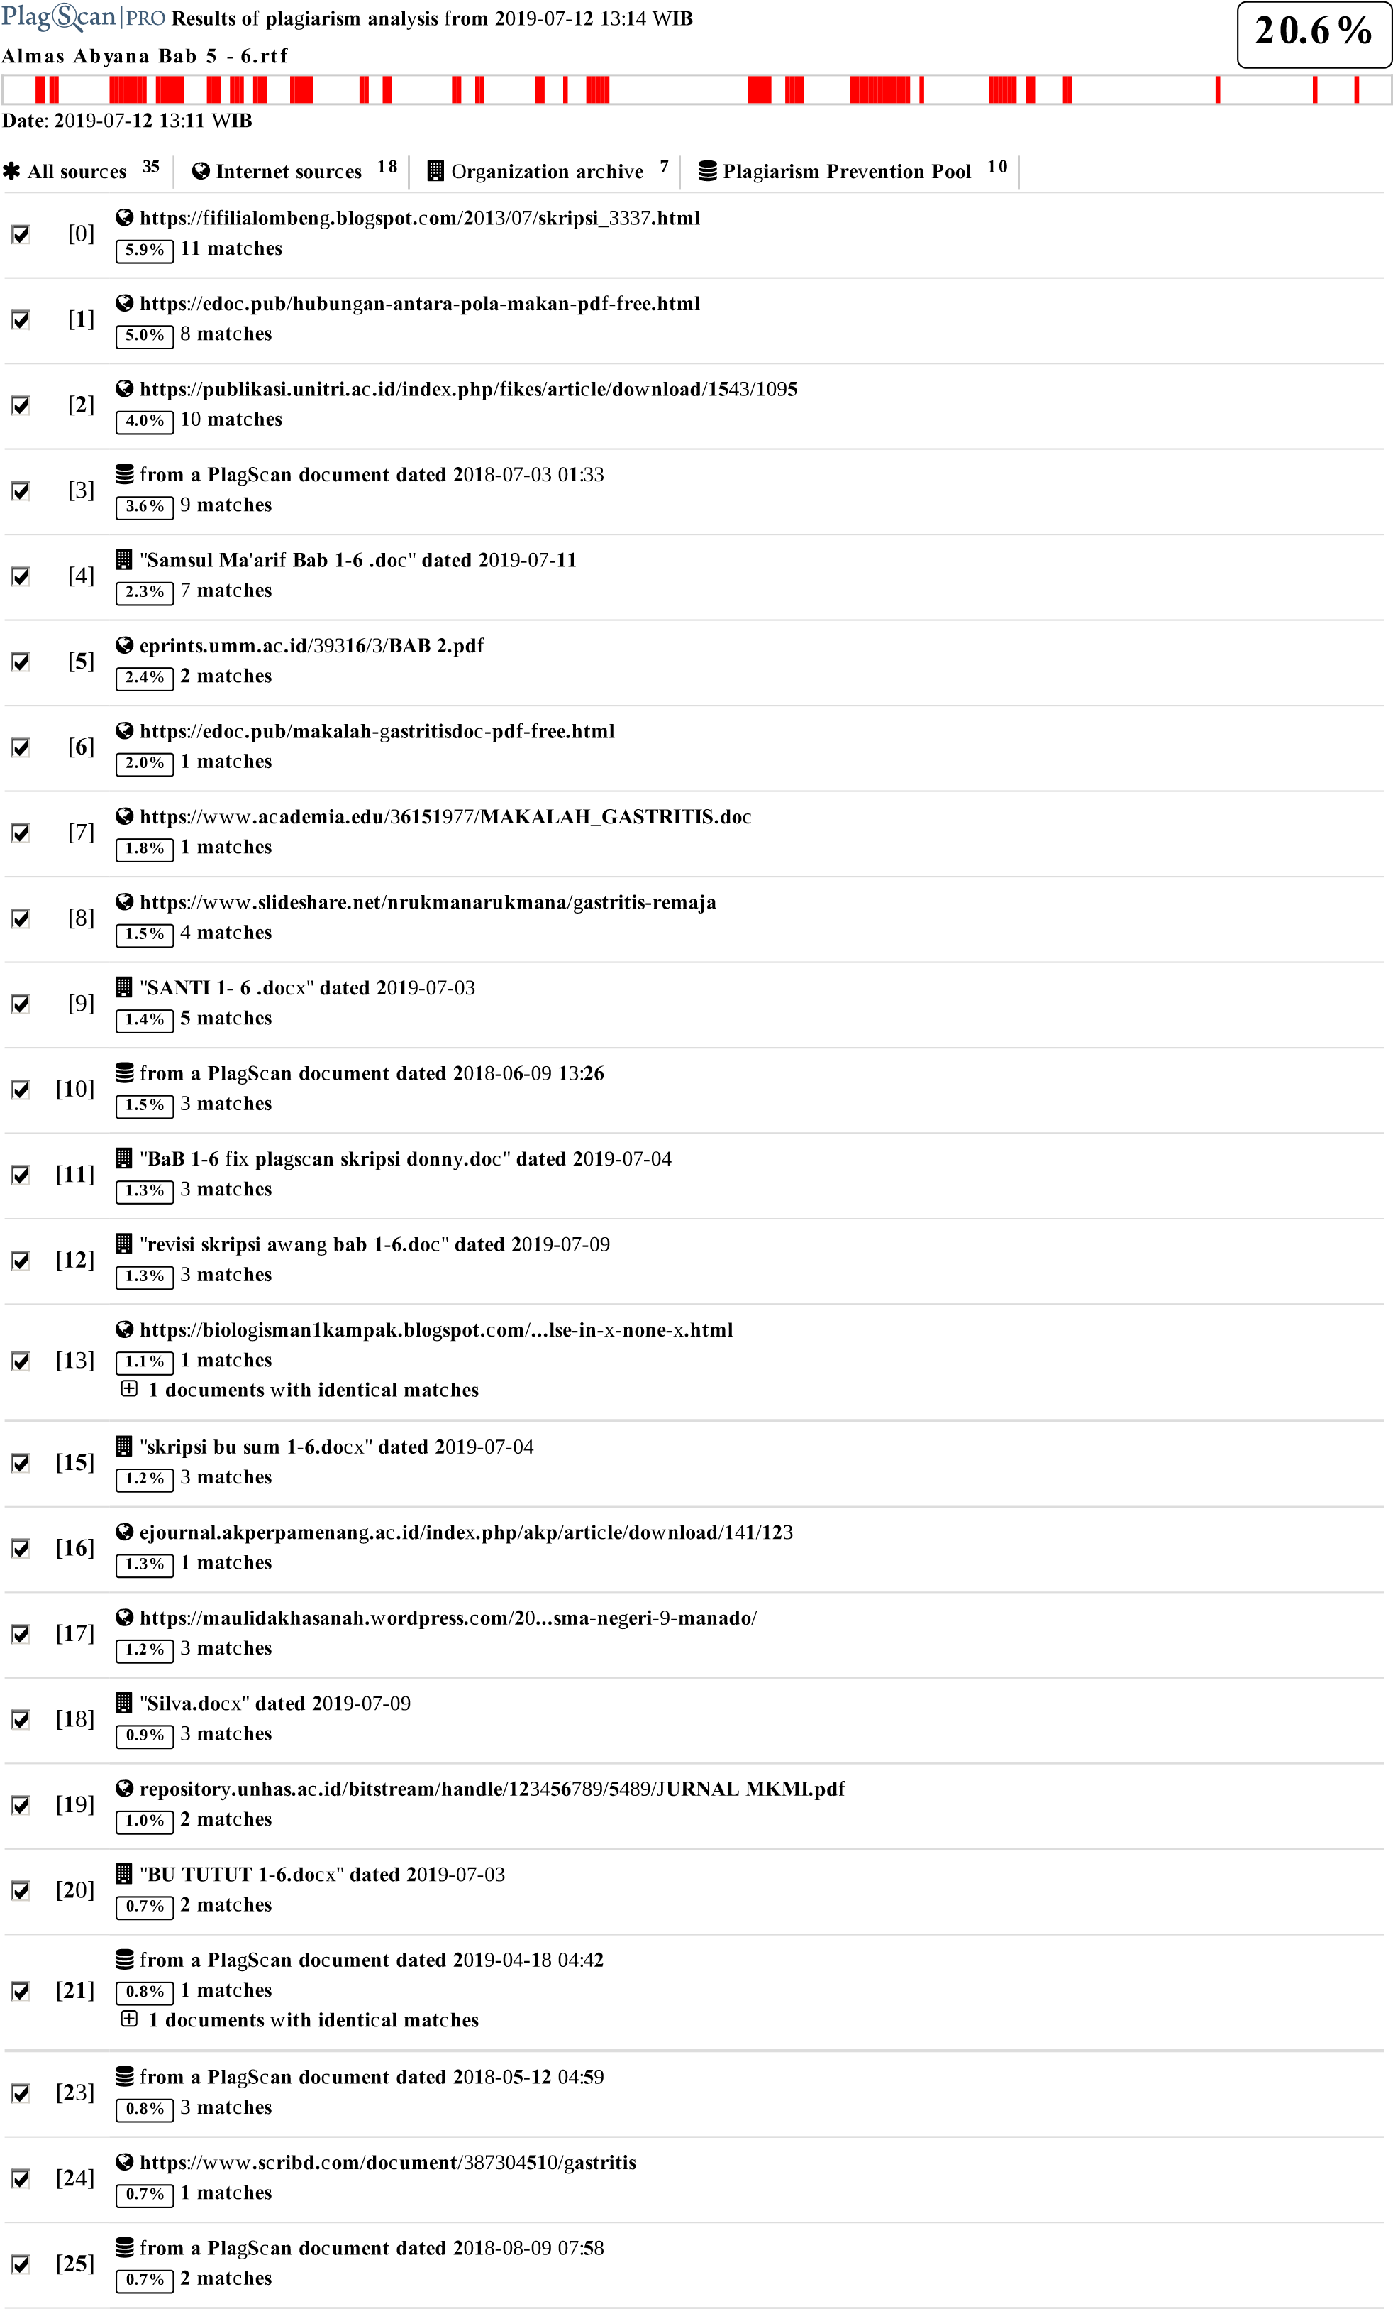

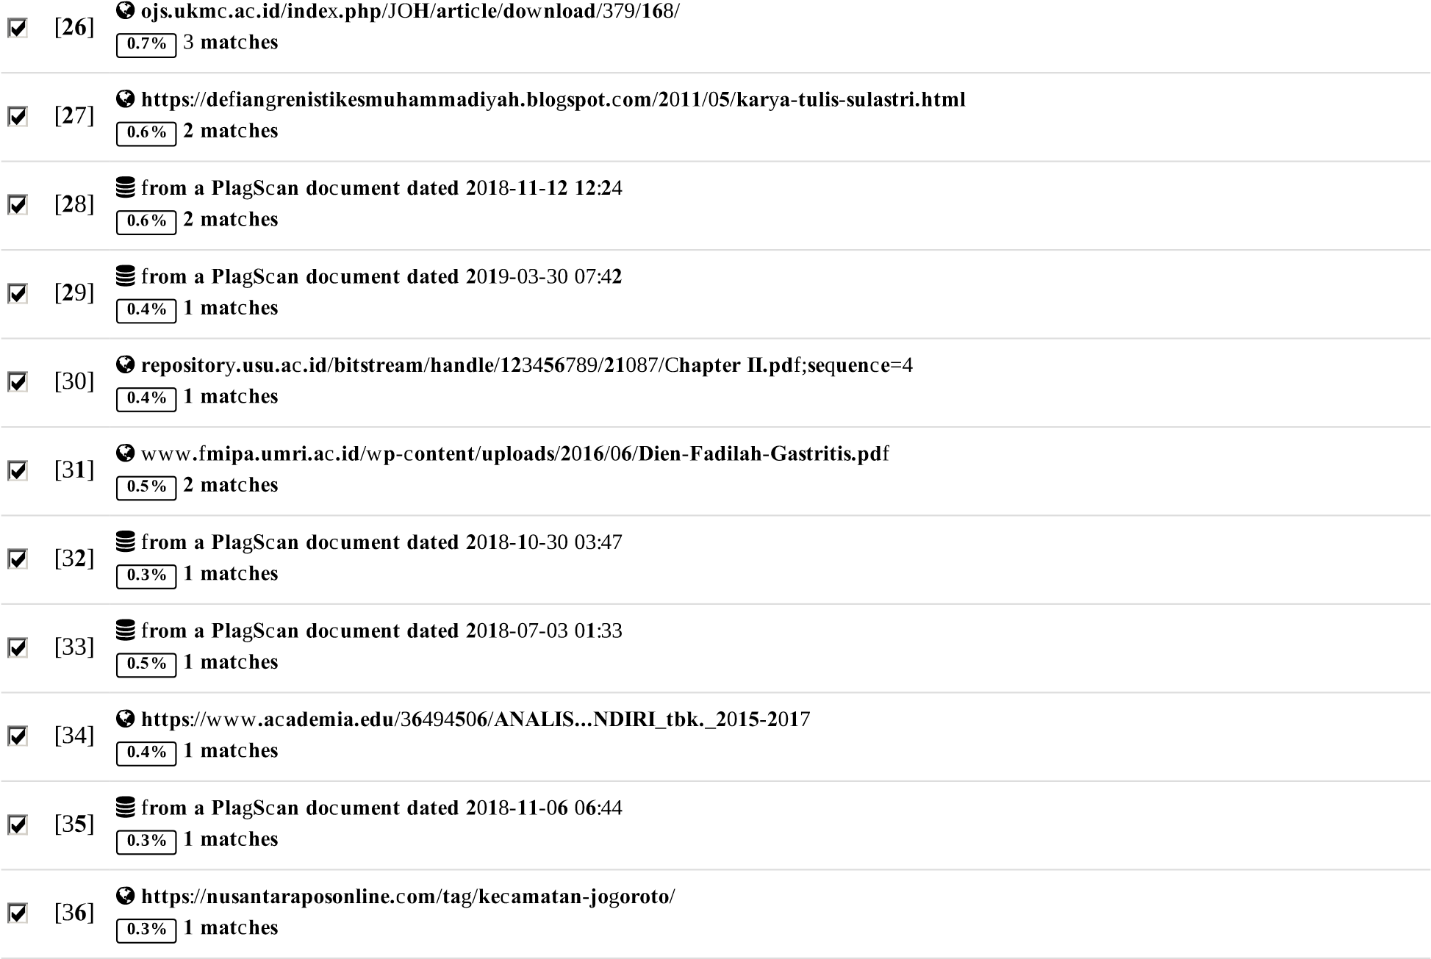

**15 pages, 2567 words**

**PlagLevel: 20.6% selected / 20.6% overall**

4**1 mat**c**hes** f**rom** 37 **sour**c**es**, **o**fw**hi**c**h 1**9 **are online sour**c**es.**

**Settings**

**Data poli**cy:*Compare with web sources, Check against my documents, Check against my documents in the organization repository, Check against organization repository, Check against the Plagiarism Prevention Pool*

**Sensiti**v**it**y:*Medium*

**Biblio**g**raph**y:*Consider text*

C**itation dete**c**tion**:*Reduce PlagLevel*

W**hitelist**:*--*

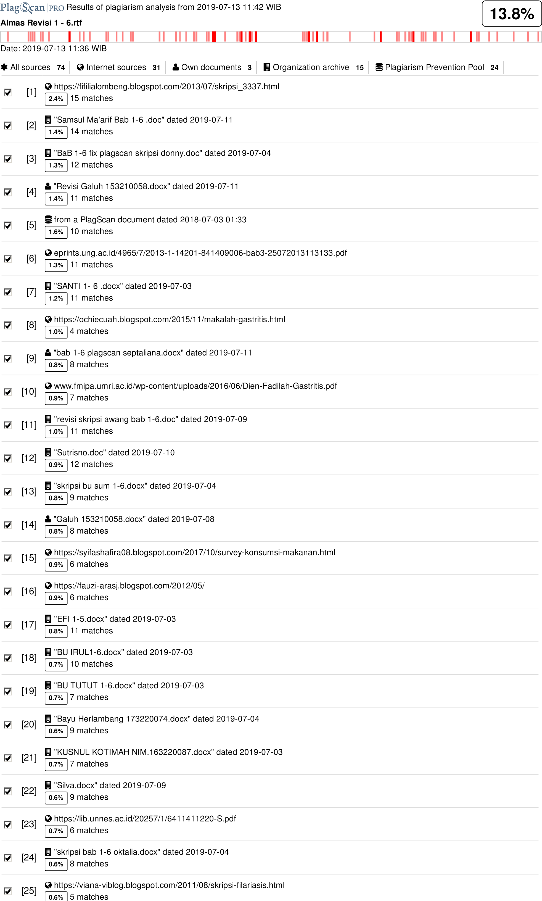

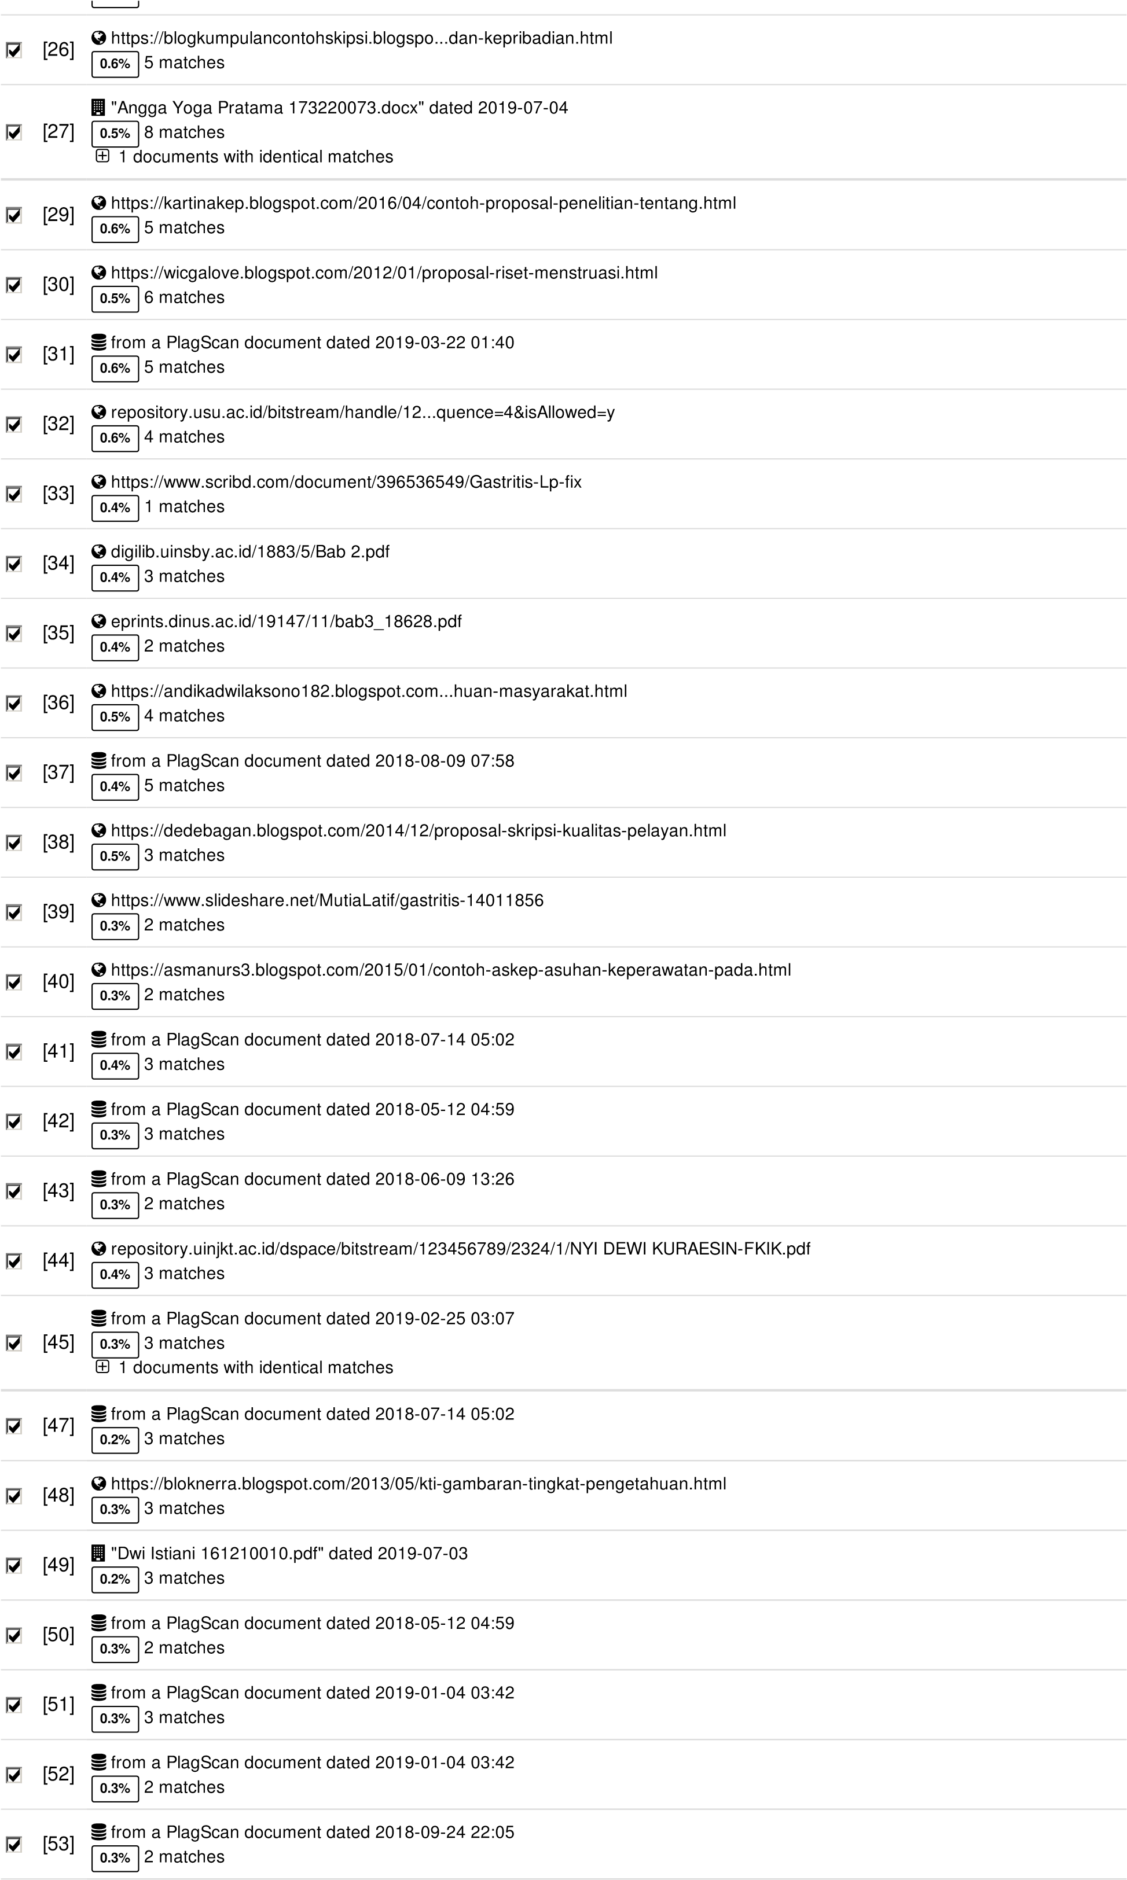

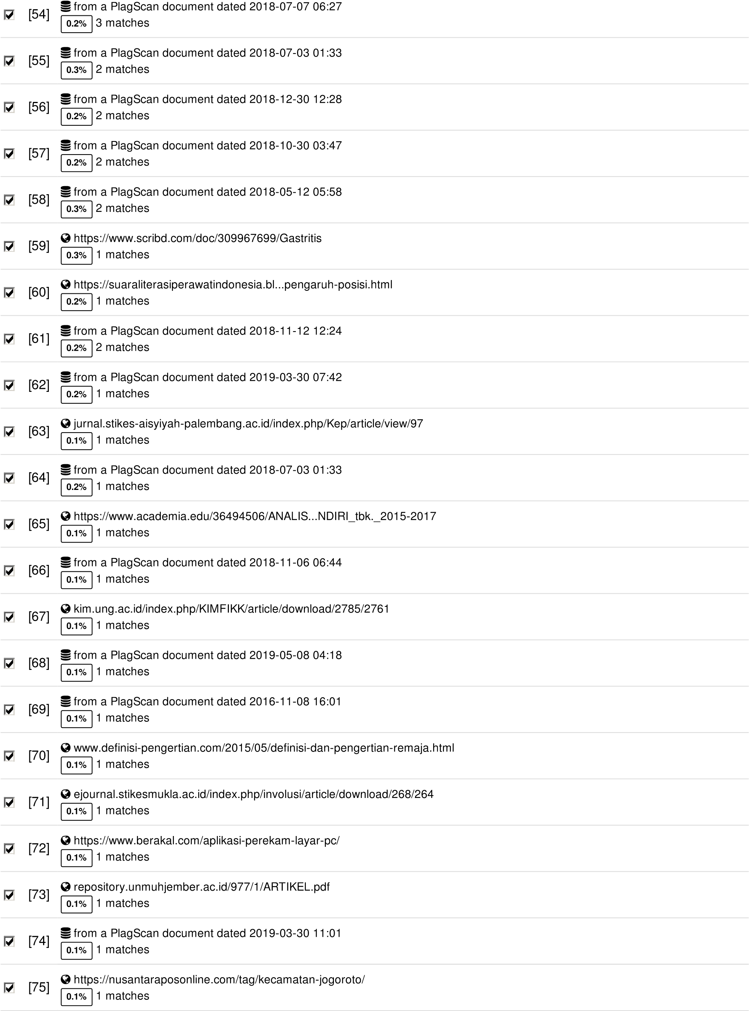

**44 pages, 6332 words**

**PlagLevel: 13.8% selected / 39.0% overall**

170 matches from 76 sources, of which 31 are online sources.

**Settings**

Data policy: *Compare with web sources, Check against my documents, Check against my documents in the organization repository, Check against organization repository, Check against the Plagiarism Prevention Pool*

Sensitivity: *Medium*

Bibliography: *Consider text*

Citation detection: *Reduce PlagLevel*

Whitelist: *--*